**Good Afternoon Everyone** - staff, children (at home or in school) and parents (at home or work). Week 3 of term 6! We have been enjoying the weather and getting on our bikes, following last week’s newsletter. Some cupcakes were made…..and lots were eaten……and we enjoyed reading some of Dickens’ stories. Does anyone live in Dickens Avenue or Pickwick? If you do you have your own personal link to the great man.

**19TH JUNE IS WALLACE AND GROMIT WRONG TROUSERS DAY**  We all love Wallace and Gromit, especially because they are local, having been created in Bristol. This event joins thousands of fantastic fundraisers to raise money to support critically ill children and babies at Bristol Children's Hospital, you may well see this event on the local news. However you don’t have to fundraise, but can join the ‘fun spirit’ of the event from the comfort of your own home, or at a safe social distance with family and friends by donning your weirdest, wackiest and most wonderful wrong trousers. Whether you parade your pyjamas on a video call, shimmy around in sequins or just have some fun in some funky flares, all you have to do is have fun!

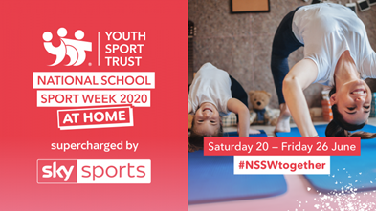**NATIONAL SCHOOL SPORTS WEEK 2020 – AT HOME**  The annual National School Sport Week campaign takes place in the last week of June every year to celebrate the important role of Physical Education and school sport in enhancing young people's wellbeing. This year, the Youth Sport Trust is running their national campaign which will aim to unite the country - families, schools, sport and businesses - in a celebration of the power of sport to bring people together, even during isolation. The UK-wide campaign will challenge people to take on their families, friends and neighbours in virtual sporting challenges – helping us all to connect in an unprecedented period of school closures and social distancing. The campaign builds on the Youth Sport Trust’s #StayHomeStayActive campaign which has been supporting schools, parents and young people with daily free resources to get young people moving and enjoying the PE curriculum while at home. What will you do? Challenge your parents to a skipping contest, go for a long walk every day or a keepy uppy contest? Let us know.

**THINGS TO INVESTIGATE ONLINE** Have you ever heard of Laurel and Hardy? Stan Laurel, who was part of this comedy duo with Oliver Hardy, and was born on 16th June 1890. Although he made movies in Hollywood and lived in California, he was actually born in Lancashire, England. He is still regarded as one of the founders of comedy alongside Charlie Chaplin and Buster Keaton, but was also an actor, writer and director. Take a look at him singing in this clip from one of Laurel and Hardy’s films, ‘Way Out West’ …it’s brilliant! <https://www.youtube.com/watch?v=qApsAPnoH7c>

We hope you have a funny week in your wrong trousers…..Stan Laurel style!

 Miss McLoughlin and Mrs Courtney