**‘Famous People Born in May’ Quiz - Answers**

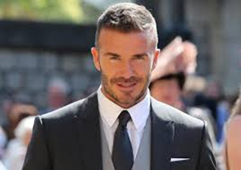1.

David Beckham was born on 2nd May, 1975.

He is a former professional footballer and co-owns Inter Miami CF and Salford City.

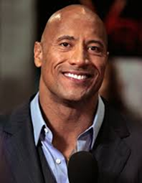2.

Dwayne ‘The Rock’ Johnson was born on 2nd May, 1972.

He is a retired American wrestler, former football player and actor.

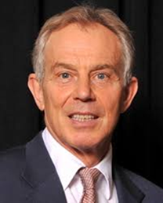3.

Tony Blair was born on 6th May, 1953.

He was leader of the Labour Party and Prime Minister of the United Kingdom from 1997 – 2007.

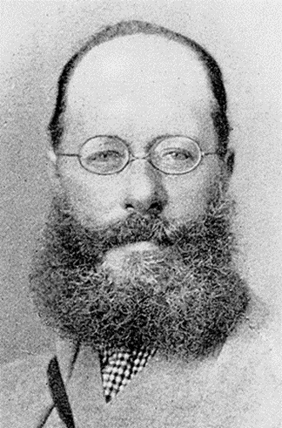

4.

Edward Lear was born on 12th May, 1812.

He was an English artist, illustrator, musician, author and poet. He is known for his limericks. You may have read his famous nonsense song, ‘The Owl and the Pussycat’.

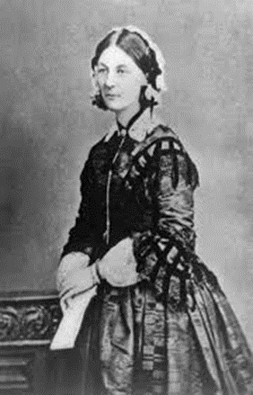

5.

Florence Nightingale was born on 12th May, 1820. She is seen as the founder of modern nursing and served during the Crimean War. Florence was known as the, ‘lady with the lamp’.

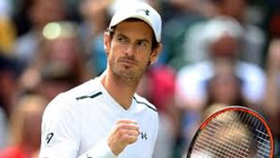6.

Andy Murray was born 15th May 1987.

He is a British professional tennis player from Scotland and has won the Davis Cup, Olympic gold and Wimbledon to name a few of his achievements.

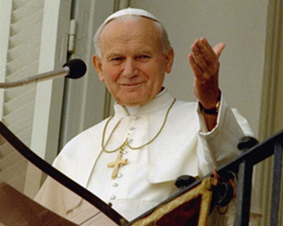7.

Pope John Paul II was born on 18th May, 1920.

He was Pope between 1978 and 2005.

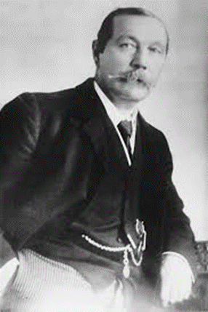8.

Sir Arthur Conan Doyle was born 22nd May, 1859.

He was a British writer and doctor, who created the fictional detective Sherlock Holmes.

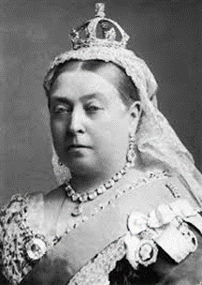9.

Queen Victoria was born 24th May, 1819.

She was Queen of the United Kingdom and Ireland, from 1837 until her death in 1901. Known as the Victorian era, she reigned longer than any other monarch before her.

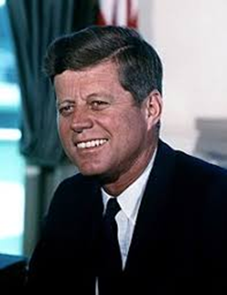10.

John Fitzgerald Kennedy was born 29th May 1917.

He was the 35th President of the United States of America from January 1961 until November 1963.