**Good Afternoon Everyone** - staff, children (at home or in school) and parents (at home or work). Week 2 of term 6! How did your swift spotting go? We have been keeping watch before they all head to Central Africa. Did you research into the Cadbury’s family? Who knew that one small shop could turn into the nation’s favourite chocolate brand? Let’s see what this week brings….

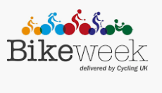**NATIONAL BIKE WEEK**  We know how many of you love to ride your bikes and we have seen how some of you have learnt to ride a bike since March, an amazing achievement! This week is **National Bike Week** and will see lots of people riding their bikes as their daily exercise and even online events on bike safety and knowing the mechanics of your bike. We have attached a great booklet full of bike related ideas – from recipes to keep you fuelled during a bike ride, to some bike related challenges to try. Again let us know of any successes and achievements.

**THE BIG LUNCH AND NATIONAL CUPCAKE DAY**  These two events are both linking food to thinking of others. National Cupcake Day is on **13th June** and is to raise money for Alzheimer’s Awareness, but is also a good opportunity to try your baking skills out and give those in your own family a little treat to make hem smile. There are hundreds of cupcake recipes to choose from and you can be as creative as you like. Rainbow cupcakes, animal themed cupcakes, even family themed cupcakes! You could then share them at your own ‘Big Lunch’. The Big Lunch is the UK’s thanksgiving weekend for neighbours and communities - a time where people come together to celebrate community connections and get to know one another a little better. Now more than ever, we need to make time for each other, so let’s get the nation talking over a glass of squash and a bite to eat and have some fun with ‘The Big Virtual Lunch’. Maybe you could have a socially distanced lunch with a friend, an outdoor picnic or share one of your cupcakes with a neighbour. We can’t wait to hear about your plans.

**THINGS TO INVESTIGATE ONLINE**

On the 9th June 1870 Charles Dickens died in Kent, England. He was one of our most famous authors, you may have heard of his novels ‘Oliver Twist’ or ‘A Christmas Carol’, but did you know that he had links to Bath and Corsham! His first novel, ‘The Pickwick Papers’, is said to have been inspired by a Corsham man named Moses Pickwick. Moses ran a coach business from the Hare and Hounds Pub in Pickwick, a coach which Dickens would have used to commute from London to Bath, and Charles Dickens is even supposed to have stayed in the pub on his journey! Although there are no record to prove this, it is amazing to think that one of the most famous authors in the world may have stayed in our town. Look at the link below to watch a short video about this great man’s life <https://www.youtube.com/watch?v=unKuZ2wlNdw>

Happy cycling, baking and resaerching everyone!

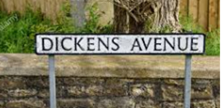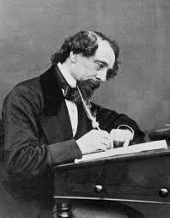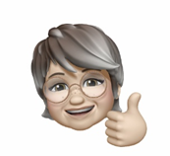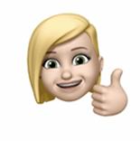 Miss McLoughlin and Mrs Courtney