**Books and Films Quiz - Answers**

1. Lily and James Potter

2. Olaf

3. Sherwood

4. Hedgehog

5. Bear

6. Meerkat

7. Dopey

8. Aslan

9. Captain Hook

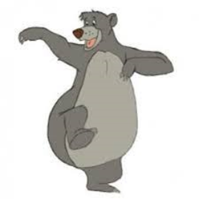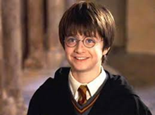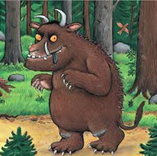10. Roasted fox