Tuesday 17th March 2020

Dear Parents,

**COVID-19 UPDATE - THE SCHOOL RESPONSE**

**GOVERNMENT UPDATE**

Yesterday evening, Monday 16th March, the Government announced new measures for managing the COVID-19 virus.

We would encourage you to review the updated information online: <https://www.gov.uk/guidance/coronavirus-covid-19-information-for-the-public>

* Anyone with a fever or persistent cough should stay at home for seven days if they live alone or 14 days if they live with others.
* Anyone who lives with someone displaying coronavirus symptoms should also stay at home for 14 days.
* [People who have to isolate themselves](https://www.bbc.co.uk/news/uk-51506729) should ask others for help. *Those people should, if possible, avoid leaving the house "even to buy food or essentials" - but they may leave the house "for exercise and, in that case, at a safe distance from others"*
* Everyone should stop non-essential contact with others. This is particularly important for people over 70, those with underlying health conditions and pregnant women.
* People should work from home where they can.
* People should avoid places like pubs, clubs and theatres - *public gatherings and crowded places.*
* People should stop all unnecessary travel.
* By the weekend, those with the most serious health conditions should be largely shielded from social contact for 12 weeks.

The government says its previous advice also remains, everyone should regularly wash their hands and avoid contacting the NHS unless it's essential. These measures, according to the government, will delay the spread of the epidemic so that the NHS can cope with demand and save lives.

GOOD HYGIENE PRACTICE

In the meantime, we would appeal to you for your active support in monitoring and promoting your child’s hygiene so that we can all take responsibility for helping protect our school community. Daily, we are reminding our children to wash their hands regularly and cough into a tissue or their sleeve rather than their hands. We are emphasising that the very best way to wash hands is with soap and water regularly, especially:

• Before leaving home • On arrival at school

• After using the toilet • Before eating lunch

• After breaks and sports activities • Before going home

Obviously, as we increase the number of times we wash our hands in school, some little hands may become quite dry. You may feel that your child would benefit from applying some hand cream at the start or end of the day to moisturise them.

We would ask parents and all visitors to please sanitise their hands before entering the school, and also on their way out. If the hand gel runs out, please wash your hands in the staff toilets before going into the school.

MINIMALISING RISK

To minimalise risk, we have reviewed all unnecessary public gatherings at school –

* Parent Consultation meetings have been postponed UNTIL FURTHER NOTICE. *However, please do not hesitate to speak with your class teacher before then if you wish.*
* Golden Assembly on Fridays will be held in house only until further notice. These celebrations will no longer be parents, family and friends - UNTIL FURTHER NOTICE.
* From today, Year 6 Boosting sessions will be postponed - UNTIL FURTHER NOTICE.
* Year 6 swimming will be cancelled - UNTIL FURTHER NOTICE.
* From today, class trips to the library will be cancelled - UNTIL FURTHER NOTICE.

‘VULNERABLE’

Attached is the Gov.UK list of those categories of people considered to have underlying medical conditions which make them more vulnerable to the virus.

If you feel that your child is vulnerable due to underlying medical conditions, you may wish to speak with your GP and seek advice about their attendance at school. In addition, speak with your class teacher to discuss how we can minimise risk further.

SCHOOL CLOSURE / HOME LEARNING

Whilst schools are currently expected to remain open, this will depend on the school’s ability to function whilst managing staff sickness or self isolation. It may be that the school will have to consider full or partial closure in coming days or weeks. Obviously, we will make your aware of this as soon as we possibly can.

We are starting to make plans so that there will be as little disruption to your children’s education as possible, should we have no alternative other than to close temporarily. Plans will involve preparing work for children to complete at home. As you will appreciate, this is not something that we have ever encountered before, so the preparation will take some time. Work would be available on the class pages of the school website as soon as possible after closure.

Whilst we will do all we can to provide resources, it may be worthwhile ensuring your child has pencils, pens, colours etc. at home. Will they have access to a computer? Please let your class teacher know if you do not have a computer, so that alternative arrangements can be made.

KEEP US UPDATED

We ask that you keep us informed of anything that you think we need to know – and we will obviously continue to keep you up to date with any information we receive from Public Heath England, The Department for Education or the Local Authority.

As you will appreciate, this is a changing situation and we will continue to update you with further information regarding the school’s operations.

Finally, - Happy Saint Patrick’s Day to all of our school and parish community!

Yours sincerely,

Rita E. McLoughlin

Executive Headteacher

GOV.UK - We are advising those who are at increased risk of severe illness from coronavirus (COVID-19) to be particularly stringent in following social distancing measures.

This group includes those who are:

* aged 70 or older (regardless of medical conditions)
* under 70 with an underlying health condition listed below (ie anyone instructed to get a flu jab as an adult each year on medical grounds):
  + chronic (long-term) respiratory diseases, such as [asthma](https://www.nhs.uk/conditions/asthma/), [chronic obstructive pulmonary disease (COPD)](https://www.nhs.uk/conditions/chronic-obstructive-pulmonary-disease-copd/), emphysema or [bronchitis](https://www.nhs.uk/conditions/bronchitis/)
  + chronic heart disease, such as [heart failure](https://www.nhs.uk/conditions/heart-failure/)
  + [chronic kidney disease](https://www.nhs.uk/conditions/kidney-disease/)
  + chronic liver disease, such as [hepatitis](https://www.nhs.uk/conditions/hepatitis/)
  + chronic neurological conditions, such as [Parkinson’s disease](https://www.nhs.uk/conditions/parkinsons-disease/), [motor neurone disease](https://www.nhs.uk/conditions/motor-neurone-disease/), [multiple sclerosis (MS)](https://www.nhs.uk/conditions/multiple-sclerosis/), a learning disability or cerebral palsy
  + [diabetes](https://www.nhs.uk/conditions/diabetes/)
  + problems with your spleen – for example, [sickle cell](https://www.nhs.uk/conditions/sickle-cell-disease/) disease or if you have had your spleen removed
  + a weakened immune system as the result of conditions such as [HIV and AIDS](https://www.nhs.uk/conditions/hiv-and-aids/), or medicines such as [steroid tablets](https://www.nhs.uk/conditions/steroids/) or [chemotherapy](https://www.nhs.uk/conditions/chemotherapy/)
  + being seriously overweight (a body mass index (BMI) of 40 or above)
* those who are pregnant

Note: there are some clinical conditions which put people at even higher risk of severe illness from COVID-19. If you are in this category, next week the NHS in England will directly contact you with advice the more stringent measures you should take in order to keep yourself and others safe. For now, you should rigorously follow the social distancing advice in full, outlined below.

People falling into this group are those who may be at particular risk due to complex health problems such as:

* people who have received an organ transplant and remain on ongoing immunosuppression medication
* people with cancer who are undergoing active chemotherapy or radiotherapy
* people with cancers of the blood or bone marrow such as leukaemia who are at any stage of treatment
* people with severe chest conditions such as cystic fibrosis or severe asthma (requiring hospital admissions or courses of steroid tablets)
* people with severe diseases of body systems, such as severe kidney disease (dialysis)

GOV.UK - What is social distancing?

Social distancing measures are steps you can take to reduce the social interaction between people. This will help reduce the transmission of coronavirus (COVID-19).

They are:

1. Avoid contact with someone who is displaying symptoms of coronavirus (COVID-19). These symptoms include high temperature and/or new and continuous cough;
2. Avoid non-essential use of public transport, varying your travel times to avoid rush hour, when possible; 3.Work from home, where possible. Your employer should support you to do this. Please refer to [employer guidance](https://www.gov.uk/government/publications/guidance-to-employers-and-businesses-about-covid-19) for more information;
3. Avoid large gatherings, and gatherings in smaller public spaces such as pubs, cinemas, restaurants, theatres, bars, clubs
4. Avoid gatherings with friends and family. Keep in touch using remote technology such as phone, internet, and social media.
5. Use telephone or online services to contact your GP or other essential services.

Everyone should be trying to follow these measures as much as is pragmatic.

For those who are over 70, have an underlying health condition or are pregnant, we strongly advise you to follow the above measures as much as you can, and to significantly limit your face-to-face interaction with friends and family if possible.

This advice is likely to be in place for some weeks.

GOV.UK - Handwashing and respiratory hygiene

There are general principles you can follow to help prevent the spread of respiratory viruses, including:

* washing your hands more often - with soap and water for at least 20 seconds or use a hand sanitiser when you get home or into work, when you blow your nose, sneeze or cough, eat or handle food
* avoid touching your eyes, nose, and mouth with unwashed hands
* avoid close contact with people who have symptoms
* cover your cough or sneeze with a tissue, then throw the tissue in a bin and wash your hands
* clean and disinfect frequently touched objects and surfaces in the home

GOV.UK - Self Isolation

* if you live alone and you have symptoms of coronavirus illness (COVID-19), however mild, stay at home for 7 days from when your symptoms started. (See [ending isolation](https://www.gov.uk/government/publications/covid-19-stay-at-home-guidance#ending-isolation) section for more information)
* if you live with others and you or one of them have symptoms of coronavirus, then all household members must stay at home and not leave the house for 14 days. The 14-day period starts from the day when the first person in the house became ill
* it is likely that people living within a household will infect each other or be infected already. Staying at home for 14 days will greatly reduce the overall amount of infection the household could pass on to others in the community
* for anyone in the household who starts displaying symptoms, they need to stay at home for 7 days from when the symptoms appeared, regardless of what day they are on in the original 14-day isolation period. (See [ending isolation](https://www.gov.uk/government/publications/covid-19-stay-at-home-guidance#ending-isolation) section for more information
* if you can, move any vulnerable individuals (such as the elderly and those with underlying health conditions) out of your home, to stay with friends or family for the duration of the home isolation period
* if you cannot move vulnerable people out of your home, stay away from them as much as possible
* if you have coronavirus symptoms:
  + do not go to a GP surgery, pharmacy or hospital
  + you do not need to contact 111 to tell them you’re staying at home
  + testing for coronavirus is not needed if you’re staying at home
* plan ahead and ask others for help to ensure that you can successfully stay at home and consider what can be done for vulnerable people in the household
* ask your employer, friends and family to help you to get the things you need to stay at home
* wash your hands regularly for 20 seconds, each time using soap and water, or use hand sanitiser
* if you feel you cannot cope with your symptoms at home, or your condition gets worse, or your symptoms do not get better after 7 days, then use the [NHS 111 online](https://111.nhs.uk/) coronavirus service. If you do not have internet access, call NHS 111. For a medical emergency dial 999

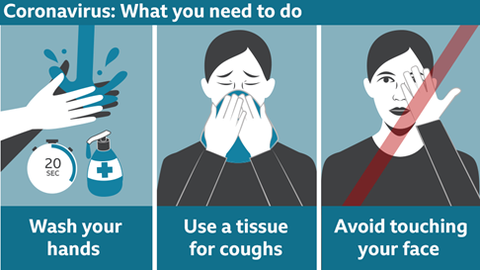

GOV.UK - In summary

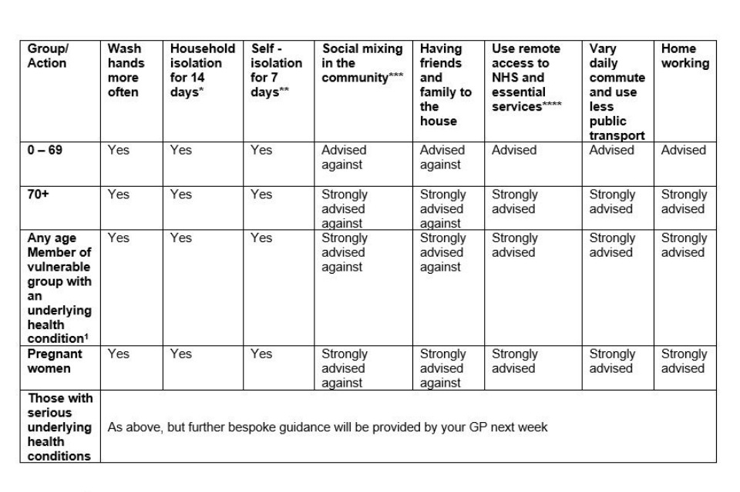

* if one member of your family or household has a new continuous cough or high temperature  
** if you live alone and you have a new continuous cough or high temperature  
*** for example cinema, theatre, pubs, bars, restaurants, clubs  
**** for example via telephone or internet  
1 such as anyone instructed to get a flu jab each year