**Famous Landmarks Quiz - Answers**

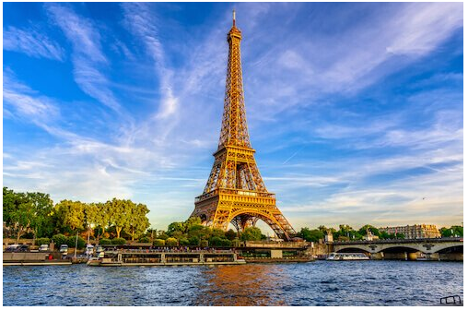

1.

Eiffel Tower – France

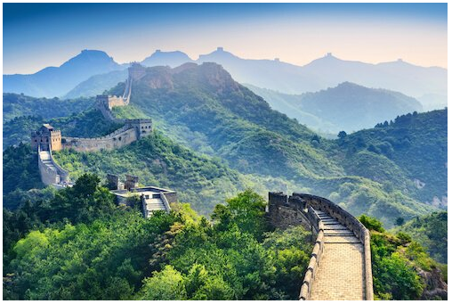

2.

Great Wall of China

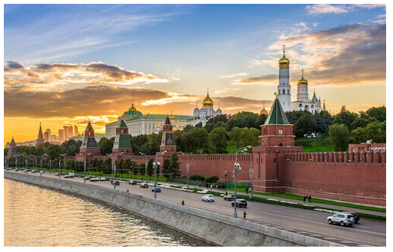

3.

The Kremlin - Russia

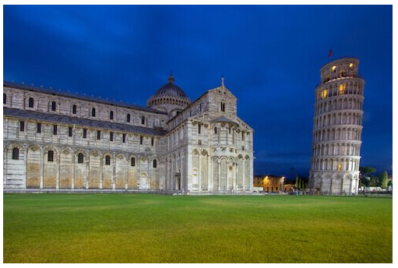4.

Leaning Tower of Pisa – Italy

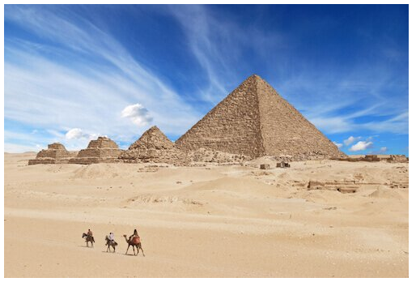5.

Great Pyramid of Giza – Egypt

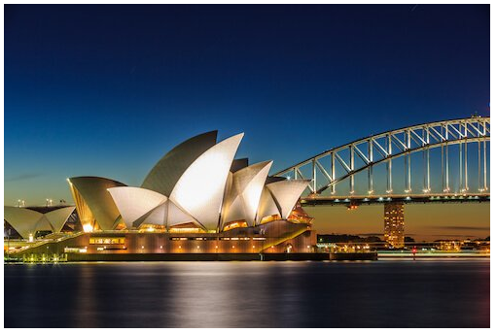6.

Sydney Opera House – Australia

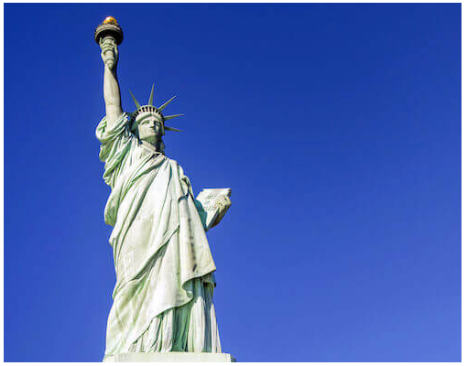

7.

Statue of Liberty – United States of America

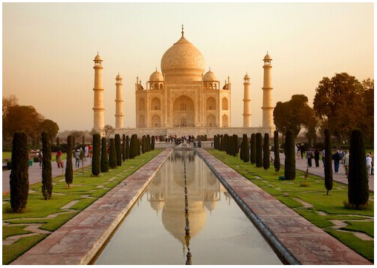

8.

Taj Mahal - India

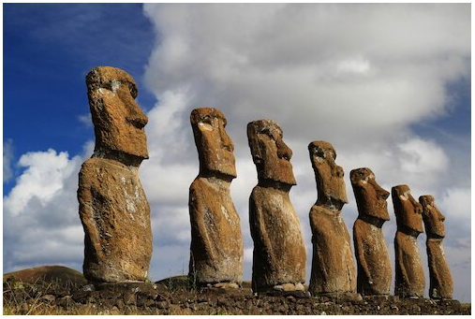

9.

Moai Statutes – Easter Island / Chile

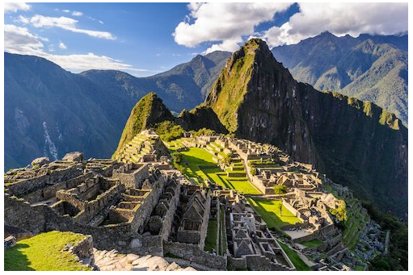10.

Machu Picchu - Peru