**YEAR 1 Home Learning – Lockdown Challenge**

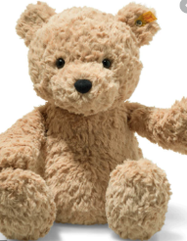**Term 6 Week 7 - 13th July 2020**

1. **Music / Drama / Dance Activity**

This week we are looking at the story ‘Whatever Next.’ It is about a bear that goes on an adventure! Can you get your favourite teddy from home and take teddy on an adventure. You MUST use your imagination!

1. **Creative / Craft & Design Activity**

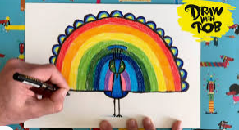Lots of the children in Year 1 have been really enjoying ‘Draw with Rob’ and have created some AMAZING pictures. This week we would like you to all draw the same thing and we can look at how similar and how different all of our creations are! We will continue with our peacock theme!

<https://www.youtube.com/watch?v=Mu_h8rNxgn4> – here is the link for the lesson!

1. **Social / Emotional Activity**

Our friendships are really important. In Year 1 we are really lucky and have so much fun together, always making each other laugh and smile. What else makes a great friendship? Can you list the ways that we can be good friends to each other, these skills will be really important for all of us at school and home.

1. **Physical Activity**

This week we want you to take part in the Rainbow Games. St. Patrick’s virtual sports day. Please see the COVID-19 section of the website for more information.

1. **Spiritual / Reflective activity**

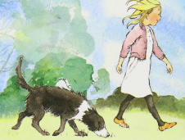Have you ever read a Michael Rosen story or poem? Michael Rosen has been very poorly in hospital and is now recovering at home. He has created such wonderful words for children all around the world. You can find out about him here… <https://www.michaelrosen.co.uk/>

Can you write or draw a prayer for Michael Rosen – so we can keep him and his family in our thoughts.

1. **Supporting the Community Activity**

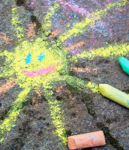Chalk your walk – brighten someone’s day by creating a fantastic chalk drawing outside your house on the pavement. If there isn’t a safe space to do this, draw a picture and put it in your window.

1. **Reading to Relax**

Have a look at the summer reading challenge. This year the theme is ‘silly squad.’

<https://www.youtube.com/watch?v=CBLXTwXf4gs>

[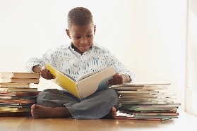](https://www.google.com/url?sa=i&url=https://www.allmomdoes.com/2017/07/06/reading-is-fun-how-to-make-summer-reading-fun-for-your-kids/&psig=AOvVaw1qB0AVQswovH9ZgK0TL6Ox&ust=1592992160794000&source=images&cd=vfe&ved=0CAIQjRxqFwoTCLD327fUl-oCFQAAAAAdAAAAABAD)What is the silliest book you own? Can you read it with a grown up.