**Home Learning – Lockdown Challenge**

**Term 6 Week 5 - 29th June 2020**

[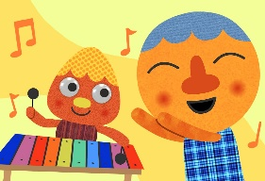](https://www.google.com/url?sa=i&url=https://supersimple.com/song/my-happy-song-featuring-noodle-pals/&psig=AOvVaw0tUmWULuHrGICsX5P6F6y_&ust=1592988053003000&source=images&cd=vfe&ved=0CAIQjRxqFwoTCODjjo_Fl-oCFQAAAAAdAAAAABAE)

1. **Music / Drama / Dance Activity**

Choose 10 of your favourite songs which make you happy. Create an album cover design for your songs whilst listening to it!

1. **[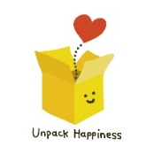](https://www.google.com/url?sa=i&url=https://www.teepublic.com/pin/5552997-unpack-happiness-box&psig=AOvVaw2Eicq0xbZ6-iJPc17AZWRD&ust=1592913012109000&source=images&cd=vfe&ved=0CAIQjRxqFwoTCNj738etleoCFQAAAAAdAAAAABAG)Creative / Craft & Design Activity**

Make your own happiness box, filled with things that make you feel happy! On the school website welcome page, there is a video of Miss McLoughlin explaining the items in her box to show you as an example. I wonder what you will put into yours. We would love to see as many as possible

1. **Social / Emotional Activity**

Positive versus negative thoughts. Please use the guide on the next page to help you think about different ways you could approach problems.

1. [](https://www.google.com/url?sa=i&url=https://community.localmasters.com/guidelines-to-embrace-yoga-in-your-day-to-day-life/&psig=AOvVaw1RsJUjpOV7eX7nyv_C6944&ust=1592991832689000&source=images&cd=vfe&ved=0CAIQjRxqFwoTCJimqZ3Tl-oCFQAAAAAdAAAAABAE)**Physical Activity**

<https://www.youtube.com/watch?v=dF7O6-QabIo> Join Adriene for a rainbow yoga session on YouTube. When you finish, make a note of how you feel after doing the activity.

[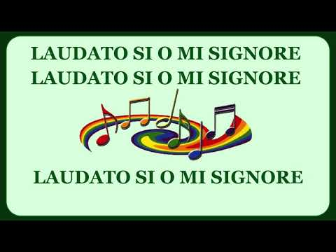](https://www.google.com/url?sa=i&url=https://www.youtube.com/watch?v%3D7XSrjv_Aga4&psig=AOvVaw3KTXv5RhwoQDsqp9dwZama&ust=1592991937122000&source=images&cd=vfe&ved=0CAIQjRxqFwoTCLDd-M_Tl-oCFQAAAAAdAAAAABAD)

1. **Spiritual / Reflective activity**

Choose your favourite hymn. Can you make a PowerPoint presentation to show the lyrics and add pictures to match the theme of the hymn? We could use these next academic year for hymn practice!

1. **Supporting the Community Activity**

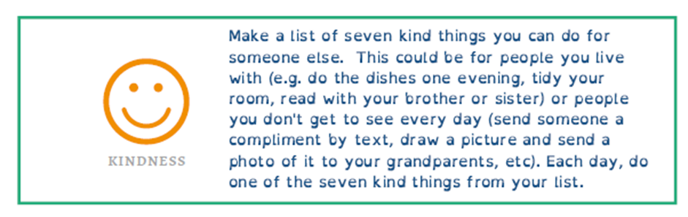

[](https://www.google.com/url?sa=i&url=https://www.allmomdoes.com/2017/07/06/reading-is-fun-how-to-make-summer-reading-fun-for-your-kids/&psig=AOvVaw1qB0AVQswovH9ZgK0TL6Ox&ust=1592992160794000&source=images&cd=vfe&ved=0CAIQjRxqFwoTCLD327fUl-oCFQAAAAAdAAAAABAD)**Reading to Relax**

Find a book with lots of different character where you can practise different voices. Make some loud, quiet, funny, strange and then read aloud to a member of your family and shock them with your expression!

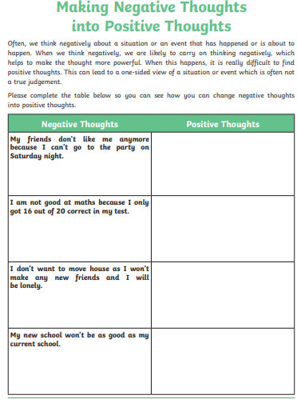

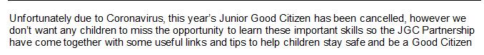

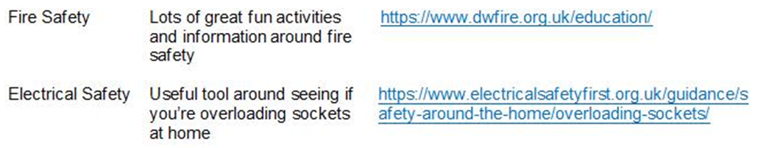

**Maths**

**Day 1**

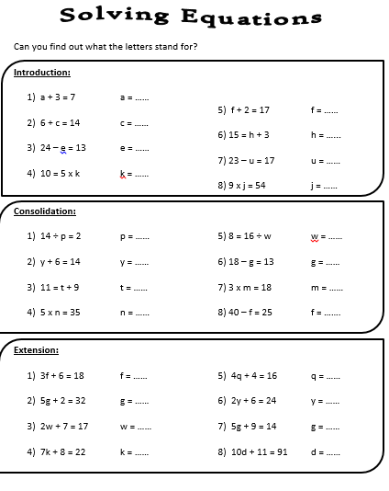

**Day 2**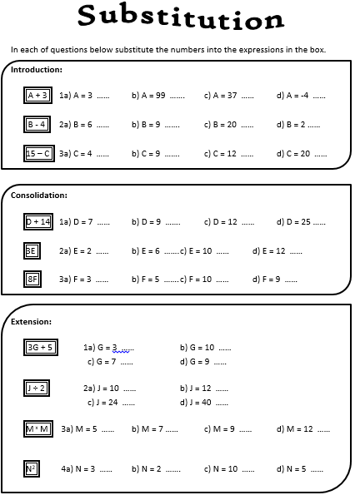

**Day 3**

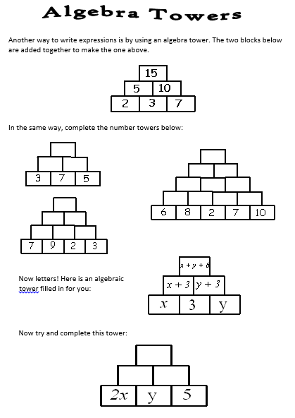

**Day 4**

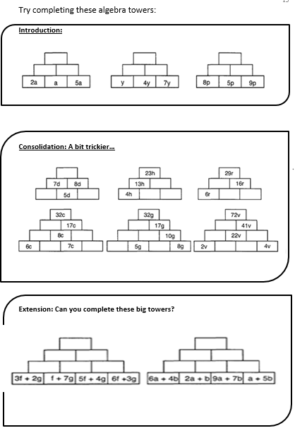

**Day 5**

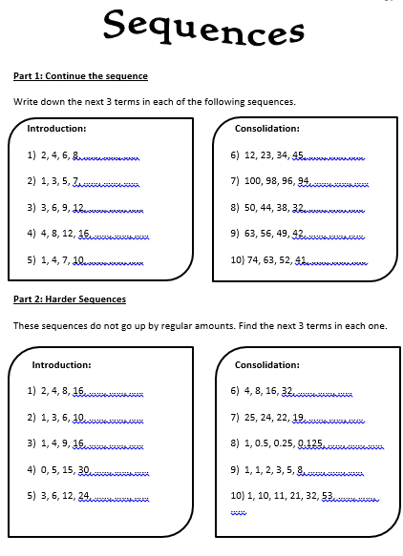

For the next couple of weeks please use this booklet, produced by ‘Talk for Writing’ to support your English activities. Some activities are here – but the whole booklet can be downloaded from:

<https://www.talk4writing.com/wp-content/uploads/2020/04/Y6-Unit.pdf>

These sessions are from the booklet ‘Doors – the World of Possibility’

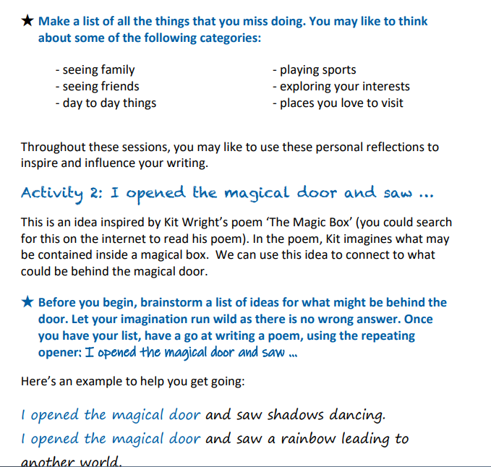

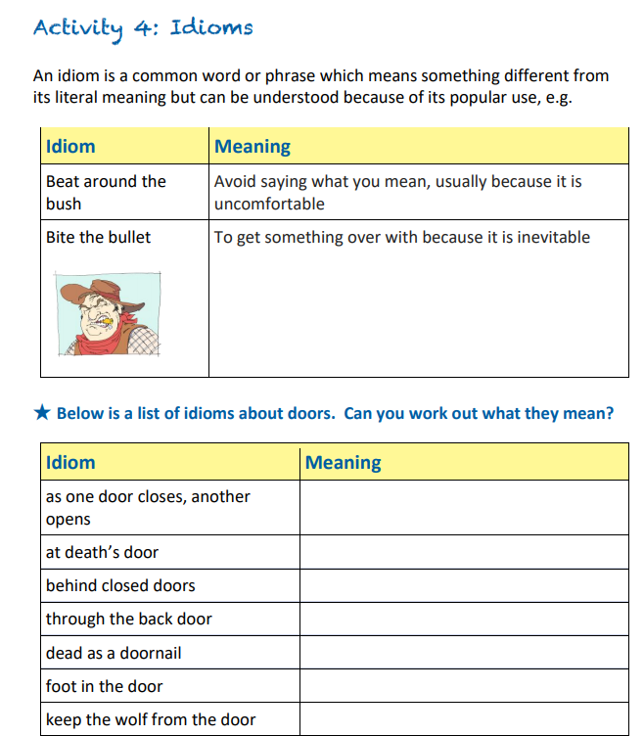

Spelling Activity

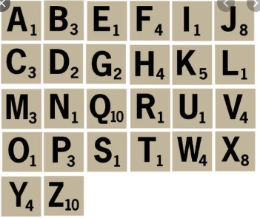

Look through any writing you have done.

Use the scrabble scorer to find the points for words that you have used.

What is the highest score you have written?

Use a dictionary to score some unusual words.