**Home Learning**

**Year 1 – Term 6**

**Week Beginning 13th July**

**Maths:**

**(You can choose to do The National Oak Lessons- link on the class page or the lessons below)**

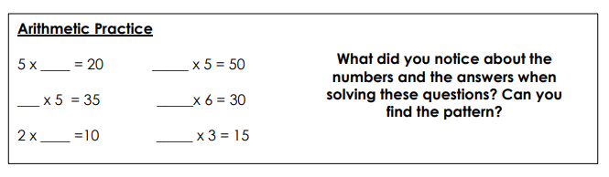**Day One:**

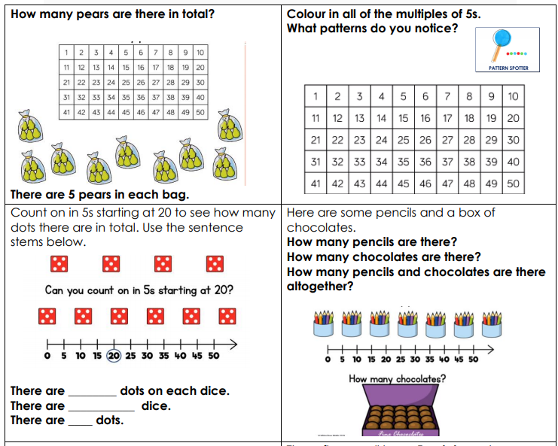

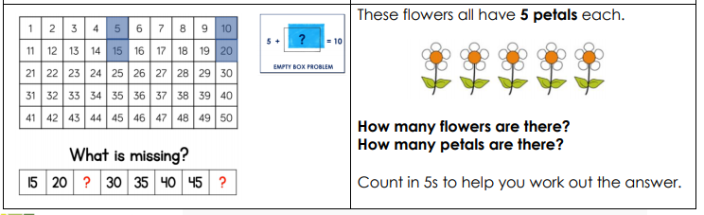

**Day Two:**

**https://www.youtube.com/watch?v=J2o0FR5oY74&list=PLQqF8sn28L9yTV9WxpHw-9BbqRe_f49fr&index=14&t=94s**

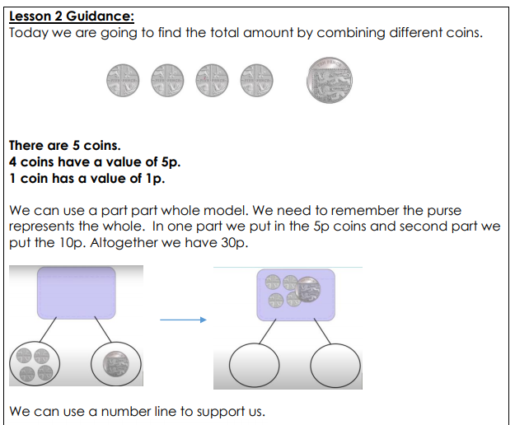

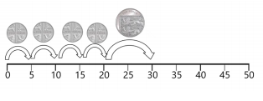

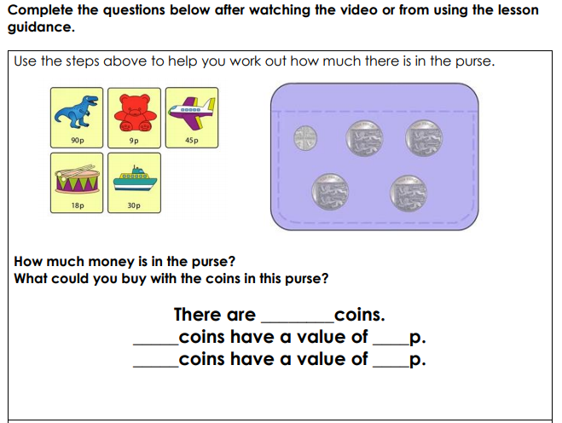

**Day 3:**

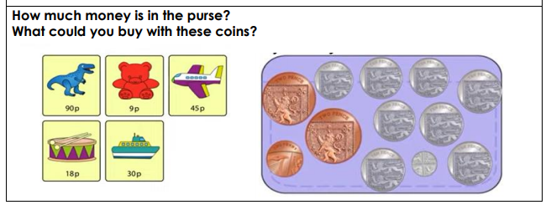

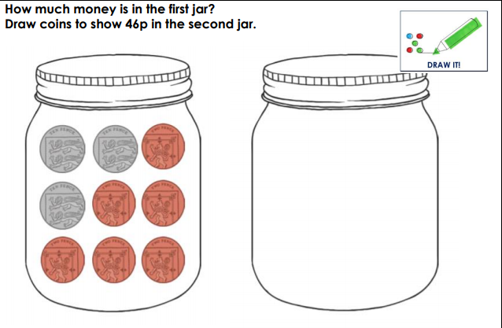

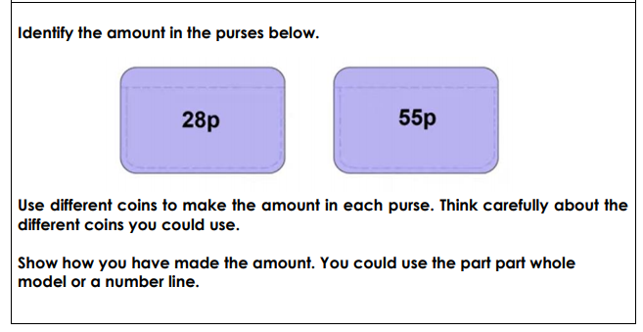

**Day 4**



**Reading:**

**English:**

**Diary entry**

**Story writing**

**Day Four:**

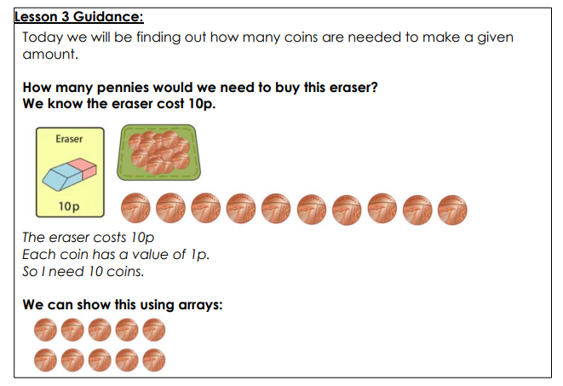

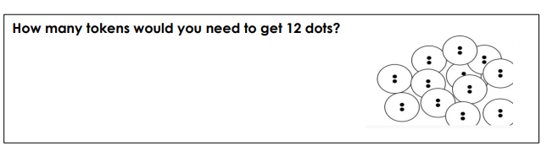

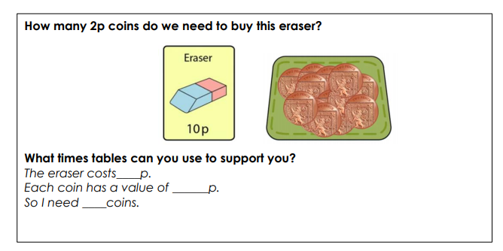**Day 5**

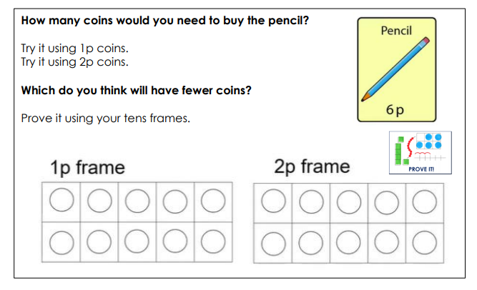

**Spellings:**

**(Draw a tens frame if you are unable to access a printer)**

**Phonics: Remember all the websites that you need for phonics are saved on our class page.**

**English:**

**Diary entry**

* Keep up writing your daily journal recording your time and learning at home. Remember to include the events, and your thoughts and feelings. ***Dear Diary…First… Then… After that… I felt… I liked…***

Think about the positive things that have happened in your day. When you reread your diary each day, these memories will help you to focus on the great things that are happening. You can fill it in each day or once a week!

***This week you will be learning about the story ‘Whatever Next’ by Jill Murphy. If you haven’t got the book, you can listen to it here…***

[**https://www.youtube.com/watch?v=6c5cb0u0rPM**](https://www.youtube.com/watch?v=6c5cb0u0rPM)

**Monday**

Listen the story, what do you like about it? What was the best bit? What did you think of the characters? Write a short book review answering these questions.

Did you like the story? Why?

Can you describe the characters in the story?

Who would you recommend read the story next and why?

**Tuesday**

<https://www.bbc.co.uk/bitesize/topics/z8x6cj6/articles/zxvcrdm>

Today we want you to think about using a comma in a list. Watch the video above to learn about commas. Think about yesterday’s story. If you went to the moon, what would you need? Write a list of the things you would take and remember the use a comma.

**I went to the moon and took…**

**Wednesday**

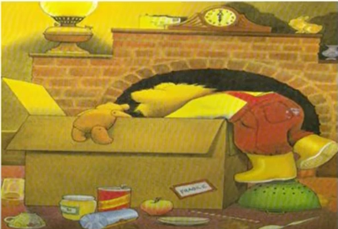

Have you noticed the envelope above the fire? What do you think is in it? Can you write the letter that you imagine is inside?

**Thursday**

Listen to the story again. At the end Mummy says ‘you and your stories, whatever next?’

Where do you think Baby Bear will go on his next adventure? Draw a picture of the story setting and write a description to tell us about where the adventure will take place.

**Friday**

Last week you thought of some great conversation starters with the people you love. What do you think Baby Bear would say to owl a few days after their adventure? Can you write a letter to Owl from Baby Bear? Remember, when you ask a questions, you need to use a question mark.

**OR**

You could write a leaflet all about the moon. What information do you already know? What else do you want to find out?

More information…

<https://www.sciencekids.co.nz/sciencefacts/space/moon.html>

BBC bitesize

<http://www.primaryhomeworkhelp.co.uk/moon/facts.htm>