**Home Learning**

**Year 1 – Term 5 Week 3**

**4th May 2020**

**Reading:**

Pick a new book for the week. This week you are going to pick someone special in your family who would love to listen to a story. On Friday, you can video call them and become a story teller. You could pick a poem or use one of the big cat books. Read each day and you will be a confident and fluent story teller on Friday!

Big Cat books have made their books available on line during school closures. This link will give you a password and link. Please look at the Big Cat section and together you can pick a fiction or non-fiction book (look at the banding of their current reading book to guide your choice).

<https://collins.co.uk/pages/big-cat-ebooks>

**English:**

**Diary entry:** How are you getting on with your diary? Are you enjoying looking back at what you’ve been up to? If you would like to continue with your diary, we’d love to see what you’ve been up to. You might want to write in your diary weekly or daily.

**Instruction writing**

This week we will be learning how to write instructions. Over the week can you…

Listen to the story ‘Carla’s Sandwich’

<https://www.youtube.com/watch?v=M-aceEquCtY>

What did you like about it? What was your favourite part? Can you draw a picture of the sandwich that you thought was the most interesting from the story… can you label it?

Can you think about your favourite sandwich? What would you put in it? Draw a picture of your favourite sandwich and write down the ingredients that you need by labelling the picture.

Now it is time to write your instruction words. You need to use verbs (bossy words) to help you write instructions. Verbs you might want to use: **cut, spread, put, get, peel, slice, mix, melt, taste.**

Connective words that might help: **First, next, after, second, meanwhile, finally,**

**OR** There is a weeks’ worth of instruction writing on the national oak academy. You may wish to use these online videos or you can follow these ideas.

To access instruction writing you need to look for the **week 1 (April 20th)** work in English section for Year 1.

<https://www.thenational.academy/online-classroom/year-1#schedule>

**Spellings:** Look at the spellings for week 3 that were sent to you before Easter, can you learn them all?

**Phonics:**

*Daily phonics lessons are online. Please see phonics letters for the times of lessons and how to access them.*Don’t forget the flash cards are there to watch on our class page!

**Maths:**

**Mental Arithmetic. Solve these arithmetic addition sentences. An example has been done for you. Create three more of your own.**

|  |  |  |  |
| --- | --- | --- | --- |
| **12 + 8 = _____**  **12 + ____= 20**  **8 + _____= 20**  **20= 12 + _____**  **20= ____ + _____** |  |  |  |

# Multiplication: Making Arrays

**Arrays are all around us. Go for array hunt around your home and make different arrays with loose objects. Record your findings on a table like the ones below.**

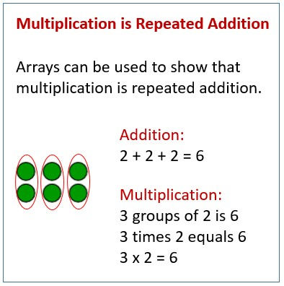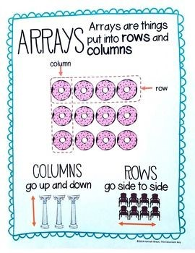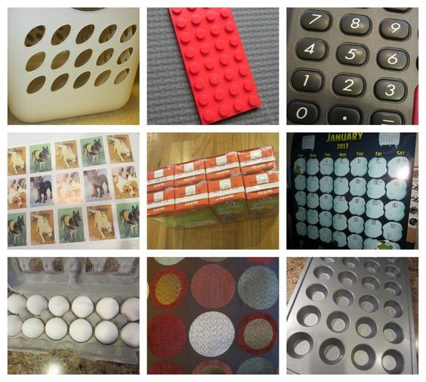

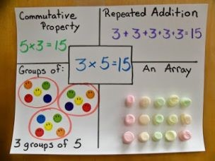

**Science:**

**Can you fill in the missing boxes below using the picture above to help you? (The Repeated Addition, Equal Groups and Arrays for the sum 2 X 10=20)**

10X2=20

2X10 = 20

**Amir and Whitney are making arrays. Who has made a mistake? Explain why.**

**I think __________ made a mistake because**

**_________________________________.**

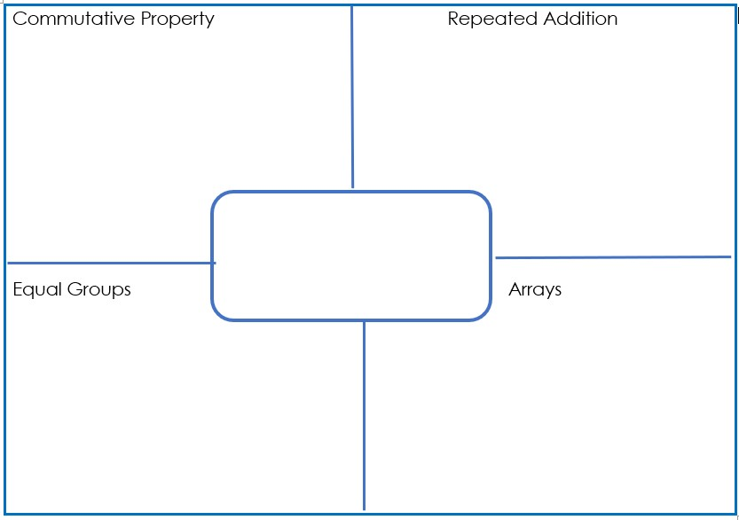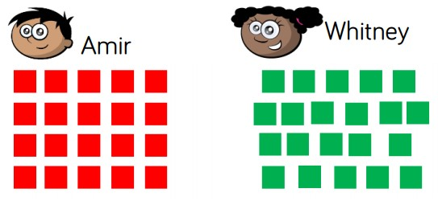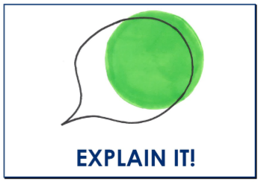

**Science:**

What do plants need to survive?

<https://www.bbc.co.uk/teach/class-clips-video/science-ks1-ks2-ivys-plant-workshop-what-do-plants-need-to-survive/zkw2gwx>

[](https://www.bing.com/images/search?view=detailV2&ccid=4uYf/Yt7&id=026DC5799A602DD8A2865AA7A4B361806C2186B0&thid=OIP.4uYf_Yt75ERWGjuX3WaGzAAAAA&mediaurl=http://1.bp.blogspot.com/_mcV14rOgvIs/TTRjaqClSKI/AAAAAAAAFBA/PeWDI2XCZYs/s200/peace-symbol-coloring-page.jpg&exph=191&expw=200&q=symbol+of+peace&simid=608051301602821088&selectedIndex=6&adlt=strict)Watch this video about Ivy’s plant shop. Can you write a letter to Ivy explain what a plant needs to survive, I think she needs a reminder!

**History:**

VE (Victory in Europe) Day

Friday 8th May marks the day when the war in Europe was over.

Watch the video which shows when Winston Churchill (the prime minister at the time) announcing peace in Europe.

Look at how everyone is feeling, there is so much joy and happiness. <https://m.youtube.com/watch?v=NEavcsrMoMw>

Can you organise a VE Day celebration in your house. You need to make a party food list (remember food would have been rationed and so you would have to think carefully about what food you would want and make sure you had enough for the rest of the week).

Or you can design a symbol of peace. Peace is so precious and something that everyone was desperate for, can you imagine how wonderful peace was after a 6 year war.

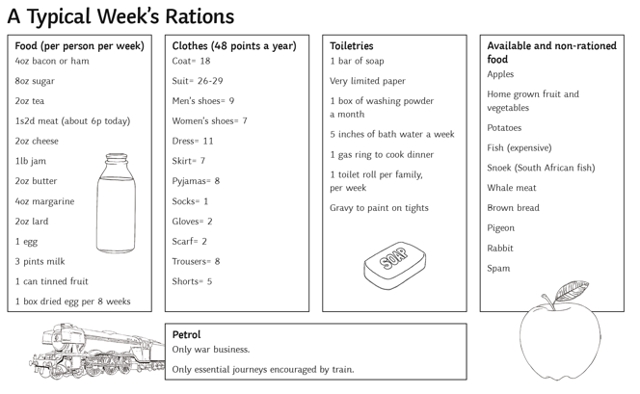

**Geography:**

Where do you live? I want you to compare where you live (a town or village) with someone who lives in a city. Can you write 5 questions you’d like to ask someone that lives in a city? If you know someone who lives in a city, phone them and see if they can answer your questions!

**Art:**

[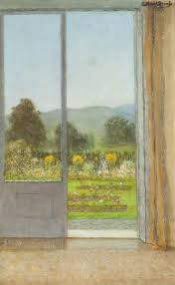](https://www.google.co.uk/imgres?imgurl=https://artuk.org/download/view-from-my-window-150615&imgrefurl=http://artuk.org/discover/artworks/view-from-my-window-150615&tbnid=fr7dPNWheiUNBM&vet=12ahUKEwj8gvGNtvnoAhVJwIUKHZcwCkkQMygregQIARBu..i&docid=r74WqVvf4h4B1M&w=738&h=1200&q=a%20view%20from%20my%20window%20picture&safe=strict&ved=2ahUKEwj8gvGNtvnoAhVJwIUKHZcwCkkQMygregQIARBu)**We would love it if you could draw ‘A view from my window’. If you could use colour and send a photo of it to the school office that would be amazing!**

**RE:**

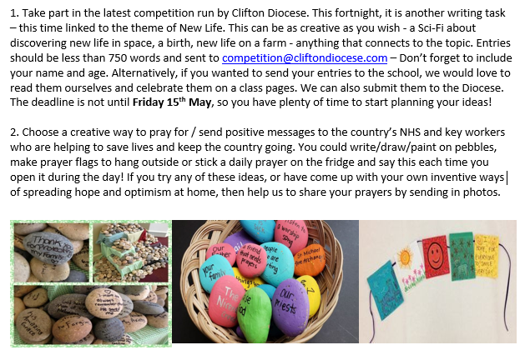

**Grammar and Punctuation:**

Capital letters for names. Can you write the names of your family and friends? Remember to use a capital letter for any name!

**PE**

Go Noodle have some fantastic ideason how to keep a healthy mind and body! Go to [www.gonoodle.com](http://www.gonoodle.com) to have a look for this week’s PE

**Mindfulness**

**Shark Fin!**

Shark Fin is a fantastic tool that you can use during any quick moment in your day. It help to calm your mind when your minds and body may be fighting against it.

* Place the side of your hand on your forehead, with your palm facing out to the side.
* Close your eyes.
* Slide your hand down your face, in front of your nose.
* Say “shhh” as you slide your hand down your face
* If you are sitting down, you do the 5 Shhs while you move your hand: Sit up straight, sit still, sit silently, soft breathing, shut eyes.
* If you are standing do the same but you are standing straight, still, silently, using soft breathing and shut eyes while you move your hand down your face.