**Home Learning**

**Year 1 – Term 6 Week 3**

**15th June 2020**

**Maths (You can choose to do The National Oak Lessons or the lessons below)**

[**https://www.thenational.academy/year-1/maths/to-apply-knowledge-of-number-bonds-year-1-wk5-1#slide-2**](https://www.thenational.academy/year-1/maths/to-apply-knowledge-of-number-bonds-year-1-wk5-1#slide-2)

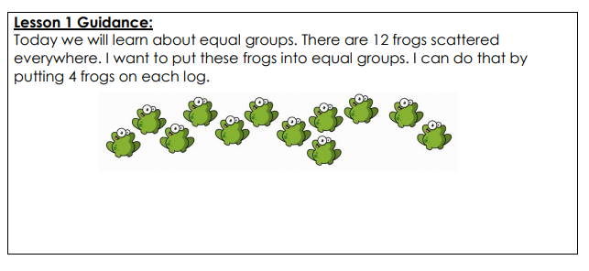

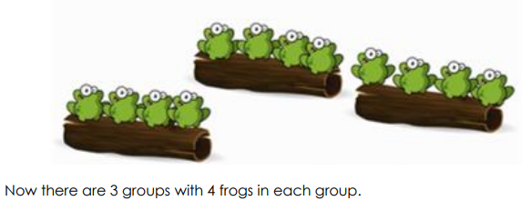

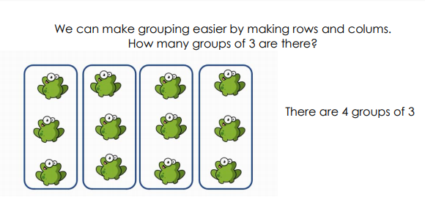

Complete the questions below after watching the video or from using the lesson guidance. You may want to use some Lego pieces, milk bottle lids or any small items to help you make equal groups as you complete the learning.

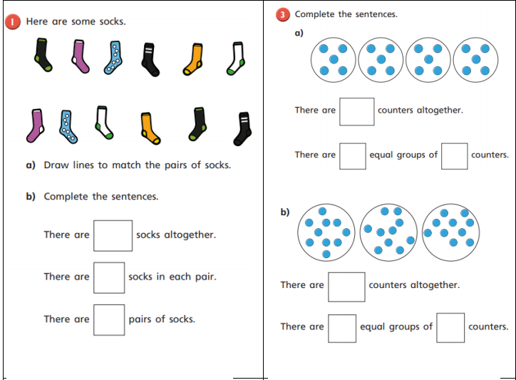

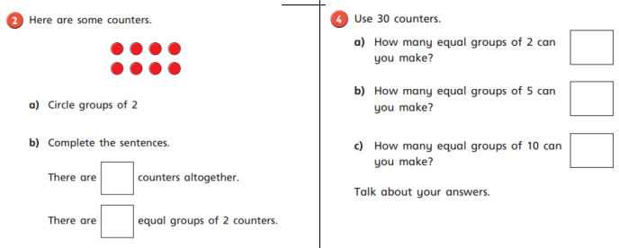

**Day Three**

This is a twenty minute practical online lesson on counting in twos and tens. You will need counters or you could just use pasta. You don’t have to do all of it just get as far as you want to.

<https://www.youtube.com/watch?v=Q0Z5UjVoIDg&list=PLQqF8sn28L9yTV9WxpHw9BbqRe_f49fr&index=4&t=0s>

**Day Four**

Lesson 2 Guidance: Practice counting in tens. Use the number line to help you.

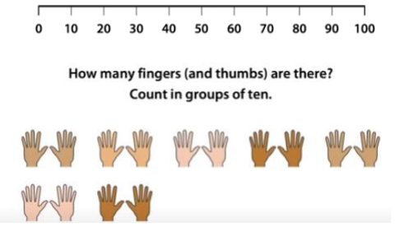

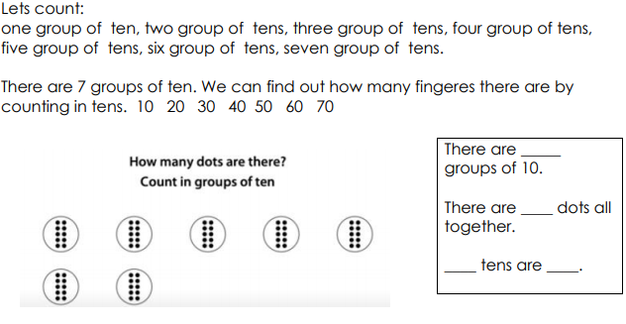

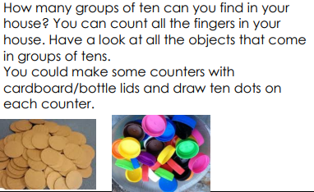**Day Five**

**Reading:**

* Look at the front cover of a book you haven’t read and make a prediction on what you think the book will be about. Read the blurb and add to your prediction. Think about where the story might be set, the characters you think may be involved in the story and what you think will happen. Use the following sentence stems: **I wonder if, I bet, I imagine, I think x will happen next…because…**
* Try and pick a book that is a little different to the one that you picked last week.
* Read the book and summarise in a few sentences what the book was about. Was your prediction correct?
* Answer the questions in the back of your book. If you are using the online resources, there are activities to go with each book.
* Read the book over the week. On Friday, sit your teddy bears in a circle and read them the book like a teacher would.

As well as the big cat books, if you would like to look at a different resources try these …

[https://home.oxfordowl.co.uk/books/free-ebooks/](https://www.google.com/url?q=https%3A%2F%2Fhome.oxfordowl.co.uk%2Fbooks%2Ffree-ebooks%2F&sa=D&sntz=1&usg=AFQjCNEZP7LIQ8zlFo5pQ5vGHcscHcY1zQ)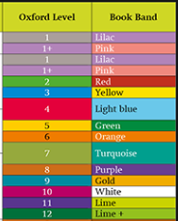

When you first enter the site, it will ask you to select the book level for your child. You can do this either by their age group, book series or by Oxford Owl Level.

If you then select **Browse by Oxford Level** and select the colour – for example Book Band blue – Oxford Level 4– you will then be able to access the books in that band/level.

To read the ebooks you will then have to register and login, however this is free to all parents and new ebooks are regularly added. It is recommended to read the books at a computer or laptop, however these can be read on a mobile.

**English:**

**Diary entry**

* Keep up writing your daily journal recording your time and learning at home. Remember to include the events, and your thoughts and feelings. ***Dear Diary…First… Then… After that… I felt… I liked…***

Think about the positive things that have happened in your day. When you reread your diary each day, these memories will help you to focus on the great things that are happening. You can fill it in each day or once a week!

**Recount writing:** Recount texts can come in the form of diary entries, newspaper articles and letters, and usually have the following features:

* Written in chronological order
* Written in the first person (diaries and letters)
* Written in the past tense
* Use time connectives

**Monday**: Discuss an exciting day you had with a grown up. What happened that made you really happy? Where were you? Did you see anyone? Create a story map (little pictures in the correct sequence) of all the things that happened that day. Over the next 3 days, you are going to use your story map to help you write down what happened. Can you use time connectives to make it really interesting?

**Tuesday**: Write the beginning of your recount

**Wednesday**: Write the middle of your recount

**Thursday:** Write the end of your recount (and illustrate).

**Friday:** Can you write a letter to someone special in your life. It will cheer them up and spread a smile!

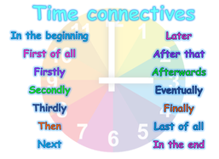

**OR** On the National Oak Academy there is a weeks’ worth of recount writing (week 8). You may wish to use these online videos or you can follow the ideas above.

**Phonics:** *Daily phonics lessons are online. Please see the link on our class page.*Don’t forget the flash cards are there to watch on our class page!

**Science: The ultimate paper aeroplane**

Year 1 love making paper aeroplanes and so we have created to ultimate science experiment for them!

1. Can you make a paper aeroplane?
2. Can you throw it and measure how far it goes.
3. <https://www.stem.org.uk/system/files/elibrary-resources/2020/05/Plane%20Instructions%20Final.pdf>

Can you make the ultimate paper aeroplane.

1. Can you throw it and measure how far it goes.
2. Which one was the best? How do you know? Why do you think that was?

We would love some photos or videos of your paper aeroplanes!

**History:**  Queen Victoria was the first monarch to live in Buckingham Palace. It is a fascinating place to explore. This week we would like you to use the website to explore the different parts of the palace and see what you can find out. Can you draw a picture of your favourite room?

<https://www.rct.uk/visit/the-state-rooms-buckingham-palace>

**Geography: Map Reading**

We would like you to have a go at reading or creating a map. Ask a grown up to plan a route for one of your family walks. Can you either, look at a map as you go and draw the route that you take or create your map so someone else can do your walk?

**Art- Father’s Day Cards**

Here’s a simple idea for a really lovely, personalised Father’s Day Card. If you haven’t got paint at home then you can always draw around you hand and decorate it. You could make one for your Dad, your Grandad or a special Uncle etc.



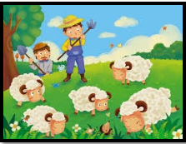

**RE:**

**Parables**

Over the next couple of weeks we will be looking at parables. Parables are stories told by Jesus which have meaning for us to learn from. Before we look at some of the parables Jesus told, listen to an adult read the story below – what can we learn from its message?

The Boy who cried Wolf

There once was a shepherd boy who was bored as he sat on the hillside watching the village sheep. To amuse himself he took a great breath and sang out, "Wolf! Wolf! The Wolf is chasing the sheep!"

The villagers came running up the hill to help the boy drive the wolf away. But when they arrived at the top of the hill, they found no wolf. The boy laughed at the sight of their angry faces.

"Don't cry 'wolf', shepherd boy," said the villagers, "When there's no wolf!" They went grumbling back down the hill.

Later, the boy sang out again, "Wolf! Wolf! The wolf is chasing the sheep!" To his naughty delight, he watched the villagers run up the hill to help him drive the wolf away.

When the villagers saw no wolf they sternly said, "Save your frightened song for when there is really something wrong! Don't cry 'wolf' when there is NO wolf!"

But the boy just grinned and watched them go grumbling down the hill once more.

Later, he saw a REAL wolf prowling about his flock. Alarmed, he leaped to his feet and sang out as loudly as he could, "Wolf! Wolf!"

But the villagers thought he was trying to fool them again, and so they didn't come.

At sunset, everyone wondered why the shepherd boy hadn't returned to the village with their sheep. They went up the hill to find the boy. They found him weeping.

"There really was a wolf here! The flock has scattered! I cried out, "Wolf!" Why didn't you come?"

An old man tried to comfort the boy as they walked back to the village.

"We'll help you look for the lost sheep in the morning," he said, putting his arm around the youth, "Nobody believes a liar...even when he is telling the truth!"

***Discuss: What do you think the meaning of the story is?***

**Grammar and Punctuation:**

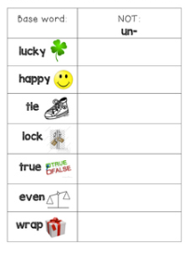

What happens to these words when we add a **prefix**?

Add the prefix ‘un’ to the start of each of the base words. What happens to the meaning of the word?

**PE**

**Here are lots of activities to work on at home for Term Six**

https://www.sportengland.org/jointhemovement#get_active_at_home

**PHSE**

Have a circle time this week. Find a quiet place in the house, make it cosy. Choose a blanket to snuggle up on and one teddy (it is your turn to talk when the teddy is in your hand). Discuss how everyone is feeling? Any worries to share? Anything really positive to share? This only needs to be about ten minutes but use it as a time to allow the children to talk though any worries/ things that they’ve enjoyed etc. Finish on a positive note.