**Home Learning**

**Year 1 – Term 6 Week 1**

**1st June 2020**

**Reading:**

* Look at the front cover of a book you haven’t read and make a prediction on what you think the book will be about. Read the blurb and add to your prediction. Think about where the story might be set, the characters you think may be involved in the story and what you think will happen. Use the following sentence stems: **I wonder if, I bet, I imagine, I think x will happen next…because…**
* Try and pick a book that is a little different to the one that you picked last week.
* Read the book and summarise in a few sentences what the book was about. Was your prediction correct?
* Answer the questions in the back of your book. If you are using the online resources, there are activities to go with each book.
* Read the book over the week. On Friday, sit your teddy bears in a circle and read them the book like a teacher would.

As well as the big cat books, if you would like to look at a different resources try these …

[https://home.oxfordowl.co.uk/books/free-ebooks/](https://www.google.com/url?q=https%3A%2F%2Fhome.oxfordowl.co.uk%2Fbooks%2Ffree-ebooks%2F&sa=D&sntz=1&usg=AFQjCNEZP7LIQ8zlFo5pQ5vGHcscHcY1zQ)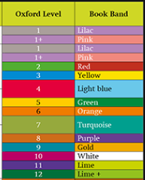

When you first enter the site, it will ask you to select the book level for your child. You can do this either by their age group, book series or by Oxford Owl Level.

If you then select **Browse by Oxford Level** and select the colour – for example Book Band blue – Oxford Level 4– you will then be able to access the books in that band/level.

To read the ebooks you will then have to register and login, however this is free to all parents and new ebooks are regularly added. It is recommended to read the books at a computer or laptop, however these can be read on a mobile.

**English:**

**Diary entry**

* Keep up writing your daily journal recording your time and learning at home. Remember to include the events, and your thoughts and feelings. ***Dear Diary…First… Then… After that… I felt… I liked…***

Think about the positive things that have happened in your day. When you reread your diary each day, these memories will help you to focus on the great things that are happening. You can fill it in each day or once a week!

**Poetry**

Have a look at this picture….

**Monday**: Have a look at some of the traditional rhymes that are on our class page. Pick one that you are less familiar with. Read it and underline any words you are unsure of. Discuss with an adult what they mean… can you use the new word in a different sentence?

In your book, can you finish these sentences?

*I liked the poem because / I did not like the poem because…*

*The poem made me feel….*

*My favourite bit was … because …*

*My favourite word from the poem is …*

If you learnt a new word from the poem, can you write down the meaning?

**Tuesday**: Can you learn the poem that you have picked, by heart?

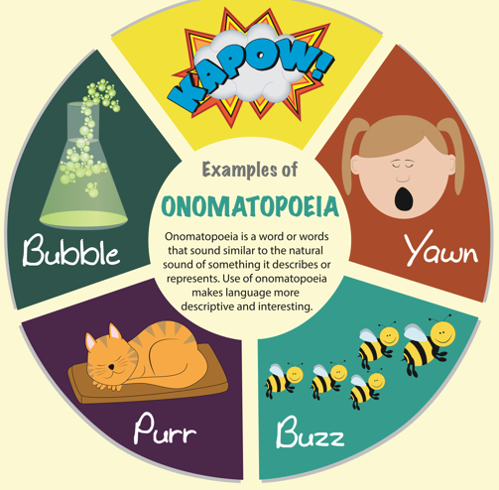**Wednesday**: Onomatopoeia: Have a look at these examples of onomatopoeia.

(Onomatopoeia is when a word describes a sound and actually mimics the sound of the object or action it refers to when it is spoken.)

I heard the bees buzz and the cat purr.

Kapow, the sound of Daddy chopping the carrots!

What sounds can you hear in your house? Can you write a few sentences about the sounds you can hear in your house?

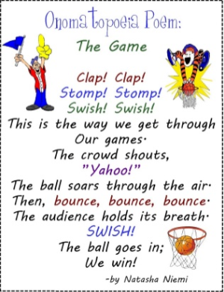

**Thursday:** Today you are going to plan your own poem using onomatopoeia. Have a look at this poem about basketball. What is your favourite sport to play or watch? Is it gymnastics, football, swimming, diving, hockey, rugby, cricket…? Write down as many examples of onomatopoeia associated with your sport / game / audience that you can think of. Use pictures to plan your poem.

**Friday:**

Read your plan, say your poem out loud!

Now write it!

**OR** This week on the National Oak Academy there is a weeks’ worth of poetry writing. You may wish to use these online videos or you can follow the ideas above.

**Phonics:** *Daily phonics lessons are online. Please see the link on our class page.*Don’t forget the flash cards are there to watch on our class page!

**Maths: (You can choose to do The National Oak Lessons or the lessons below)**

[**https://www.thenational.academy/year-1/maths/to-apply-knowledge-of-number-bonds-year-1-wk5-1#slide-2**](https://www.thenational.academy/year-1/maths/to-apply-knowledge-of-number-bonds-year-1-wk5-1#slide-2)

**Money**

**Day One:**

This is the time to have a look at this coin sheet and go over the names and value of each coin. Discuss which one is worth the most? What tells you/ How do you know that? Which is the biggest which is the smallest? Does the smallest have the least value? Why do you think that? Keep day one really light, have a look at the coins you have in your purse. An extra idea would be to hide the coins around the house and have a ‘Coin Hunt’

**Day Two:**

Today is about coin value, organising and categorising the coins. First step have a go at this together, using and asking the questions below.

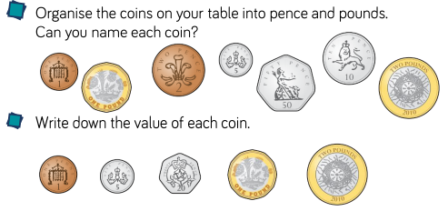**Task**

**Questions**

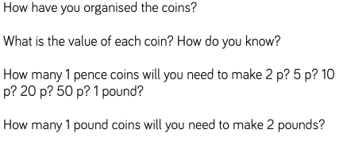

**Reasoning**

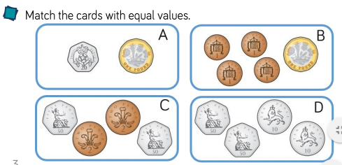

**Day Three**

Today is about reasoning and problem solving to check the last two days understanding.

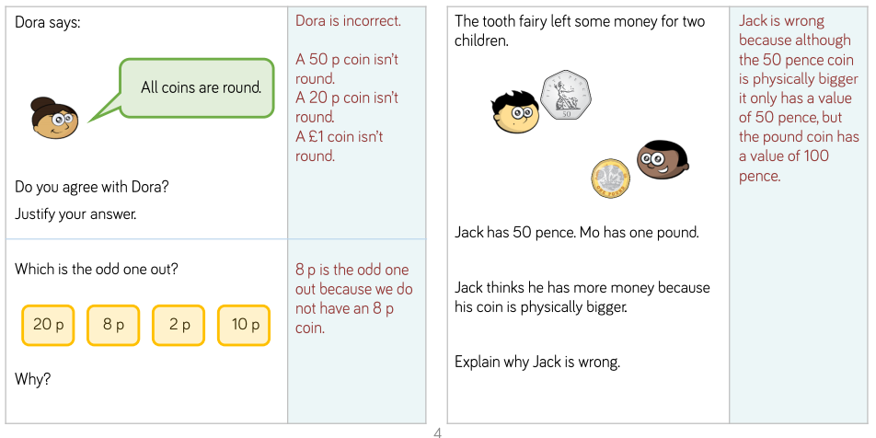

**Day Four** Today is about introducing notes. Use Google to show a £5, £10, £20 and £50 note. Discuss how we have notes to save us having so many coins in our pockets. Discuss £5 is the same as five one pound coins, £10 is the same as ten one pound coins etc. Have a go at the below task together.

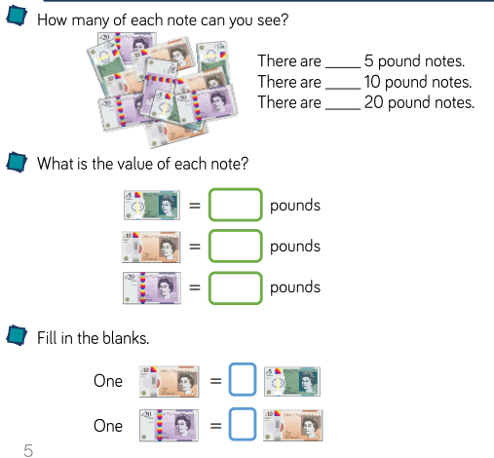**Task**

**Day Five** Today is about exploring different ways to make coins. If you have these coins at home, then explore all the different ways to make these coins/ amounts.

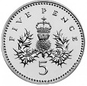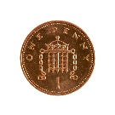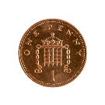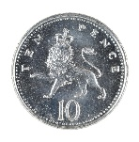 E.g.

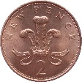



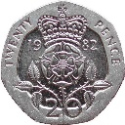

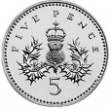

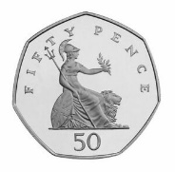

**PSHE:**

<https://www.youtube.com/watch?v=OMg6t-z8KEI>

Can you design your own signature greeting for the people you love? Mrs Solomon and Mrs Sykes had lots of fun designing our greetings!

**Science:**

Science experiment: Observing a plant using water.

1. Fill each cup with water half way.
2. Add 3 drops of food colouring into each of the cups. Each cup should be a different colour.
3. Carefully cut the end of each of the flower’s stem or celery.
4. Place each stem/celery in a different coloured water cup.
5. Wait one hour and observe your flowers’ petals.
6. Wait one day and observe your flowers’ petals.

What did you see? Take a photo / draw a picture and write about what you observed!

**History: Kings and Queens!**

2nd June 2020 will mark the 67th anniversary since the Queen’s coronation in 1953! She acceded to the throne on the 6th February 1952.

Have a look at some photographs and videos of the coronation! It was a very happy occasion for the whole country.

Things you could do…

* Write a diary pretending you were watching the coronation, what did you see, how did you feel?

**Or**

* Draw a picture of what you could see at the coronation. Write labels for the special things that you can see.

**Geography:**

<https://www.bbc.co.uk/bitesize/topics/zyhp34j/articles/zjg46v4>

Have a look at the information about Antarctica, what an incredible place! Can you find Antarctica on a map? Can you send us a postcard from Antarctica?

**Art**

Here is a nice activity the children can do by themselves. They’ll need to use a ruler to draw lines across the picture. The more lines, the smaller the sections will be. 15-20 lines are usually good for an A4 sized picture. Then colour in the sections different coloirs

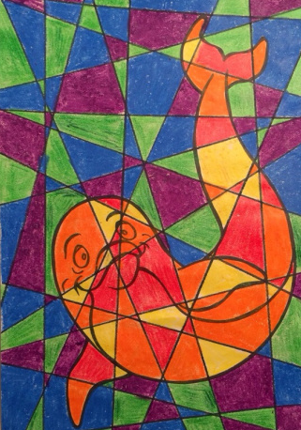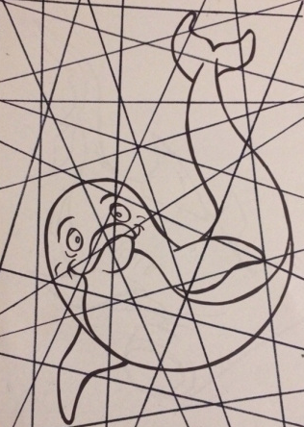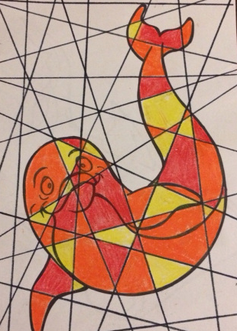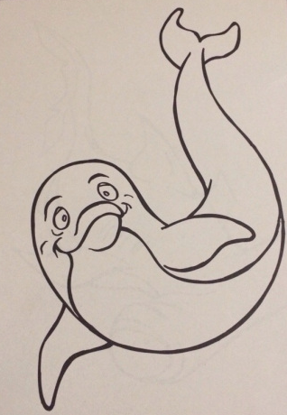

**RE:**

This week was Pentecost Sunday and this feast will be our focus for the next couple of weeks.

What do you already know about Pentecost?

You can read the story here ... <http://www.dltk-bible.com/cv/pentecost.htm>

Make a poster / booklet / short film to show what you already know and can remember about Pentecost.

Use the key questions below to prompt your thinking.

What does Pentecost celebrate? How does this link to Easter?

Think of at least 5 key words that you think link to Pentecost. Why did you choose them?

What symbols and images do we associate with Pentecost? Why?

How does the Catholic Church mark Pentecost Sunday? (Liturgical colour? Bible reading?)

**Grammar and Punctuation:**

Which of the following words need a capital letter in the middle of a sentence? Why?

table tim flower august tuesday mrs courtney milk biscuit

**PE**

Cosmic Yoga on You Tube has some wonderful ideas to start the day feeling alert and enthused!