**Home Learning**

**Year 6 – Term 5 Week 4**

**Wb 11th May 2020**

# Reading

This is a great opportunity to read some good books – if you don’t have your Green Record at home please keep a record of your reading in the back of your school exercise book.

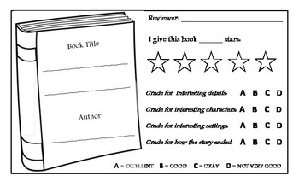Please review one of your most recent reads.

Why would you recommend this book?

Who was your favourite character?

Where was it set?

Can you summarise it in 20 words?

**English** this week is based on Oak National Academy’ s unit of work on Leaflets (Week 2 on their website).

<https://www.thenational.academy/online-classroom/year-6/english#subjects>

These lessons can be accessed online, alternatively please have a go at the activities in the pack.

**Comprehension** – Please read the information and answer the questions in your notebook

|  |  |
| --- | --- |
| 1. Which of the following words could replace 'region' in the text? 2. ‘the richest biome is the tropical rainforest biome…’ What is meant by richest in this sentence? 3. The Saguaro and Joshua tree are described as drought-resistant.   What does this mean? | 1. Prevalent   Can you give 1 synonym and 1 antonym? |

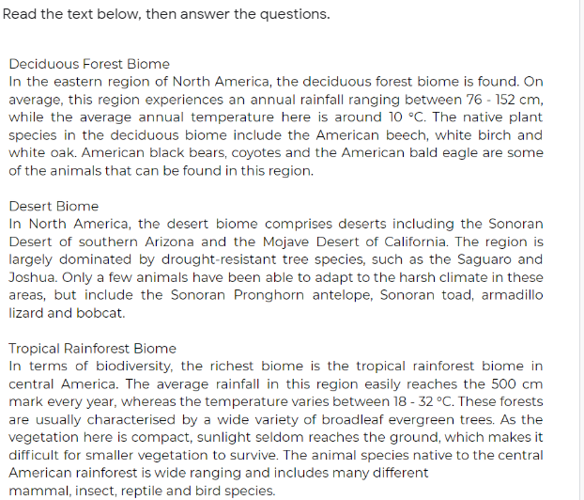

**English Writing**

Please look at Lesson 3 from Oak Academy

<https://www.thenational.academy/year-6/english/information-leaflet-lesson-3-identifying-features-year-6-wk2-3>

Think about what you would like to write your leaflet on.

(You could do one of our topics or something that you are interested in)

Start to plan: How will you use each feature in your writing? In a second session please look at Lesson 5.

You will be writing your leaflet today, please include as many features as possible. Aim to make your leaflet 3 or 4 paragraphs long. You could use your notebook, or fold paper into an interesting booklet.

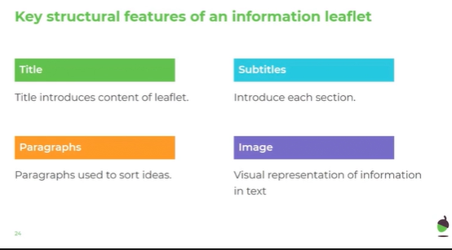

**Grammar – hyphens and dashes.**

**Today’s online lesson can be found at:** <https://www.bbc.co.uk/bitesize/articles/zmnwjhv>

L.O To use hyphens and dashes. Put the dashes and hyphens in the correct places and then copy the sentences into your book. Write the reason why the dashes have been used after the sentences. Either for:

1. Repetition
2. Subordinate Clause
3. or Suspense

1. Sacrificing her was a mistake a mistake that could have been avoided.

2. As the temple door opened, I peered inside the pitch black room and saw nothing.

3. It was only when I squinted that I could see what lay at the bottom of Lake Texcoco gold, lots of gold.

4. When we get there if we get there I will have something to say about this terrible journey to Tenochtitlan.

5. As I wondered through the city on this damp cold night I found two Aztec farmers cultivating crops on a Chinampa which they co owned together.

**Spellings**There are 10 spellings to learn each week. Use a dictionary or google to check the definitions of words you don’t know and use them in sentences. Could you find their synonyms and antonyms? What is the root word of each word? Use the look, say it, cover, write, check strategy to test yourself.

Please choose 2 other words that you need to learn.

Hyphenated Words

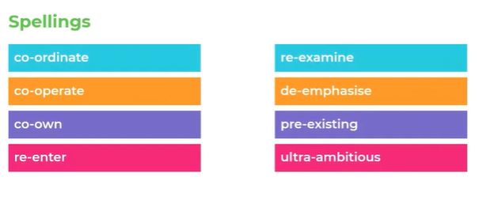

Maths

**This week you can choose between following a lesson from the Oak Academy online (you will need a pen and paper), arithmetic or an investigation (or all three!).**

**Day 1 Oak Academy: Finding the Value of Missing Angles**

<https://www.thenational.academy/year-6/maths/find-the-value-of-missing-angles-year-6-wk3-1>

**Day 1 Arithmetic:**

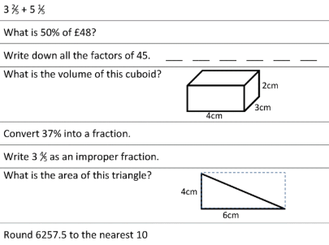

**Day 1 investigation:**

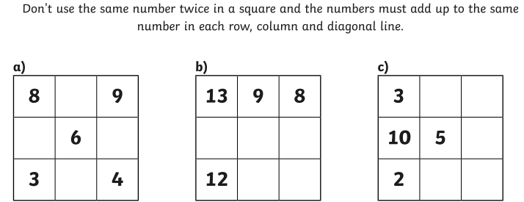

**Day 2 Oak Academy: Compare and Classify Triangles**

<https://www.thenational.academy/year-6/maths/compare-and-classify-triangles-year-6-wk3-2>

**Day 2 Arithmetic:**

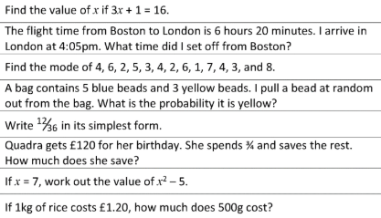

**Day 2 Investigation:**

You may use a calculator and you can use all 4 number operations:

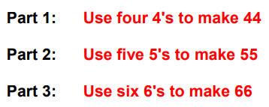

**Day 3 Oak Academy: Compare and Classify Quadrilaterals**

<https://www.thenational.academy/year-6/maths/compare-and-classify-quadrilaterals-year-6-wk3-3>

**Day 3 Arithmetic:**

1. In a group of children, 2/8 like to play football. If there are 32 children how many do not like to play football?
2. 9.4x 100=
3. What is the mean of 25, 6, and 2?
4. Which is the smallest? 0.7 0.14 0.66 0.43 0.291
5. 5 2/5 + 8 1/5
6. How much is half of a third?
7. A rectangular swimming pool measures 4.5 m by 2.5 m. What is the perimeter?

**Day 3 Investigations:**

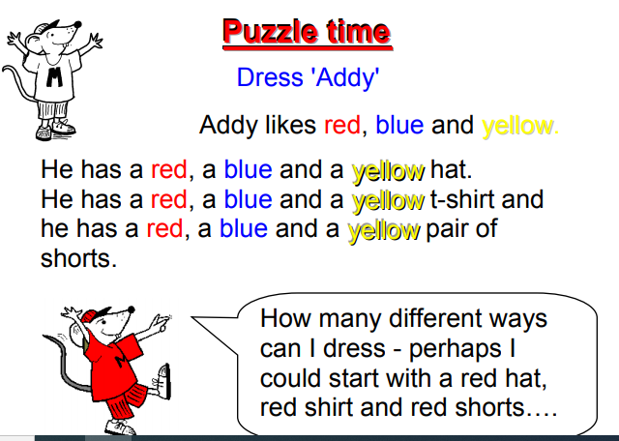

**Day 4 Oak Academy: Find Unknown Angles in Triangles**

<https://www.thenational.academy/year-6/maths/find-unknown-angles-in-triangles-year-6-wk3-4>

**Day 4 Arithmetic:**

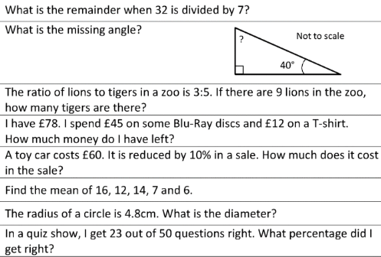

**Day 4 Investigation:**

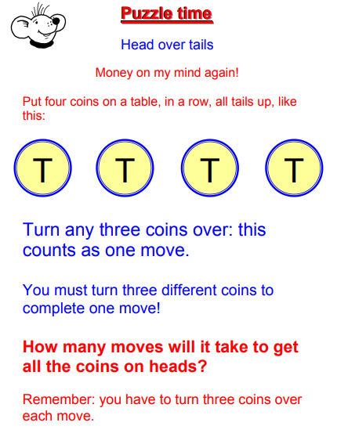

**Day 5 Oak Academy: Calculate Unknown Angles in Quadrilaterals**

<https://www.thenational.academy/year-6/maths/calculate-unknown-angles-in-quadrilaterals-year-6-wk3-5>

**Day 5 Arithmetic:**

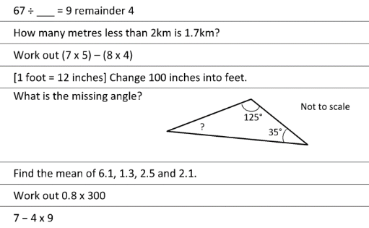

**Day 5 Investigation:**

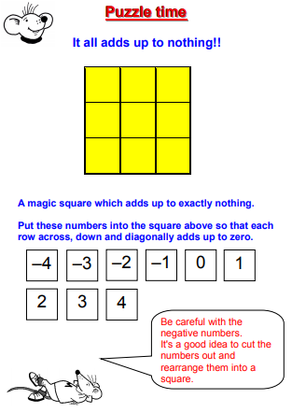

**HISTORY:**

https://www.bbc.co.uk/bitesize/topics/zq6svcw/articles/zbqyy4j

Have a look at the website above. Can you then play any of these games with your family. If not, could you design a game which could have been played during this time using your knowledge of what they did do?

Religion

**This week, we are exploring the meaning of the words from the Lord’s Prayer.**

Our Father, Who art in heaven  
Hallowed be Thy Name;  
Thy kingdom come,  
Thy will be done,   
on earth as it is in heaven.

Where does this prayer come from? Look up Luke 11:1-4

Who taught this prayer?

### How do we know what God’s will is? Can you give two examples of things you think are God’s will? Try looking up. **MT19:21, MT7:1, MT5: 43-44**

Give us this day, our daily bread,  
and forgive us our trespasses,  
as we forgive those who trespass against us;   
and lead us not into temptation,  
but deliver us from evil. Amen.

Trespasses means the things we deliberately do wrong. What did Jesus say about forgiveness? Try looking up MT 18: 21-22

When did Jesus pray ‘thy will be done?’ Where was he? Was it easy for him to pray this? Was it what he wanted? Is it easy for us to pray this? Look up **MT 26: 39**

**Create a poem or a piece of art work called ‘Living out the Our Father’**

Science

Curious Creatures – When scientists discovered the Platypus in 1797 they struggled to classify it. It seemed to have features from a number of different groups.

1. How would you classify it? (look up more information if you can?) <https://australianmuseum.net.au/learn/animals/mammals/platypus/>
2. Can you create your own creature that could also be interesting to classify.
3. 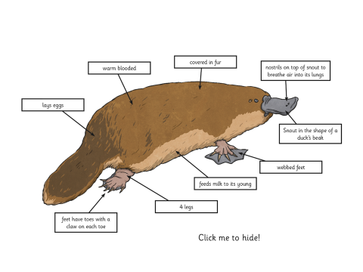

Art



For your writing last week you were asked to write an autobiography.

This week in Art you could design your front cover! Below are some examples from famous people- I wonder what yours will look like?

PSHE

Could you write a letter or message of hope to a relative or friend that you haven’t seen for a while? If you aren’t able to post it, perhaps take a photo and email it.

**Useful Websites:**

<https://www.nhs.uk/change4life/recipes>- Cooking Ideas

professor assessor <https://prof123.com>

<https://www.bbc.co.uk/bitesize> -lots of ideas and information.