**Home Learning – Lockdown Challenge**

**Term 6 Week 6 - 6th July 2020**

**Whole School Challenge**

Create a short presentation/speech about something you have learnt/ achieved at home during lockdown. If you are coming into school, you could bring in a prop or a photograph to aid your news or you could send your photos into school.

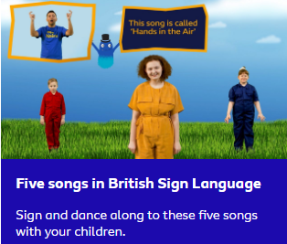Yellow Group A – Tuesday 7th July

Yellow Group B – Friday 10th July

1. **Music / Drama / Dance Activity**

Sing a new song and learn how to perform it using Sign Language.

Click on this website and pick a video, you have 5 to choose from: <https://www.bbc.co.uk/teach/bring-the-noise/5-songs-in-bsl/z4g88xs/>

1. 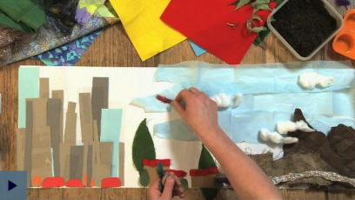**Creative / Craft & Design Activity**

**Watch an online art clip and create a collage landscape**

**Artist Emma Majury makes a collage of two contrasting landscapes, using paper, plastic, card, fabric, cotton wool, feathers and leaves among other materials**. I wonder what you will make this week… I would love to see your creation!

<https://www.bbc.co.uk/teach/class-clips-video/art-and-design-using-textured-materials-landscape-collage/zfrfbdm>

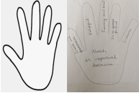

1. **Social / Emotional Activity**

**I am special** – Draw around your hand and in the middle write your name followed by the words ‘is special because’.

In each finger write something that makes you special.

**Also consider**:

• Who is special to you?

• Why? Explain why your person is special to you.

1. **Physical Activity**

The Tokyo 2020 Olympics has been postponed until next year. However, that doesn’t mean we cannot get involved! I challenge you to try the Tokyo Ten Moving games, see the activities attached below.



1. **Spiritual / Reflective activity**

**Create a Calm Jar and practice being ‘Still’**

**Equipment**: Jar (a thick jam jar with a good lid), water, glitter, glycerine & food colouring.

**Method**: Mix the ingredients together to create a calming jar of glitter.

**After**: What are the things on your mind at the moment? Pick up the jar and shake it. Watch the glitter swirl around and settle at the bottom. Imagine the things on your mind slowly settling down.

**Psalm 46:10** ‘Be still and know that I am God’.



1. **Supporting the Community Activity**

Paint or draw a picture for someone who lives near to you. Post it through their letterbox and put a smile on their face ☺

1. 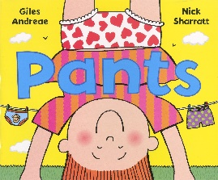**Reading to Relax**

Read or listen to a funny story. This week, Mrs Fudge read her favourite, funny story to the class. She read the story ‘Pants’, keep an eye out for her video.

* Use Oak Academy, Talk 4 Writing scheme, Twinkl or your own ideas for English and Maths. Also, see the Writing competition information attached to this page.

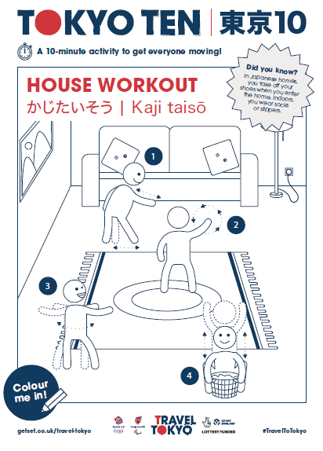

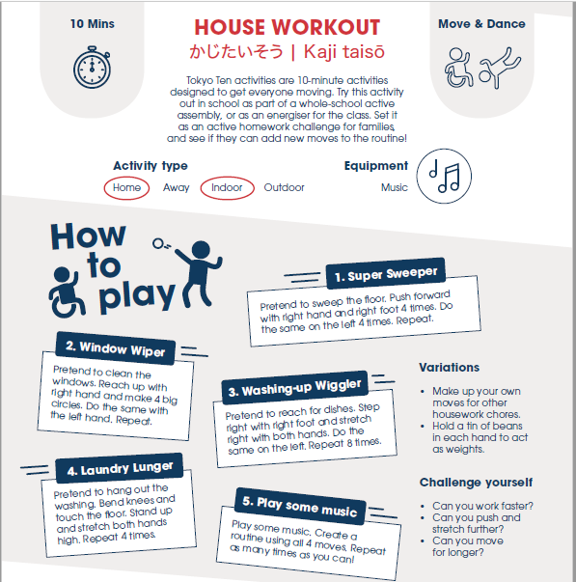

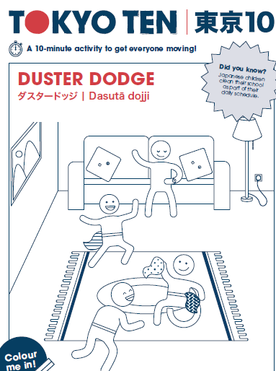

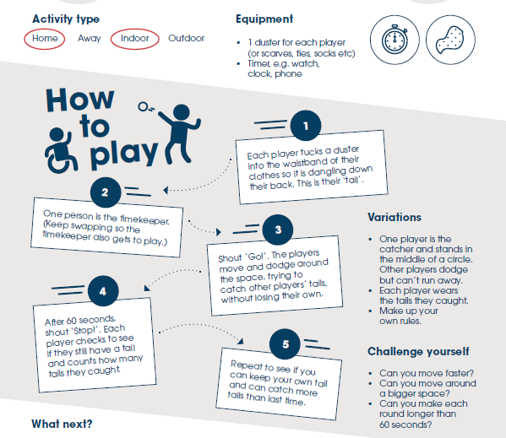

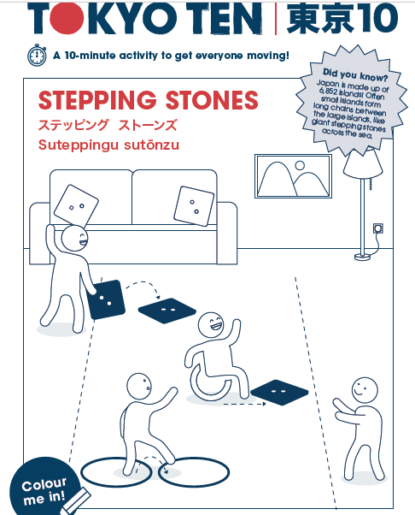

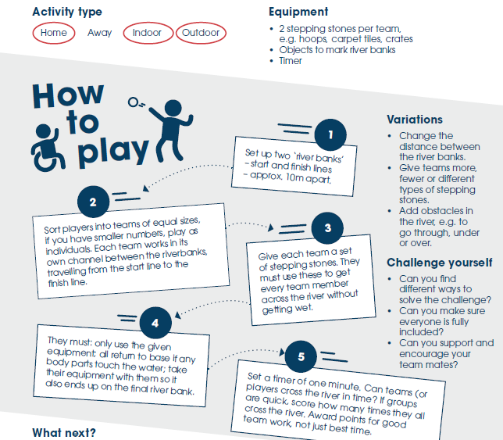

StoryTown Corsham will take place on the weekend of 16-18 October. It’s a celebration of reading, writing and storytelling - and it’s a brilliant way of sharing the Corsham’s creativity. So, how can you get involved?

**StoryTown 2020**

**Writing Competition**

*If only I could…*

We would like you to think about the situation we have all found ourselves in this year – but don’t panic: we are not asking for your Covid-19 stories. Instead, we’d like you to think about the power of your imagination. If we hadn’t experienced lockdown, what might you have done? Where might you have gone? Who might you have seen, or visited? This is about possibilities, no matter how wild and crazy. Have fun and tell us what you would do if only *you* could...

**The rules:**

* There is a maximum word limit of 500 words
* Entries need to be typed and be part of an email - not sent as an attachment - and emailed to: [StoryTownCorsham@gmail.com](mailto:StoryTownCorsham@gmail.com)
* Please include your **first** name and the **age category** you fit into:

Under 8

9-12

13-17

18+

* Please include a **telephone number**. This should be a parent or carer’s number if you are under 18.
* By entering the competition, you agree to StoryTown sharing your work, through a physical exhibition and/or through digital means
* Poetry or prose submissions are permitted.

**The deadline**: Sunday 30 August. You have plenty of time to get pen to paper (well, finger to keyboard) and send us your wonderful work.

**The prize:** Well… a chance to get your name in print and published. There will be a book token available for the winner in each age group.

Good luck!

*StoryTown is brought to you by…*

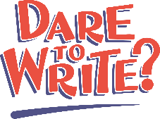

*For further information about how Corsham Town Council uses your personal data, including your rights as a data subject, please see our privacy policy:* [*https://www.corsham.gov.uk/information/policies.php*](https://www.corsham.gov.uk/information/policies.php)