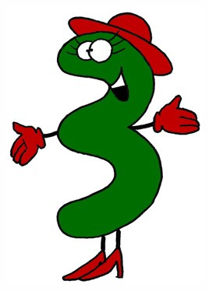Sorting with a Carroll Diagram

Can you sort out this information?

Clive Five does not like Number Flakes.

Nick Six lives in an even numbered house.

Hebe Three lives in an odd numbered house.

Nick Six likes Number Flakes.

Nora Four does not like Number Flakes.

Nora Four lives in an even numbered house.

Clive Five lives in an odd numbered house.

Hebe Three likes Number Flakes.

|  |  |  |
| --- | --- | --- |
|  | Likes Number Flakes | Does not like Number Flakes |
| Odd Numbered House |  |  |
| Even Numbered House |  |  |

Numberline Lane www.numberlinelane.co.uk