**Home Learning – Lockdown Challenge**

**Term 6 Week 8 - 20th July 2020**

1. **Music / Drama / Dance Activity**

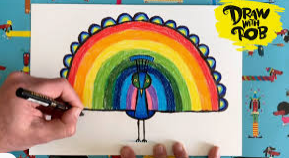Can you make your own beautiful music? Safely collect some glass jars and fill them with different amounts of water. Tap them with a metal spoon to see what sound they make. Is it high or low? You can add more water or pour some away until you like the sounds they make. Make up a pattern, tapping the jars in the same order. Repeat the pattern and then change to a new pattern. Repeat the 2nd pattern and then finish again with you first patter. Can you play the whole tune again? For more idea, watch <https://www.youtube.com/watch?v=iFwtybB3R6Q>

1. **Creative / Craft & Design Activity**

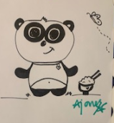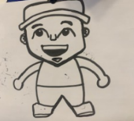Lots of the children in Yellow Bubble have enjoyed ‘Draw with Rob’ and have created some AMAZING pictures. This week we would like you to all draw the same thing and we can look at how similar and how different all of our creations are! We will continue with our peacock theme! <https://www.youtube.com/watch?v=Mu_h8rNxgn4> – here is the link for the lesson! Miss Jones had a go last week with yellow bubble.

1. **Social / Emotional Activity**

Try the ‘helpful hand’ breathing. Show your family the different breaths we did at school, e.g. Rainbow breath, Elevator breath, Bow and arrow breath. Which breath of the day did you enjoy doing? Can you invent some of your own?

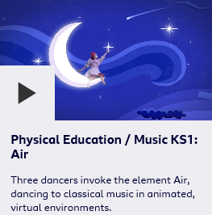

1. **Physical Activity**

**Dance with the Elements** – Visit BBC to explore the different dances. <https://www.bbc.co.uk/teach/class-clips-video/physical-education--music-ks1-dance-with-the-elements/z7m2y9q>

1. **Spiritual / Reflective activity**

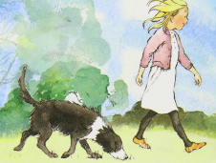Have you ever read a Michael Rosen story or poem? Michael Rosen has been very poorly in hospital and is now recovering at home. He has created such wonderful words for children all around the world. You can find out about him here… <https://www.michaelrosen.co.uk/>

Can you write or draw a prayer for Michael Rosen – so we can keep him and his family in our thoughts.

1. 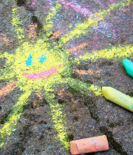**Supporting the Community Activity**

Chalk your walk – brighten someone’s day by creating a fantastic chalk drawing outside your house on the pavement or make a trail when out on a walk. If there isn’t a safe space to do this, draw a picture and put it in your window.

**Head over to the ‘Covid-19’ tab and try the teachers’ challenges…**

**Science activities below…**

