**YEAR 1 Home Learning – Lockdown Challenge**

**Term 6 Week 6 - 6th July 2020**

1. **Music / Drama / Dance Activity**

What is your favourite song? This week we would like you to create a dance to your favourite song. Then show your family and make them smile. Oti Mabuse has some lovely dance videos.

1. 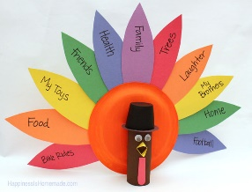**Creative / Craft & Design Activity**

Can you make a happiness peacock? We are very lucky in Corsham and see peacocks around us daily! On each feather, can you write words that make you happy or thankful? You can either draw your peacock and write words on your drawing or follow the instructions to make your peacock (the instructions are for a turkey and so you will need to change the colours to make it look like one of our Corsham peacocks)! <https://www.happinessishomemade.net/thanksgiving-kids-craft-gratitude-turkeys/>

1. **Social / Emotional Activity**

Lie outside either in your garden, at a park or in a field. Close your eyes and focus on all the different sounds that you can hear. Describe them to a grown up in your house. How did each sound make you feel? Did you notice any sounds that you don’t normal hear?

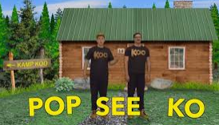4. **Physical Activity**

Go to GoNoodle and look at the Pop See Ko video. Follow the song and the actions that go with it. Can you create your movements for the song?

1. **Spiritual / Reflective activity**

When we pray, we are talking to God. He loves to listen to you, however you are feeling. What do you want to tell him? It could be good news, some worries, you may want to thank Him or you could just want to tell him about your day. Take some time to chat to God. You may want to write Him a letter, say a prayer quietly in a calm space or draw Him a picture.

1. **Supporting the Community Activity**

This week we want you to help someone that you live with. Think of a job that you can do that would be really helpful (like making the beds each day, washing up after breakfast, tidying the shoe cupboard and matching all of the shoes!)

1. **Reading to Relax**

[](https://www.google.com/url?sa=i&url=https://www.allmomdoes.com/2017/07/06/reading-is-fun-how-to-make-summer-reading-fun-for-your-kids/&psig=AOvVaw1qB0AVQswovH9ZgK0TL6Ox&ust=1592992160794000&source=images&cd=vfe&ved=0CAIQjRxqFwoTCLD327fUl-oCFQAAAAAdAAAAABAD)This week, can you read in a different space each day? You could make a den, read outside, read on the sofa, read under a blanket…

Which space was the most relaxing?

1. **Whole School Challenge**

Create a short presentation/speech about something you have learnt/ achieved at home during lockdown. If you are coming into school, you could bring in a prop or a photograph to aid your news or you could send your photos into school. By Wednesday 8th July