**YEAR 1 Home Learning – Lockdown Challenge**

**Term 6 Week 5 - 29th June 2020**

[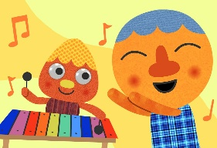](https://www.google.com/url?sa=i&url=https://supersimple.com/song/my-happy-song-featuring-noodle-pals/&psig=AOvVaw0tUmWULuHrGICsX5P6F6y_&ust=1592988053003000&source=images&cd=vfe&ved=0CAIQjRxqFwoTCODjjo_Fl-oCFQAAAAAdAAAAABAE)

1. **Music / Drama / Dance Activity**

Choose 10 of your favourite songs which make you happy. Create an album cover design for your songs whilst listening to it! I wonder how many children will have Shotgun by George Ezra – a Year One favourite! Or possibly Dinosaur Stomp by Koo Koo Kanga Roo!

1. **[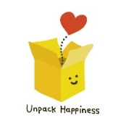](https://www.google.com/url?sa=i&url=https://www.teepublic.com/pin/5552997-unpack-happiness-box&psig=AOvVaw2Eicq0xbZ6-iJPc17AZWRD&ust=1592913012109000&source=images&cd=vfe&ved=0CAIQjRxqFwoTCNj738etleoCFQAAAAAdAAAAABAG)Creative / Craft & Design Activity**

Make your own happiness box, filled with things that make you feel happy! On the school website welcome page, there is a video of Miss McLoughlin explaining the items in her box to show you as an example. I wonder what you will put into yours?

1. **Social / Emotional Activity**

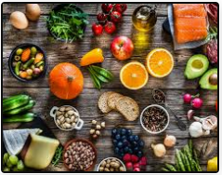Cooking can be a great way to relax and spend time together with loved ones

(cooking together or eating together)! Use the link below to find some cooking videos and see how delicious your creations can be. <https://www.nutrition.org.uk/healthyliving/hewathome/bnfhewathome.html>

1. **Physical Activity**

[](https://www.google.com/url?sa=i&url=https://community.localmasters.com/guidelines-to-embrace-yoga-in-your-day-to-day-life/&psig=AOvVaw1RsJUjpOV7eX7nyv_C6944&ust=1592991832689000&source=images&cd=vfe&ved=0CAIQjRxqFwoTCJimqZ3Tl-oCFQAAAAAdAAAAABAE)<https://www.youtube.com/watch?v=dF7O6-QabIo> Join Adriene for a rainbow yoga session on YouTube. When you finish, make a note of how you feel after doing the activity.

1. **Spiritual / Reflective activity**

[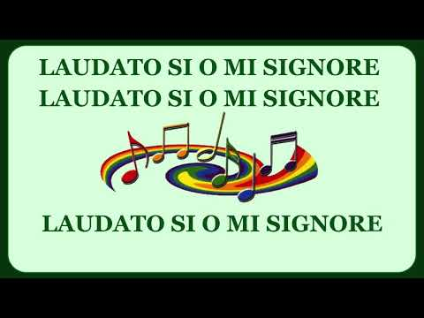](https://www.google.com/url?sa=i&url=https://www.youtube.com/watch?v%3D7XSrjv_Aga4&psig=AOvVaw3KTXv5RhwoQDsqp9dwZama&ust=1592991937122000&source=images&cd=vfe&ved=0CAIQjRxqFwoTCLDd-M_Tl-oCFQAAAAAdAAAAABAD)Choose your favourite hymn. Can you create a picture when you listen to it? The picture will show others how this hymn makes you feel. Here are some examples of hymns you might like to use…

**Shine Jesus Shine** <https://www.youtube.com/watch?v=J3iB30gCqAc>

**Jesus’ Love is very wonderful** <https://www.youtube.com/watch?v=CaMVjO_GruA>

**This little light of mine** <https://www.youtube.com/watch?v=QCN893hzueQ&list=PLH_rt2X-6pJr1ryGsanjUroITL93PHnJo>

[](https://www.google.com/url?sa=i&url=https://www.publicdomainpictures.net/en/view-image.php?image%3D201827%26picture%3Dha-ha-writing&psig=AOvVaw1M3gyzrLpZHBqZsjbrGP3u&ust=1592992104328000&source=images&cd=vfe&ved=0CAIQjRxqFwoTCIih8JbUl-oCFQAAAAAdAAAAABAD)

1. **Supporting the Community Activity**

Write some jokes to post to a neighbour to make their day! Check your material makes your family laugh before you send them! In Year One we have some very funny children and so we are expecting laughter across the Corsham area!

1. [](https://www.google.com/url?sa=i&url=https://www.allmomdoes.com/2017/07/06/reading-is-fun-how-to-make-summer-reading-fun-for-your-kids/&psig=AOvVaw1qB0AVQswovH9ZgK0TL6Ox&ust=1592992160794000&source=images&cd=vfe&ved=0CAIQjRxqFwoTCLD327fUl-oCFQAAAAAdAAAAABAD)**Reading to Relax**

Find a book with lots of different character where you can practise different voices. Make some loud, quiet, funny, strange and then read aloud to a member of your family and shock them with your expression!