**Home Learning**

**Year 1 – Term 6 Week 1**

**ANSWER SHEET**

**Maths:**

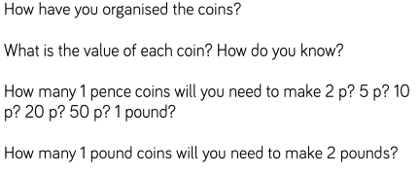

X2 1p’s to make 2p, X 5ps to make 5p, X10 1ps to make 10p, X 20 1ps to make 20p, X 50 1ps to make 50p, x 100 1ps to make £1

Two

Yo

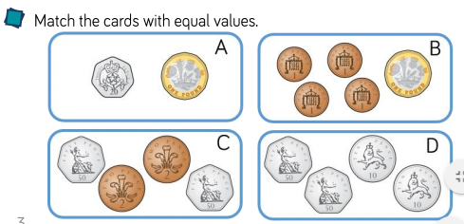**Day Two**

**Day Three** Answers are already there in purple writing.

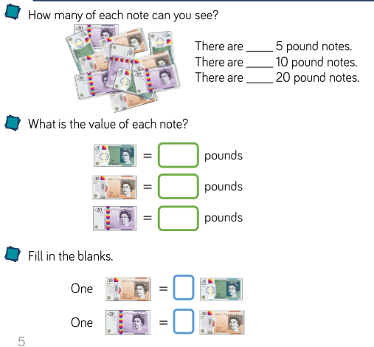**Day Four**

3

4

4

5

10

20

2

2

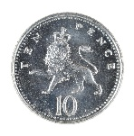**There are lots of possibilities, here are a few of them..**

10 (one **way** using only one **10p** coin); 5+5 (one **way** using two 5p coins and no **10p** coins); 5+2+2+1, 5+2+1+1+1, 5+1+1+1+1+1 (three **ways** using one 5p coin and no **10p** coins);

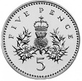

5 (one **way** using only one **5p** coin); 2+2+1, 1+1+1+1+1+1, 1+2+2

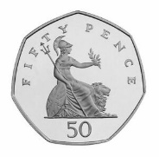50 (one **way** using only one **50p** coin);10+10+10+10+10, 20+20+10, 10+10+10+20, 0+10+10+20, 20+10+10+10, x 50p 1’s, 25 x 2ps

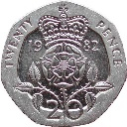

20 (one **way** using only one **20p** coin); 10+10, 5+5+5+5, 10+5+5, 2+2+2+2+2+2+2+2+2+2,10+5+2+2+1, X 20 1ps

**Reading:**

*Keep up the good reading!*

**English:**

**Diary entry**

It has been such a pleasure to see all the adventures that you have been on!

**Poetry**

Have a look at this picture….

**Monday**: Well done everyone – there are so many benefits to exploring poetry. You have been developing your speaking, listening and empathy skills!

**Tuesday**: It is so important to learn poetry. What a great skill everyone, well done!

**Wednesday**: Boom! The teachers were so impressed with the children that you could hear them whooping!

**Thursday and Friday:** We’ve loved hearing all your poetry ideas, keep up the great work.

**Phonics:** *Keep up the good work everyone, it was been lovely talking to your parents and hearing how you are approaching phonics.*

<https://www.youtube.com/watch?v=OMg6t-z8KEI>

Can you design your own signature greeting for the people you love? Mrs Solomon and Mrs Sykes had lots of fun designing our greetings!

**Science:**

Wow- what great experiments, you are really becoming scientists!

**History: Kings and Queens!**

Well done everyone, you have learnt an important part of modern history!

**Geography:**

We have a class full of explorers! Keep up the good work.

**Art:** Thank you for sending in your wonderful collages!

**RE:**

Pentecost is such a special celebration and we are so pleased that you are learning about it – well done.

**Grammar and Punctuation:**

Well done – they are all names and dates so always need a capital letter.

table **Tim** flower **August**  **Tuesday Mrs Courtney** milk biscuit

**PE**

Keep up the great work!

**Mindfulness**

It is so wonderful to feel calm!