**English and Maths**

**Year 1 – Term 6 Week 6**

**6th July 2020**

**Maths: (You can choose to do The National Oak Lessons- link on the class page or the lessons below)**

**Counting to 100:**

Children will build on their previous learning of numbers to 50. They continue grouping in 10s to make counting quicker and more efficient. Children will use the hundred square and count forwards and backwards within 100. Using dot-to-dot activities, both forwards and backwards, with a range of numbers is a fun way to explore counting to 100. What is the most efficient way to count the objects? How many are in each group? How many more groups would you need to make 100? What do you notice about the layout of the hundred square? Can you tell your friend an efficient way to find the number 57? Will I count the number ___ if I am counting from ____ to ____?

**100 square online resource**

<https://www.topmarks.co.uk/learning-to-count/paint-the-squares>

**Day One:**

How many flowers are there altogether? Can you represent the flowers using ten frames and counters?



How many straws are there? Bundle the straws into tens to make them easier to count. (You could use pasta)



Use the hundred square to:

• Count forwards from 80 to 92

• Count backwards from 73 to 65

• Write down the numbers between 75 and 81

• Find what number come

**Day Two:**

Have a look at this picture… Can you spot the mistake? Use the word because when you explain your answer.

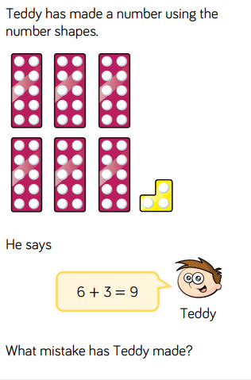

**Day Three**

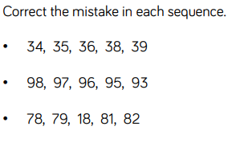

Can you make your own sequence with a sneaky mistake? See if a grown up can spot the mistake you have made.

**Day Four**

**Mathematical talk ideas**

Can you make groups? How many could we put in each group? What happens when we have 10 ones?

How many groups of 10 are there? How many ones are there?

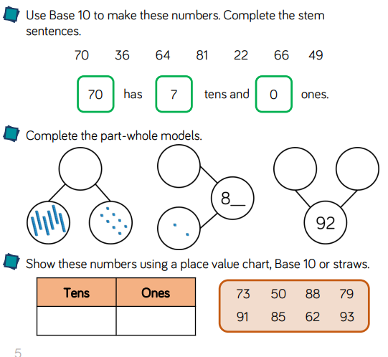

**Day Five**

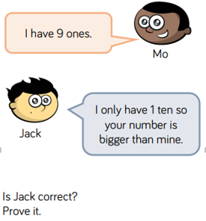

**English:**

**Diary entry**

* Keep up writing your daily journal recording your time and learning at home. Remember to include the events, and your thoughts and feelings. ***Dear Diary…First… Then… After that… I felt… I liked…***

Think about the positive things that have happened in your day. When you reread your diary each day, these memories will help you to focus on the great things that are happening. You can fill it in each day or once a week!

**(You can choose to do The National Oak Lessons- link on the class page or the lessons below)**

**Monday: Speaking and Listening**

When you're speaking, talk clearly and loudly enough for the other people to hear. Remember to use words everyone will understand. There is a video here explaining why it is so important

<https://www.bbc.co.uk/bitesize/topics/zvkk7ty/articles/zt68pbk>

Retell a story to someone in your family, use all the skills from the video. A really good one to help is ‘We’re Going on a Bear Hunt.’

**Tuesday**: **Conversation**

<https://www.bbc.co.uk/bitesize/topics/zvkk7ty/articles/zqhdng8>

When you're having a conversation:

* Listen to what the other person is saying and show interest in what they are saying.
* Let them finish before responding.
* Ask relevant questions that start with 'how' or 'why'.
* It's OK to disagree, but don't let it become an argument.

Write down some question that you can ask a family member or friend. The questions need to show that you listen to them and so need to be about something that interests them. Phone them up, ask the questions and listen to the answers!

**Wednesday**:

Words that rhyme have the **same sound**.

'Cheese' and 'peas' both have the same sound.

Have a look at these words and see if you can find words that rhyme.

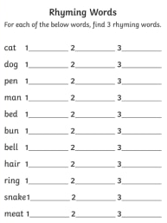

**Thursday: Rhyming Poems**

Look at the words you have found that rhyme, which words would make a good poem? Have a look at this video about how to write a poem. Pick the words you want to use and make a short plan, ready to write your poem tomorrow.

**Friday:**

Can you write your poem! It might be serious, it might be silly, it might be happy… it is up to you!

Perform your poem to someone in your family.

**Phonics:** *Daily phonics lessons are online. Please see the link on our class page.*Don’t forget the flash cards are there to watch on our class page!