**Home Learning**

**Year 1 – Term 6 Week 4 22nd June 2020**

**Maths: (You can choose to do The National Oak Lessons or the lessons below)**

[**https://www.thenational.academy/year-1/maths/to-apply-knowledge-of-number-bonds-year-1-wk5-1#slide-2**](https://www.thenational.academy/year-1/maths/to-apply-knowledge-of-number-bonds-year-1-wk5-1#slide-2)

**More Than and Less Than**

**Day One:** *Practical.* Gather up counters around the house. Put say six counters on a plate and ask, “What would one more than be? (7)” “What would two more be?” etc. Draw a one to twenty number line on a scrap piece of paper if that helps. Go over one more, two more, ten more until confidence is shown. If it helps write 0 10 20 30 40 50 60 70 80 90 100 on a piece of scrap paper so the children can have a visual representation.

**Day Two:** *Practical.* Repeat the same as yesterday but now demonstrate ‘One less, two less, four less etc. Finish by doing ten less’ If it helps write 0 10 20 30 40 50 60 70 80 90 100 on a piece of scrap paper so the children can have a visual representation.

**Day Three:** *Introduce symbols*. Today is about using the more than and less than symbol. The greater than symbol faces > and the less than symbol faces <. When we use it in a number sentence it looks like this 12>3 (Twelve is greater than three) To help children to remember which way around it goes we use the greater than and less than crocodiles. We tell the children that the crocodiles jaws are always open to the bigger number.

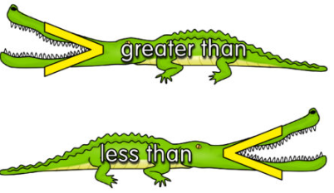**Greater Than (>) and Less Than (<) Crocodiles**

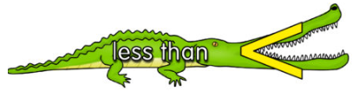

**1p**  **10p**

One pence is less than 10p (the greater than crocodile is eating the bigger number, 10)

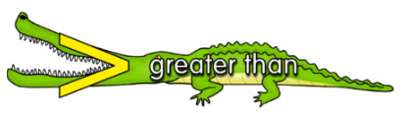

**20p**  **2p**

The twenty pence is greater than the 2p so the crocodile is eating the bigger number and now the symbol is facing the other way.

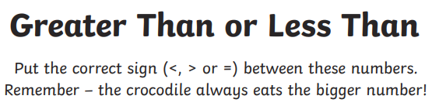**Task**

**4 1 2 12**

**10 20 5 30**

**Day Four**

*Consolidation*. This is a chance to practice yesterday’s learning. Spend this lesson really getting to grips with using the symbols. On a post it draw each symbol (< and >). Then (like above) write two numbers on posts its and decide which symbol goes in the middle.

E.g.

16

35

>

<

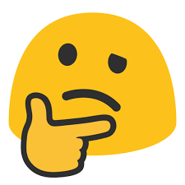

**Day Five** *Introduce the = concept*

**Play ‘I’m thinking of a number’**

One of you to think of a number Keep it in your head and don’t tell the other person. Say, “I’m thinking if a number, it’s less than _____ but more than___ what is my number?”

“I’m thinking if a number, it’s less than __5___ but more than__3_ what is my number?” (4)

Have a go at this task. Explain that if the number is **the same** either side we use the **=** sign.

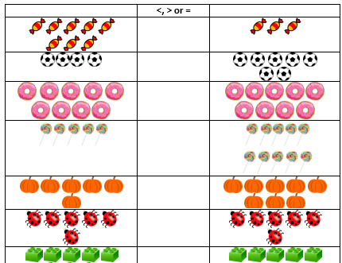

**Questions**

**Reading:**

Pick a new book to read, look at the title and read the blurb. What do you think will happen? Read the book, were you correct? Practise your book for fluency over the week. We have loved seeing the videos that you have sent in of reading and would happily welcome more!

The links to both Big Cats and Oxford Owls are on our class page in the useful websites section.

**English:**

How are you getting out with your diary? The recount writing that you did last week will really help you to develop the language that you are using. Remember you don’t have to do this every day.

**This week we want you to focus on question marks and exclamation marks!**

**Monday**: You can identify questions in writing because they always end with a question mark.

Questions often start with 'W' words. Can you write down as many ‘w’ words that help you to write a question? Can you think of any that don’t start with ‘w’?

<https://www.bbc.co.uk/bitesize/articles/zpshjsg> watch this video about questions. Can you practise writing question marks (you could do this with chalk outside, with your finger in rice, in paint…)

Watch a video about exclamation marks: <https://www.bbc.co.uk/bitesize/articles/z7ms3dm> Can you practise writing exclamation marks (you could do this with chalk outside, with your finger in rice, in paint…)

**Tuesday**: Have a look at the sentences below. Do they need a full stop, question mark or an exclamation mark?

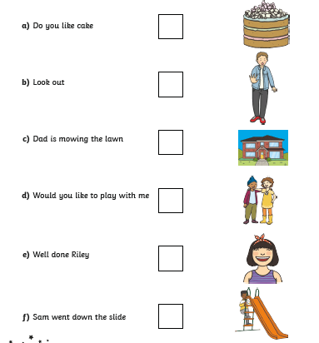

**Wednesday**: Think of a topic that really interests you. It could be dinosaurs, kings and queens, pirates, under the sea, books, space, cars…

Write 5 questions and use question marks to punctuate each of your questions.

**Thursday:** With the help of an adult can you find the answers to your questions. Are any of the answers so interesting that they need an exclamation mark?!

**Friday:** Free write Friday! Today, we want you to write about anything that interests you. It could be a letter, a fact file, a story or a recount. But… we challenge you to use at least 1 question mark, 1 exclamation mark and full stops throughout!

**Phonics:** *Daily phonics lessons are online. Please see the link on our class page.*Don’t forget the flash cards are there to watch on our class page!

There is also now a link to Mr Thorne’s phonics page on our class webpage, which some families may enjoy looking at.

**Science: Exploring the roots of a plant!**

In your garden can you dig up a flowering plant, preferably one with roots (check with a grown-up which one!). Garden weeds work really well for this. The children can then carefully look at the different parts. What do they notice? What shape are they? What does each part do? Why are they that colour? Are all plants the same? The children could use safe scissors and cut through the stem and observe the different tubes that supply the plants with water and other essential nutrients.

**History:**

Did you know that Queen Elizabeth the 2nd is related to Queen Victoria? Have a look at this family tree and discuss with a grown up.

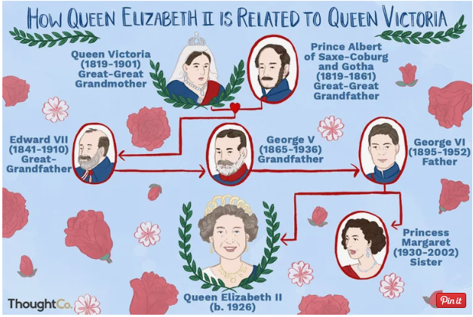

What can you find out about your family history? Draw some pictures, write some facts **OR** make a family tree of your own!

**Geography:**

The weather this week has been fascinating! So much change. Can you make some predictions about the weather ahead? Use weather symbols and present your weather predictions to your family (you could even dress up as a weather person!) Watch the weather report and see if you were right! Look at the symbols used and discuss with a grown up.

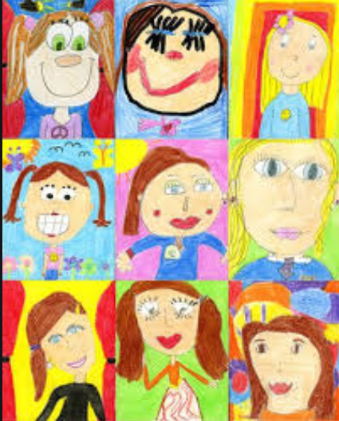

**Art**

Have a go at drawing and painting/colouring someone in your household!

**RE: What is a parable?**

Last week the children heard a story that had a message (the boy who cried wolf). They were able to find the message and discuss that message.

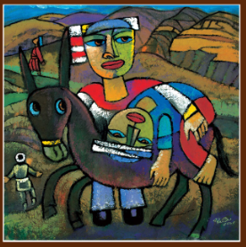Jesus told stories to help people understand his message. These stories are called parables. Look at the story of ‘The Good Samaritan.’ What was Jesus trying to teach through this story? Why was it an important story? Have you seen anyone follow these examples of kindness in your life?

Watch the story here…

<https://www.youtube.com/watch?v=MLzdQtetedc>

Can you explore the story by picking 1 of these activities?

* Create a story map / cartoon strip of the story
* Rewrite the story
* Create a piece of art that tells an important part of the story

This art work was created by Dr. He Qi and you might recognise it from our school hall!

**PE** Go Noodle [www.gonoodle.com](http://www.gonoodle.com) is still producing some fantastic ideas to keep fit

**PSHE:** At the end of each day can you answer these questions…

What was the best thing that happened today?

What kind thing did someone do for you today?

How do you feel at the moment?