**Home Learning**

**Year 1 – Term 6 Week 2**

**ANSWER SHEET**

**Maths:**

**Day One: Always, Sometimes Never Questions are not always about having the right answer, rather can you prove it!**

The bronze coins are smaller in value than the silver coins- **Always**

Money in notes is worth than the money in coins- **Sometimes**

When you pay with a pound coin you get change back- **Sometimes**

Is the same as two ___1ps_____ is the same as two___5ps___

Is the same as two ___50ps_____ is the same as two ___10ps_____

**Day Two**

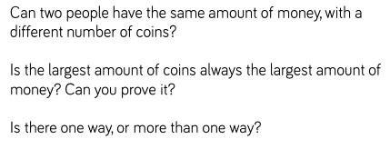

Yes

**Day Four**

No

More than one way

**Day Three**

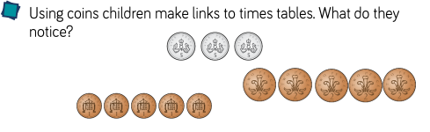

Children could be making links heere such as

“Three times five is fifteen” and “Five times two

Is ten” and “Five times one is five”

**Day Four- Coin Value**

## How many pence are in £1? **100** How many pence are in £1.75 **175**

## How many pence are in £1.50? **150** How many pence are in £1.30? **130**

## How many pence are in £1.25? **125** How many pence are in £1.10? **110**

## How many pence is in £2? **200**

## 

**Reading:**

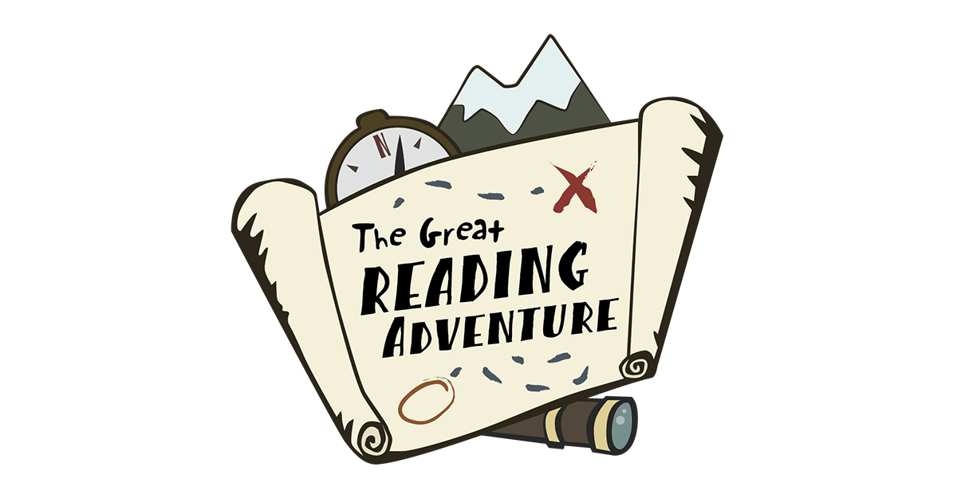 *Keep up the good reading!*

**English:**

**Diary entry**

It has been such a pleasure to see all the adventures that you have been on!

**Monday and Tuesday**: Adjectives are a brilliant way to make your sentences more interesting! Keep using this great vocabulary in your talking.

**Wednesday**: Wow – what interesting writing you are creating! Keep up the good work.

**Thursday:** Isn’t Kenya an interesting place to learning about! We love your facts.

**Friday:** What a fantastic selection of writing!

**Phonics:** *Keep up the good work everyone, it was been lovely talking to your parents and hearing how you are approaching phonics.*

**Science:**

Wow- you are so good at nature spotting!

**History: Kings and Queens!**

Well done everyone, you have learnt about one of our most impressive monarchs.

**Geography:**

We have a class full of explorers! Keep up the good work.

**Art:** Thank you for sending in your wonderful Art work! Please let us know if we are ok to pop it on our school class page.

**RE:**

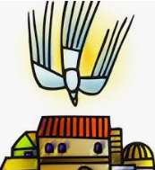

Well done – great work!

**Grammar and Punctuation:**

Well done – places always need a capital letter.

I live in England.

I went to Kenya.

My school is in Corsham.

**PE and Mindfulness**

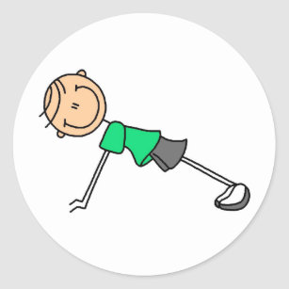Well done for keeping your mind and body fit!

**PSHE**

You are absolutely right, thank you for sharing the kind words that Gerald should have heard.