**Home Learning**

**Year 6 – Term 6 Week 1**

**Wb 1st June 2020**

**If you have not sent your pictures for our class photo in yet, please do so this week.**

# Reading

# Please choose a new book to start this term- you could ask a parent to recommend one, or have a really good look through your shelves. Are there any old favourites you’d like to revisit?

# Grammar- revision task. Please choose a page or paragraph from the book you are reading.

# Write down the first 10 nouns. Then do the same with adjectives and verbs.

# What are the first 10 pieces of punctuation? Can you explain why they’ve been used.

# How has the author joined ideas? Can you spot and conjunctions?

# Change the tense of the first two sentences by putting the verbs into past tense.

**English** this week is based on Oak National Academy’s unit of work on Instructions. Week 4

<https://www.thenational.academy/online-classroom/year-6/english#subjects>

Please follow these hints to answer the questions about the extract from The Weirdstone of Brisingamen:

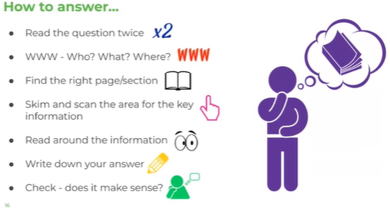

1. What happened after the birds crowed?
2. What does the phrase –their relief was short lived mean?
3. Can you give another word for ‘halted’?
4. Draw a sketch of Stormy Point- adding as many details as you can.

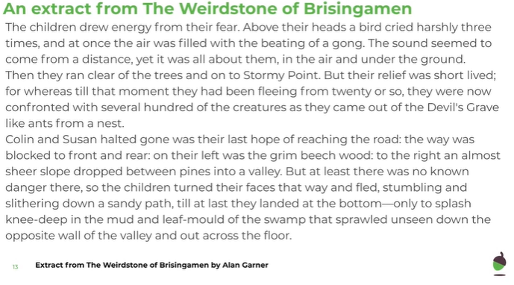

**English Writing Day 5 -Mr Fozzard Explains the features of instructions:**

Can you write a set of instructions using these features?

How to capture an Outlandish Creature.

This is based on the Oak Academy text for this week.

You could also write your instructions about a topic of your choice.

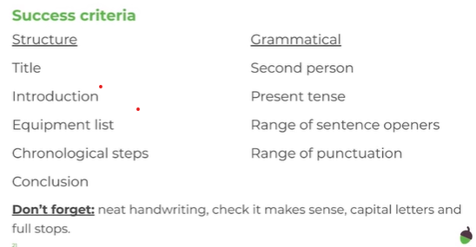

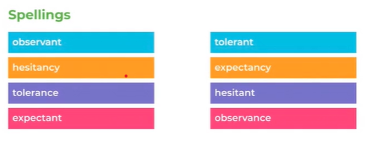

**Spellings**There are 10 spellings to learn each week. Use a dictionary or google to check the definitions of words you don’t know and use them in sentences. Could you find their synonyms and antonyms? What is the root word of each word? Use the look, say it, cover, write, check strategy to test yourself.

Please choose 2 other words that you need to learn.

**Maths**

Day 1 Oak Academy:

<https://www.thenational.academy/year-6/maths/coordinates-and-shapes-to-recognise-3-d-shapes-year-6-wk5-1>

Day 1 Arithmetic Day 1 Investigation

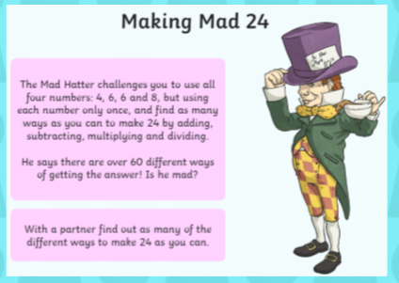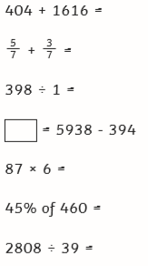

Day 2 Oak Academy:

<https://www.thenational.academy/year-6/maths/coordinates-and-shapes-to-recognise-nets-of-3-d-shapes-year-6-wk5-2>

Day 2 Arithmetic Day 2 Investigation:

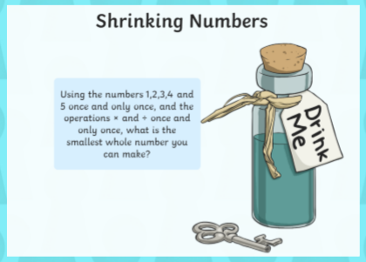

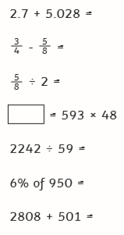

Day 3 Oak Academy

<https://www.thenational.academy/year-6/maths/coordinates-and-shapes-to-solve-problems-involving-3-d-shapes-year-6-wk5-3>

Day 3 Arithmetic Day 3 Investigation

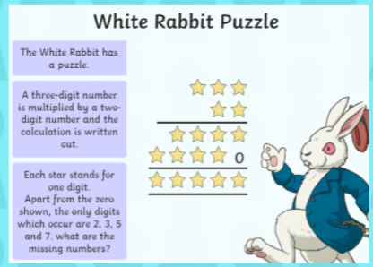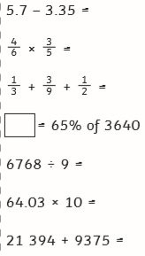

Day 4 Oak Academy:

<https://www.thenational.academy/year-6/maths/coordinates-and-shapes-to-illustrate-and-name-parts-of-a-circle-year-6-wk5-4>

Day 4 Arithmetic Day 4 Investigation

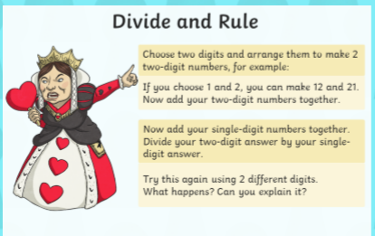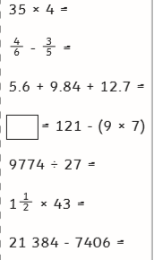

Day 5 Oak Academy:

<https://www.thenational.academy/year-6/maths/coordinates-and-shapes-to-solve-practical-problems-involving-circles-year-6-wk5-5>

Day 5 Arithmetic Day 5 Investigation

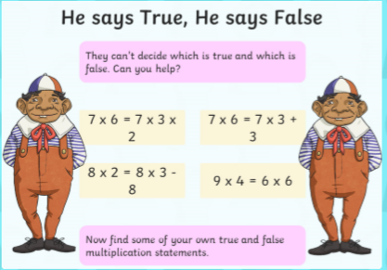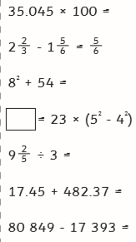

Religion

This week was Pentecost Sunday and this feast will be our focus for the next couple of weeks.

**What do you already know about Pentecost?**

**Make a poster / booklet / short film to show what you already know and can remember about Pentecost.**

Use the key questions below to prompt your thinking:

* *What does Pentecost celebrate? How does this link to Easter?*
* *Think of at least 5 key words that you think link to Pentecost. Why did you choose them?*
* *What symbols and images do we associate with Pentecost? Why?*
* *How does the Catholic Church mark Pentecost Sunday? (Liturgical colour? Bible reading?)*
* *Which sacrament(s) could you link to Pentecost? Why?*
* *What was the impact of the first Pentecost Sunday?*
* *What impact can Pentecost have on Christians today?*

Science

LO: What are Micro Organisms?

What does yeast do? Can you find out? Which products use yeast?

Do you have a compost bin? Can you find any evidence of Microorganisms?

(Take care- some microorganisms are not good for us – please ask an adult before touching anything you think may be a microorganism)

Please find out about one microorganism and draw a labelled diagram of it.

Art

Ms Cara from Oak Academy will show you how to make amazing Optical Illusions to impress your family!

<https://www.thenational.academy/year-6/foundation/optical-illusions-and-using-shading-to-show-form-year-6-wk3-5#slide-2>

Use thick and thin areas of colour to create your image. Leaving different spaces between the lines.

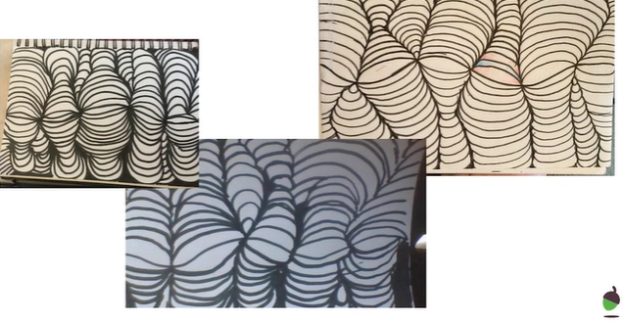

PSHE

There is a book about Worries on our webpage- please read it through. Have a chat with someone else, a parent, sibling, friend or relative (it could be a phone call) do you worry about the same things? How can you make each other feel happier about the things that bother you?

**History:**

After this week, our topic is geography based. Therefore, for your final History project we would like you to find out more about a period in History of your choice. Maybe you would like to find out about the Tudors or what life was like in Britain during the Middle Ages? Other periods in history that you may like to find out about include:

* The Stone Age
* The Stuarts
* The Georgians
* The Victorians
* Modern history
* American history (or the history of another country).

**Useful Websites:**

<https://www.nhs.uk/change4life/recipes>- Cooking Ideas

professor assessor <https://prof123.com>

<https://www.bbc.co.uk/bitesize> -lots of ideas and information.