**Home Learning – Lockdown Challenge**

**Term 6 Week 5 - 29th June 2020**

1. [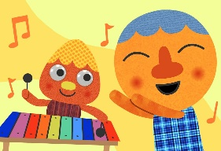](https://www.google.com/url?sa=i&url=https://supersimple.com/song/my-happy-song-featuring-noodle-pals/&psig=AOvVaw0tUmWULuHrGICsX5P6F6y_&ust=1592988053003000&source=images&cd=vfe&ved=0CAIQjRxqFwoTCODjjo_Fl-oCFQAAAAAdAAAAABAE)**Music / Drama / Dance Activity**

Choose 5 of your favourite songs which make you happy. Create an album cover design for one of your favourite songs.

1. **Creative / Craft & Design Activity**

**[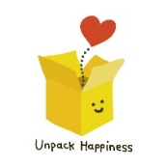](https://www.google.com/url?sa=i&url=https://www.teepublic.com/pin/5552997-unpack-happiness-box&psig=AOvVaw2Eicq0xbZ6-iJPc17AZWRD&ust=1592913012109000&source=images&cd=vfe&ved=0CAIQjRxqFwoTCNj738etleoCFQAAAAAdAAAAABAG)**Make your own happiness box, filled with things that make you feel happy! On the school website welcome page, there is a video of Miss McLoughlin explaining the items in her box to show you as an example. I wonder what you will put into yours…

Group A (Mon & Tues) please bring your happiness box in on Tuesday 30th June and

Group B (Thurs & Fri) please bring your box in on Friday 3rd July (you will tell your friends about your happiness objects). If you are at home please send in a video or a picture of your happiness objects and box.

1. **Social / Emotional Activity**

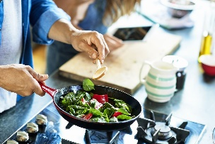Cooking can be a great way to relax and spend time together with loved ones (cooking together or eating together)!

**Get cooking!**

From Monday to Friday we will be hosting two cooking sessions each day - 10am and 2pm! We will be providing the recipe - so, just watch and then get cooking with BNF! Watch the 10am session so children can children get involved and cook-a-long!

* Quick and easy perfect pizza / Veggie coconut curry
* Breakfast fruit wholegrain crunch / Tuna & spinach wholewheat pasta bake
* Veggie sticks with mackerel dip /Mini crustless quiches
* Pea soup with quick flatbread / Kofta lollypops
* ****Blueberry wedges / Fish fingers & bro-chips

For more details,[click here.](https://www.nutrition.org.uk/healthyliving/hewathome/getcookingwithbnf.html)

1. **Physical Activity**

Try some of the basic yoga poses that Miss Jones has been trying out at home (see video and word document on the class homepage). Don’t forget to put some meditation music on.

1. 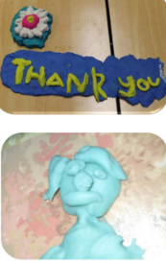**Spiritual / Reflective activity**

Thankful Play dough - Think about all the good things in your life. Think of someone or something that you are really grateful for. Encourage your child to think about someone or something that they are thankful for, e.g. family, friends, pets, animals, hobbies, sports, musical instruments or any other relevant ideas that come to mind. When they have thought of something, encourage them to make a model of it. Use some of the play dough to make a model of the thing you have thought of. If you want to, while you are making your model use the time to say thank you to God.

1. **[](https://www.google.com/url?sa=i&url=https://www.publicdomainpictures.net/en/view-image.php?image%3D201827%26picture%3Dha-ha-writing&psig=AOvVaw1M3gyzrLpZHBqZsjbrGP3u&ust=1592992104328000&source=images&cd=vfe&ved=0CAIQjRxqFwoTCIih8JbUl-oCFQAAAAAdAAAAABAD)Supporting the Community Activity**

Write some jokes to post to a neighbour to make their day! Check your material makes your family laugh before you send them!

1. **Reading to Relax**

[](https://www.google.com/url?sa=i&url=https://www.allmomdoes.com/2017/07/06/reading-is-fun-how-to-make-summer-reading-fun-for-your-kids/&psig=AOvVaw1qB0AVQswovH9ZgK0TL6Ox&ust=1592992160794000&source=images&cd=vfe&ved=0CAIQjRxqFwoTCLD327fUl-oCFQAAAAAdAAAAABAD)Find a book with lots of different character where you can practise different voices. Make some loud, quiet, funny, strange and then read aloud to a member of your family and shock them with your expression.

* Use Oak Academy, Twinkl or your own ideas for English and Maths. I have also uploaded a two week English resource (Talk 4 Writing) if you would like some new ideas.