**Home Learning**

**Year 6 – Term 6 Week 4**

**Wb 22nd June 2020**

**Transition**

**From this week onwards we will be starting to think more about your transition to secondary school and adding activities to support this.**

**Firstly, have a look at the questions below for English and answer honestly how you are feeling about each area.**

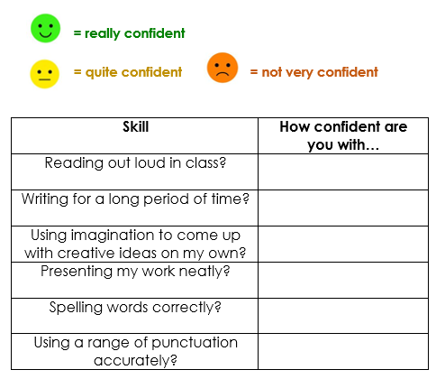

Now consider:

1. What are you really proud of in English?
2. What do you find challenging?
3. What skill are you looking forward to showcasing and why?

**Your reading and writing tasks over the next few weeks will be based on the poem ‘First day at school’ by Roger McGough (see below)**

**Reading**

1. Look at the words below. Who do you think would use language like this? How old might they be? **Make a prediction** on the poem or speaker based on these words.

Yellowwellies

millionbillionwillion

Wolves and monsters

Teacher

1. Read through the poem ‘First Day at School’ on your own. Underline all the words used to describe how the boy feels on his first day at school, and **write a list** below of the emotions he feels:
2. Why might the boy ask so many questions in the poem?
3. Why do you think there are so many **short sentences** in the poem? What do they suggest about the **boy’s feelings**?
4. In the last stanza (paragraph of a poem), the boy says he has forgotten his name. **What does this suggest about how he feels?** Try and use as many of the lines below as you can to explain your ideas.
5. Try and think about **how you felt** on your first day at primary school. Were you a little nervous or excited?

-> You could **draw an image** of you on your first day

**7. Challenge**: What do you think the poet might be trying to tell us about the first day at primary school for some five-year olds?

**First Day at School – Roger McGough**

And the railings.

All around, the railings.

Are they to keep out wolves and monsters?

Things that carry off and eat children?

Things you don't take sweets from?

Perhaps they're to stop us getting out

Running away from the lessins. Lessin.

What does a lessin look like?

Sounds small and slimy.

They keep them in the glassrooms.

Whole rooms made out of glass. Imagine.

A millionbillionwillion miles from home

Waiting for the bell to go. (To go where?)

Why are they all so big, other children?

So noisy? So much at home they

Must have been born in uniform

Lived all their lives in playgrounds

Spent the years inventing games

That don't let me in. Games

That are rough, that swallow you up.

Continues on next page

I wish I could remember my name

Mummy said it would come in useful.

Like wellies. When there's puddles.

Yellowwellies. I wish she was here.

I think my name is sewn on somewhere

Perhaps the teacher will read it for me.

Tea-cher. The one who makes the tea.

**Writing**

Imagine you are visiting the primary school of the boy in the poem. **Write a speech** to deliver to the class **offering advice and reassurance** about what primary school is really like.

You could write about:

* The best things about primary school
* Why there’s no need to be nervous
* How to make friends with other children.

**Challenge**: Think about your **language choices**. How could you use language to make your **speech clear and engaging** for younger children? Review your writing carefully, are there any particular patterns or words that you need to practice?

**Spelling:**

Please learn the following and add another four of your own.

|  |  |
| --- | --- |
| community | complete |
| communicate | comparison |
| competition | committee |

**Maths**

***For the next few weeks we will be looking at algebra. You will have the choice of following along with a ‘White Rose’ lesson (you will need to pause the video and have a go along the way’ or if you are feeling confident dive straight in with a worksheet.***

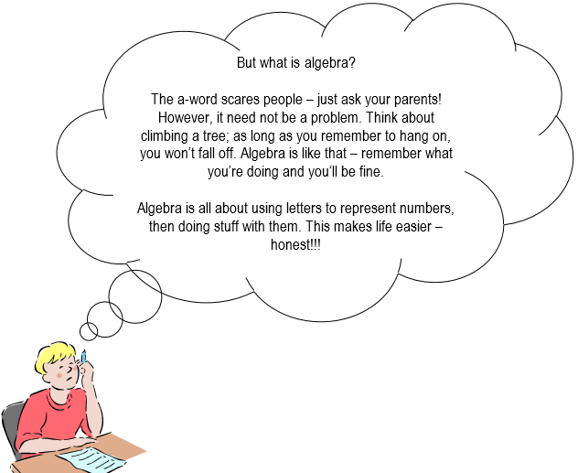

**Day 1:**

<https://whiterosemaths.com/homelearning/year-6/> **Now select ‘Summer Term Week 7- W/C 8th June’- Lesson 1**

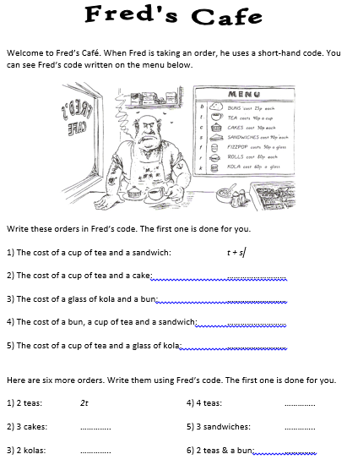

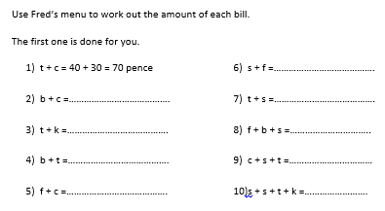

**Day 2**

<https://whiterosemaths.com/homelearning/year-6/> **Now select ‘Summer Term Week 7- W/C 8th June’- Lesson 2**

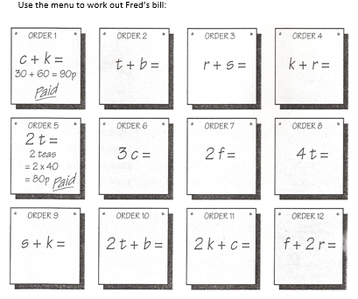

**Day 3:** <https://whiterosemaths.com/homelearning/year-6/> **Now select ‘Summer Term Week 7- W/C 8th June’- Lesson 3**

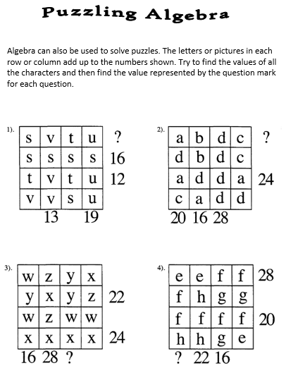

**Day 4**

<https://whiterosemaths.com/homelearning/year-6/> **Now select ‘Summer Term Week 7- W/C 8th June’- Lesson 4**

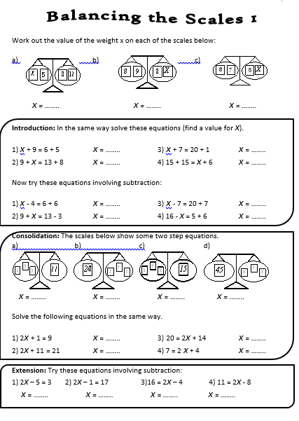

**Day 5:** <https://whiterosemaths.com/homelearning/year-6/> **Now select ‘Summer Term Week 7- W/C 8th June’- Friday Challenge**

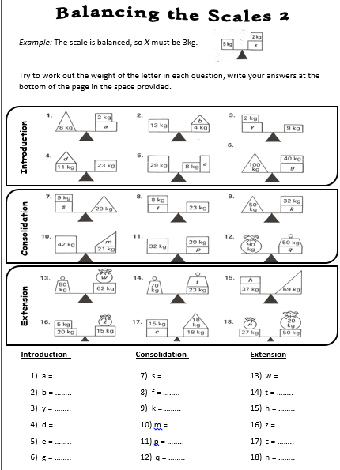

**Religion**

The Baptism of Jesus

Building on from last week, we are going to think a little deeper about the Baptism of Jesus by John the Baptist.

**How do you think the Baptism affected Jesus? What did Jesus do immediately after his baptism? Look at Mark’s Gospel Ch1 v12-13. Why do you think he did this?**

**When a baby is baptised today the parents make promises. The Priest says something like this: “In asking for baptism for your child you are accepting responsibility for bringing him up in the practice of the faith. It will be your duty to bring him up to follow Christ's teaching, by loving God and our neighbour. Do you clearly understand what you are undertaking?” How can parents help a child understand what God is calling them to be? What should parents do?**

**In the Bible the image of the spirit of God occurs many times. Look at these images. What event do you think they are describing.**

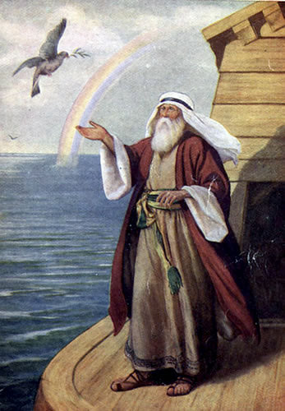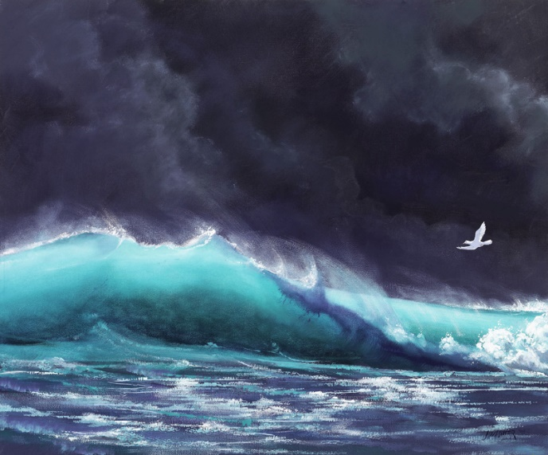

**In both cases something new is about to happen. What is that? When Jesus was baptised the Gospel writers talk about the spirit appearing. What is the new thing that will happen here? How will this change the world?**

**O Lord All The World Belongs To You**

**1. Read carefully the word of this hymn which is about God’s kingdom**

Lord all the world belongs to You

And You are always making all things new

What is wrong You forgive and the new life you give

Is what’s turning the whole world upside down

The world’s only loving to its friends,

But Your way of loving never ends

Loving enemies too and this loving with You

Is what’s turning the whole world upside down.

The world lives divided and apart

You draw men together and we start

In your body to see that in fellowship we

Can be turning the whole world upside down

The world wants the wealth to live in state

But You show a new way to be great

Like a servant You came and if we do the same

We’ll be turning the whole world upside down.

O Lord, all the world belongs to You

And You are always making all things new

Send your spirit on all in your Church whom You call

To be turning the world upside down.

**2. How does this hymn connect to the parable of the Tax Collector and the Pharisee?**

**3. According to the hymn how are we meant to live in the Kingdom?**

**4. Who is the Kingdom for?**

**5. Draw a picture to show on the one side how the world lives and on the other side how we should live in the Kingdom.**

**6. Write your own poem or hymn about the Kingdom or find examples from the news about the way the world lives/what the world thinks is important and the way Christians behave. Once you have your examples make a collage to show this. (You could look at Pope Francis as an example)**

**Science**

In science practical lessons at secondary school, you will be using lots of specialist apparatus. You will need to be able to draw scientific diagrams of apparatus

Below draw lines to match the photo with the name of equipment, then with the scientific diagram. Look up and write the use of each piece of apparatus. The first one is done for you

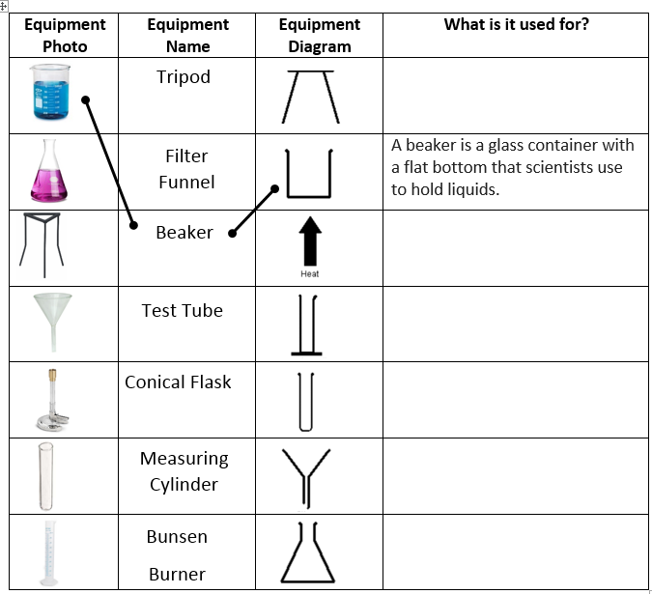

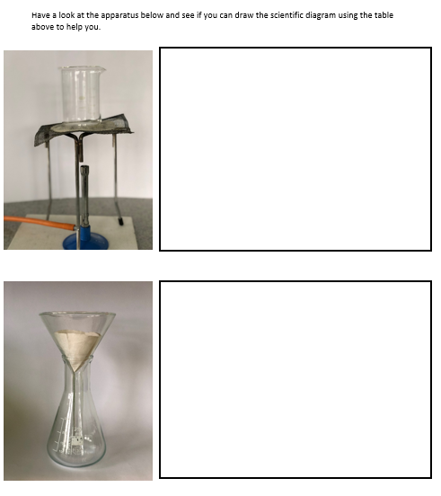

**Geography**

<https://www.bbc.co.uk/bitesize/topics/z849q6f/articles/zvsp92p>

Have a read of this first. Could you then design a ‘Biome in a box’? This could be similar to an Easter garden if any of you made these.

Here are some ideas:

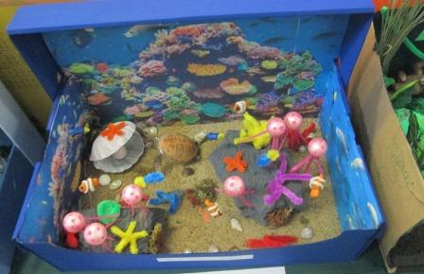 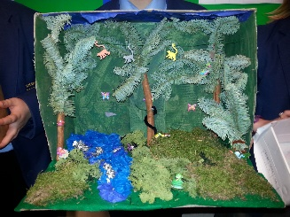 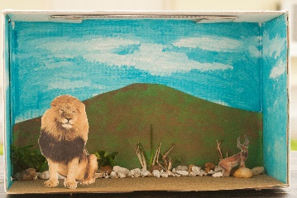

**PSHE**

**This week, please complete session 2 from the Be Awesome, Go Big workbook.**

<https://www.hachetteschools.co.uk/landing-page/hachette-schools/be-awesome-go-big-resources-for-year-6/>

The PowerPoint talks through the importance of a growth mind-set.

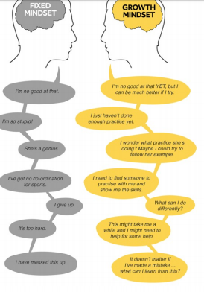

**Look at the 2 people with a different mind-set. How would you approach problems differently?**

**Does it change depending on different situations in your life?**

