**Home Learning**

**Home Learning – Lockdown Challenge**

**Term 6 Week 6 – 6th July 2020**

1. **Music / Drama / Dance Activity**

Gather together some of your favourite songs (perhaps 3 as a minimum?). Dance along to these, with a friend or a family member if possible. Take it in turns to stop the music at a random point and freeze. Discuss how you are feeling at this point. Has this song made you feel happy/excited/ calm? 

1. **Creative / Craft & Design Activity**

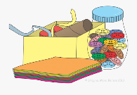For this week’s Wednesday meeting we will be sharing something which you have learnt or achieved during lockdown. Perhaps you have learnt crochet? Or refined your painting skills? Or planted something in your garden? It would be lovely if you could bring something to show on Tuesday or Thursday .It may be that you make a poster, bring in something you have made or demonstrate a skill. Each presentation will need to be no longer than three minutes in order for us to fit you all in!

1. **Social / Emotional Activity**

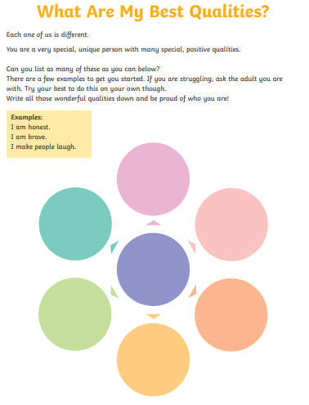

1. **Physical Activity**

Consolidate your maths and get moving with BBC Super Movers- this is some real fun!

<https://www.bbc.co.uk/teach/supermovers/ks2-maths-collection/z7frpg8>

1. **Spiritual / Reflective activity**

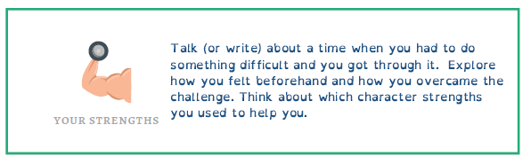

How many stories in the Bible can you think of where sopmeone had to overcome a challenge-there are many! Which if these have inspired you the most?

1. **Supporting the Community Activity**

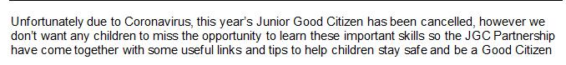

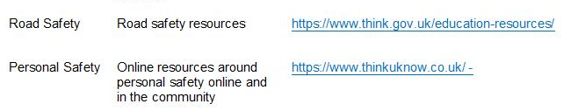

**Reading to Relax**

Find a book with an amazing setting which you would love to visit. Could you re-write this setting as if you were there? What would happen? Could you paint or draw this setting?

**Writing Project 1:** (based on the poem ‘First Day at school’ by Roger McGough)

**Write a letter** to your new Year 7 English teacher to **introduce yourself** and tell them about the three main things that make you a great student.

Think about:

* A quality that you have that you are really proud of, such as being helpful or polite.
* What makes you a great learner.
* Examples of where you have showcased these qualities.

**Challenge:** Think about how you can use **a range of language**, such as adjectives and adverbs, to best explain your qualities.

**Writing Reflection**

Consider the writing tasks from the last three weeks:

1. Writing a speech
2. Writing a poem
3. Writing a letter

Which was your favourite task and why?

Were there any tricky parts- how did you get help if there were?

What would you hope your secondary school would learn about you through the completion of these tasks?

**Writing Project 2:**

**StoryTown 2020**

**Writing Competition**

*If only I could…*

  
StoryTown Corsham will take place on the weekend of 16-18 October. It’s a celebration of reading, writing and storytelling - and it’s a brilliant way of sharing the Corsham’s creativity. So, how can you get involved?

We would like you to think about the situation we have all found ourselves in this year – but don’t panic: we are not asking for your Covid-19 stories. Instead, we’d like you to think about the power of your imagination. If we hadn’t experienced lockdown, what might you have done? Where might you have gone? Who might you have seen, or visited? This is about possibilities, no matter how wild and crazy. Have fun and tell us what you would do if only *you* could...

**The rules:**

* There is a maximum word limit of 500 words
* Entries need to be typed and be part of an email - not sent as an attachment - and emailed to: [StoryTownCorsham@gmail.com](mailto:StoryTownCorsham@gmail.com)
* Please include your **first** name and the **age category** you fit into:Under 8/9-12/13-17/ 18+
* Please include a **telephone number**. This should be a parent or carer’s number if you are under 18.
* By entering the competition, you agree to StoryTown sharing your work, through a physical exhibition and/or through digital means
* Poetry or prose submissions are permitted.

**The deadline**: Sunday 30 August. You have plenty of time to get pen to paper (well, finger to keyboard) and send us your wonderful work.

**The prize:** Well… a chance to get your name in print and published. There will be a book token available for the winner in each age group.

Good luck!

*StoryTown is brought to you by…*

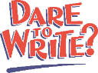

*For further information about how Corsham Town Council uses your personal data, including your rights as a data subject, please see our privacy policy:* [*https://www.corsham.gov.uk/information/policies.php*](https://www.corsham.gov.uk/information/policies.php)

**Maths**

Day 1

NB: ‘First term’ means the first number in the sequence

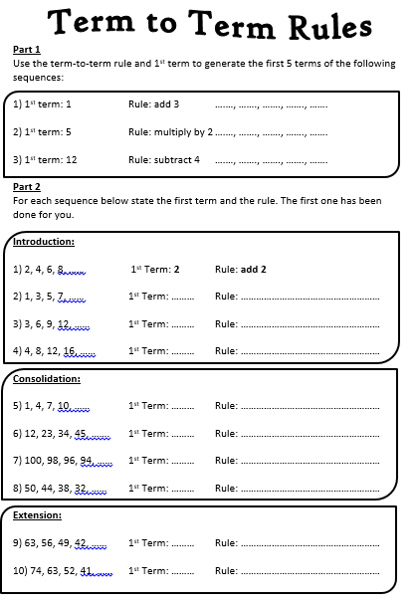

Day 2

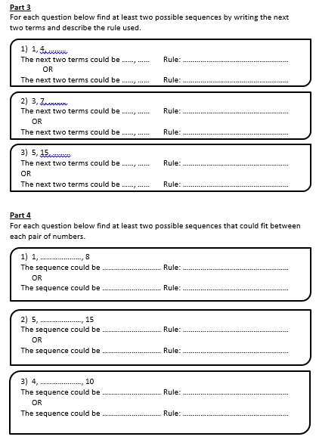

Day 3

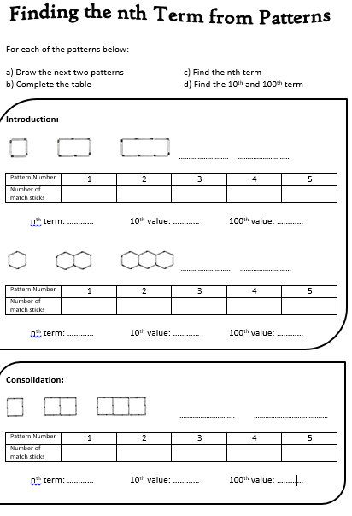

Day 4

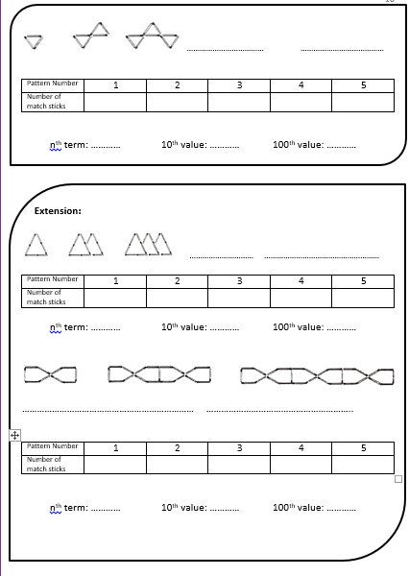

Day 5

