**Home Learning**

**Reception – Term 6**

**Week 8 – Monday 15th June 2020**

Below you will find activities for all of the 7 areas of the Early Years Foundations Stage curriculum and an activity for Religious Education (RE). Please pick what works for you and your child.

|  |
| --- |
| **1: Literacy**  **(few options)**   * Tune into the **DFE Daily phonics lesson** on YouTube (delivered by the English Hub). * Or, try ‘**Mr Thorne** does phonics with Geraldine’ on YouTube. Concentrate on one or two sounds a day in your work book after watching the video. Alternatively, you could use a **Phonics app** such as ‘*Teach your monster* *to read*’, ‘*BBC BITESIZE’* (<https://www.bbc.co.uk/bitesize/topics/zvq9bdm>),watch jolly phonics on YouTube or play ‘*Phonicsplay.com’*. * Download a **Twinkl Phonics workbook** each day to compliment your daily sound. * Pick a sequence of lessons from the**Oak National Academy website**. * **Pick a new eBook** for the week (‘Big Cat’ or ‘Oxford Owls’ have free eBooks) or collect three new ones from school.   **No screen needed:**  **Create a story book** using the Enormous Turnip as a guide.  You are going to learn a traditional tale and use the phrases and language to write the story. You can either write the story as it is or make a small change (the setting, a character or the ending).  The Enormous Turnip story! <https://m.youtube.com/watch?v=mGw5yTOPTSQ>  The first time you hear it – enjoy! Listen to it again, make notes to help your remember the important bits (you can write words, use pictures, whatever helps you to remember).  Explore the story helping you to remember, here are some ideas that you might like to use…   * You can make a puppet show of the story using teddies, homemade puppets or small world toys. * Draw a story map of the story * Retell the story to your household * Create the garden, you can do it outside, use construction, junk modelling * Draw a picture of all of the characters that pull the turnip * Learn a song about the story <https://m.youtube.com/watch?v=l5Wob-H-5uY> * More activities and resources on Twinkl.   **Monday**: Enjoy the activities above and plan your story book. What will go on each page? Create a simple story map to help (See the Twinkl version attached). If you have 5 pages in your book then make 5 boxes for your story map (similar to the jack and the beanstalk map last week). See the Enormous Turnip story map attached.  **Tuesday**: complete one page of your story book (this doesn’t mean a whole page of writing!). You will need to add pictures and a few simple sentences to retell the beginning of the story.  **Wednesday – Friday**: Complete a page a day (simple sentences and pictures to retell the story). Ask a grown up to write a word bank with the key words from the story, these words will help you to write the story. |
| **2: Maths**  **(few options)**   * **Pick a sequence of lessons from Oak National Academy**   <https://www.thenational.academy/online-classroom/reception/>  **Lots of lessons for ‘Doubling and halving’ (Week 7) and ‘Addition and subtraction’ (week 8).**   * White Rose Maths stories and activities   **No screen needed**: –  **Stage one of adding**:  Try a different activity daily      **Stage two of adding:** Use household objects or toys to practice theskill of counting on and back. When we add two numbers together (in school), we ‘lock’ the first number in our head and then count on by using our fingers. This can be a tricky skill so it’s important it’s practiced daily. |
| **3: Communication and Language**   * Host a tea party for your family/teddies/dolls. Use question words to hold a conversation with them. * Play the memory game at your tea party with your family.   Name the objects, then close your eyes while your family member hides one object. Which one has disappeared? Then swap over and you can hide an object.   * Developing children’s speaking and listening skills at the earliest stages is vital for their overall development. Please see the ‘Let’s Talk’ role play sheet attached. |
| **4: Personal Social and Emotional Development**   * What does your name mean? Research the meaning/story behind your name and make a poster. * Make a scrap book of all your favourite home learning activities or your lockdown achievements you have done while you have been at home. Comment on why you liked the activities or what is special about your new achievements. I would love to see this when you come back to school! * Breakfast Lunch Dinner Stock Illustrations – 55,057 Breakfast ...Make a meal for your family. You could make breakfast, lunch or dinner (with some adult help of course!). * It is ‘Cupcake Day’ on the 18th June 2020. Can you make your favourite cupcakes? You may decide to make cupcakes for someone else to make them smile. |
| **5: Physical Development**   * Move like the animals that are in this famous song (either inside or on a walk). Can you use your body to show your favourite animal? Don't forget to experiment with different shapes or speeds when moving.   <https://www.youtube.com/watch?v=1L993HNAa8M>   * Using the story 'Supertato Run Veggies Run' create your own racetrack, inside or outside. You could use chalk, pens and paper or construction toys such as Lego or train tracks. |
| **6: Understanding the World**   * Draw a family portrait of the people living in your home. Can you describe how you are all the same? Can you describe how you are all different?   We are same because__________  We are different because _________  • Everybody has different likes and dislikes. Interview members of your household or phone family members and ask them questions. What’s your favourite food/colour/song/story, etc. You may think of different questions to ask. Are they the same/different? |
| **7: Expressive Arts and Design**   * Create a Father’s Day card - Here’s a simple idea for a really lovely, personalised Father’s Day Card. If you haven’t got paint at home then you can always draw around your hand and decorate it. You could make one for your Dad, your Granddad or a special Uncle, etc. * Learn a new skill of Makaton. It is a type of communication that uses hand signals. Can you learn a nursery rhyme or song using Makaton?   <https://www.youtube.com/playlist?list=PLjT4XhijakZiqAV_QjFd-8nV5CuO5Rpnz>  Don't forget to send your video to Miss Jones!   * Practise meditating and finding your calm place. Take a look at the yoga poses below   <https://www.youtube.com/watch?v=jJ9zpRAPIuI>     * Explore colour mixing to create shades and colours when painting vegetable pictures. * Create a papier-mâché enormous turnip, by covering a balloon with layers of paper and glue. Once dry, it could be painted white and purple and some paper leaves added at the top. * Make some [Salt Dough](http://www.twinkl.co.uk/resource/t-t-218-salt-dough-recipe-a4-display-posters) and mould and shape the dough into shapes of different vegetables and fruit. They could then bake and decorate these, then use them in role play games and activities. * Provide some large sheets of paper or paper plates and a selection of vegetables. Encourage children to make arrangements of the vegetables to create patterns or faces. A camera could be used to record the children’s pictures. The work of Guiseppe Arcimboldo could be looked at to provide inspiration for the children’s work. |
| **8: Religious Education**  [short stories compilation: The Boy who cried "Wolf"](https://www.google.com/url?sa=i&url=http://shortstoriescomp.blogspot.com/2014/09/the-boy-who-cried-wolf.html&psig=AOvVaw1tGt3zaaWT2i6thju43dW7&ust=1591997562890000&source=images&cd=vfe&ved=0CAIQjRxqFwoTCOCK4rXb-ukCFQAAAAAdAAAAABAD)  **Reception / Year 1**  Parables  Over the next couple of weeks we will be looking at parables. Parables are stories told by Jesus which have meaning for us to learn from. Before we look at some of the parables Jesus told, listen to an adult read the story below – what can we learn from its message?  **The Boy who cried Wolf**  There once was a shepherd boy who was bored as he sat on the hillside watching the village sheep. To amuse himself he took a great breath and sang out, "Wolf! Wolf! The Wolf is chasing the sheep!"  The villagers came running up the hill to help the boy drive the wolf away. But when they arrived at the top of the hill, they found no wolf. The boy laughed at the sight of their angry faces.  "Don't cry 'wolf', shepherd boy," said the villagers, "When there's no wolf!" They went grumbling back down the hill.  Later, the boy sang out again, "Wolf! Wolf! The wolf is chasing the sheep!" To his naughty delight, he watched the villagers run up the hill to help him drive the wolf away.  When the villagers saw no wolf they sternly said, "Save your frightened song for when there is really something wrong! Don't cry 'wolf' when there is NO wolf!"  But the boy just grinned and watched them go grumbling down the hill once more.  Later, he saw a REAL wolf prowling about his flock. Alarmed, he leaped to his feet and sang out as loudly as he could, "Wolf! Wolf!"  But the villagers thought he was trying to fool them again, and so they didn't come.  At sunset, everyone wondered why the shepherd boy hadn't returned to the village with their sheep. They went up the hill to find the boy. They found him weeping.  "There really was a wolf here! The flock has scattered! I cried out, "Wolf!" Why didn't you come?"  **What do you think the meaning of the story is?**  An old man tried to comfort the boy as they walked back to the village.  Attached on our **Class Page** on the school website is a PowerPoint which goes through some of the important parables Jesus has taught us and their meanings. Go through this and talk about your ideas with a grown-up. |

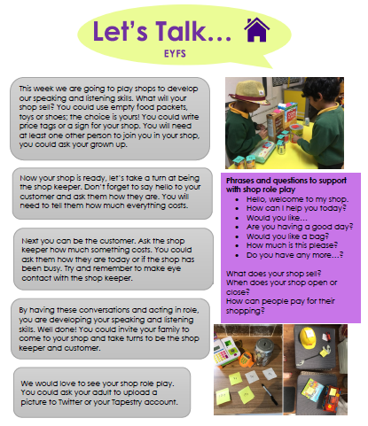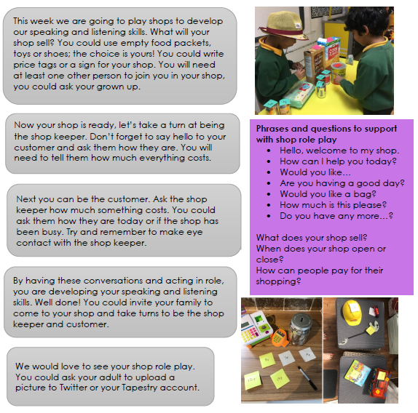

**Home Learning Challenges**

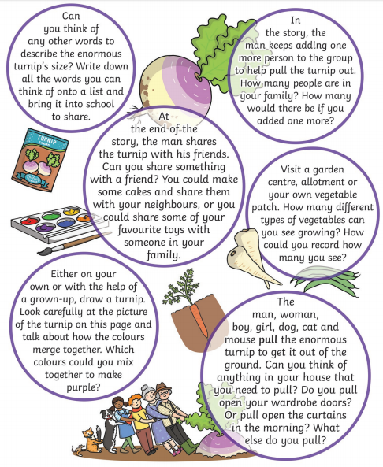

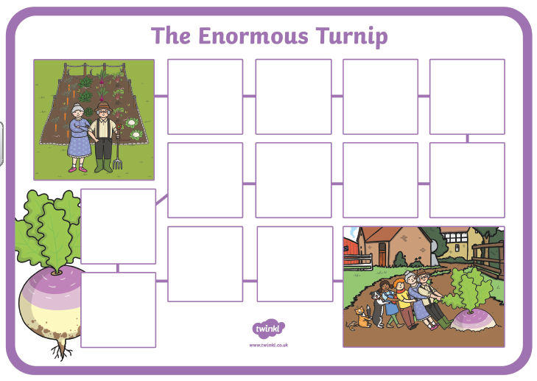

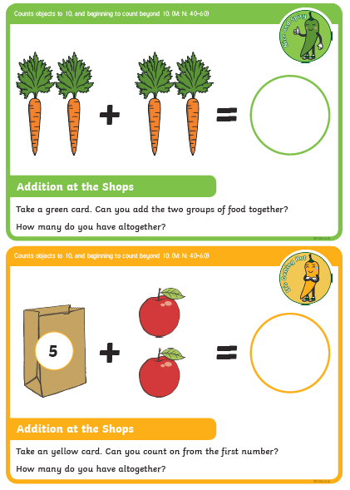

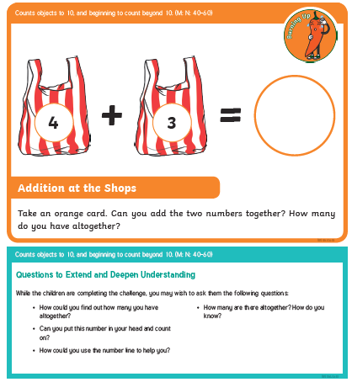

**Addition**

**Counting On**

**4+**

**=**

**==**



**5+ =**



**2+ =**

**3+ =**



**=**

**6+**

