**Home Learning**

**Reception – Term 6**

**Week 2 – Monday 8th June 2020**

Below you will find activities for all of the 7 areas of the Early Years Foundations Stage curriculum and an activity for Religious Education (RE). Please pick what works for you and your child.

|  |
| --- |
| **1: Literacy**  **(few options)**   * Tune into the **DFE Daily phonics lesson** on YouTube (delivered by the English Hub). * Or, try ‘**Mr Thorne** does phonics with Geraldine’ on YouTube. Concentrate on one or two sounds a day in your work book after watching the video. Alternatively, you could use a **Phonics app** such as ‘*Teach your monster* *to read*’, ‘*BBC BITESIZE’* (<https://www.bbc.co.uk/bitesize/topics/zvq9bdm>),watch jolly phonics on YouTube or play ‘*Phonicsplay.com’*. * Download a **Twinkl Phonics workbook** each day to compliment your daily sound. * Pick a sequence of lessons from the**Oak National Academy website**. * **Pick a new eBook** for the week (‘Big Cat’ or ‘Oxford Owls’ have free eBooks) or collect three new ones from school.   **No screen needed:**   * Write out the tricky words and cut them out letter by letter. Can you put them back together?   https://www.youtube.com/watch?v=TvMyssfAUx0  <https://www.youtube.com/watch?v=R087lYrRpgY>   * Read a story. We will be reading ‘Jack and the Beanstalk’ in class.   - What do you think happens next?  - What are some of the things your character might say? Can you draw a picture and write speech bubbles for the characters?  -We will have a go at planning a new version by changing the characters and ‘beanstalk’.   * Can you write a review of your favourite book? Maybe you could write about Jack and the Beanstalk.   - Who is your favourite character?  - Which is your favourite part?  - Why should your friends read this book?  - The book review document is at the end of this pack   * See ‘Jack and the Beanstalk’ writing sheets attached. |
| **2: Maths**  **(few options)**   * **Pick a sequence of lessons from Oak National Academy**   <https://www.thenational.academy/online-classroom/reception/>   * <https://www.bbc.co.uk/iplayer/episodes/b08bzfnh/numberblocks?seriesId=m0005y7k>   Watch the Number Block videos on Iplayer (series 3 and 4) for numbers 11-20.   * White Rose Maths stories     **No screen needed**: (Numbers 1-20) –   * Jack and the beanstalk number ordering (see sheets below). If you can already order to 20, then make your own beans (higher numbers) and order them. * Jack and the beanstalk ‘I Spy’ ADD TO 20 worksheet (below). * Measuring time taken for beans to germinate (link to how many days of the week) |
| **3: Communication and Language**   * Name 5 things   - Use the challenge cards below and have a race to see who can name 5 things of one subject the quickest. Mix this up by naming things with our senses, phonics or numbers.   * What is outside your window?   - Draw or take a picture of the view outside your window. Can you explain and describe what you can see and hear? How would you improve the view?   * Share photos/videos for your teachers to see. |
| **4: Personal Social and Emotional Development**   * Go for a walk and take pictures along the way. Use the pictures to retell the walk. * Have a think about the things you are good at, and the things you don’t find easy. How could you improve? * Draw pictures/take photos and practice improving your skills.   “I am good at_______ because_______”  “I don’t find ______ easy. I could______”   * Share photos/videos for your teachers to see. |
| **5: Physical Development**   * Brush your teeth! Make a poster explaining how and why we should brush our teeth. Can you include facts you have researched on the internet? * How should I travel?   - Cut out the spinner activity below and travel in different ways around the house/outside. Can you come up with different movements?   * Make a sandwich   - With the support of an adult, can you make your own sandwich? Which ingredients are you going to use? Can you spread the butter and cut the bread? Can you decorate your sandwich?   * Share photos/videos for your teachers to see. |
| **6: Understanding the World**   * Plant a bean and grow your own beanstalk. * Write Instructions for Miss Jones – write about how to plant a beanstalk and care for it Using non-fiction books / web on how to care for plant (information leaflets/guidance), different varieties of beans & what they look like. * Learn about different beans and how to identify and cook them * Create a diary on its growth and bring it back in to school. * Science focus: features of plants, role of each part of plant, play plant detectives, conduct experiment on what a plant needs to grow. * Can you describe what life at home is like for you? How is it different from before the lock down? What do you like? What would you change? What would you keep? Draw pictures to show this. * Use the computer/tablet to draw a picture on paint. Can you do this without the help of an adult? You could draw a picture from Jack and the Beanstalk. * Pick a science experiment to try from STEM: <https://www.stem.org.uk/resources/community/resource/258613/early-yearsreception-science-homeworks> |
| **7: Expressive Arts and Design**   * Free hand pencil drawing. Fill your page with swirls without taking your pencil off the page. Colour in the gaps. What patterns will you make? * Create Jack and the Beanstalk characters using different tools and techniques- could choose to focus on specific art equipment, e.g. how to use a paintbrush correctly to get different effects? Different types of painting techniques? * Design a land to go at the top of their beanstalk- week project (sketch ideas, design land, edit and improve, colour (pencils) add different elements using pens/pastels/paint/collage? * Design new palace for giant * Create a piece of music to match different characters, growing of the beanstalk and learn how to change the sound of an instrument (pitch, dynamics, tempo). Match to character at different parts of the story, e.g. jack at beginning, selling cow, getting magic beans, etc. * Junk modelling to create a free-standing beanstalk using variety of resources including recycled materials. * Create a Jack and the Beanstalk craft project. See the pictures below for some ideas. |
| **8: Religious Education**  Watch this video for the retelling of Pentecost - <https://www.youtube.com/watch?v=xtokHQOmFu0>  In the story, Jesus’ disciples receive the **Holy Spirit.** This helped them to spread the word of God to others and follow the example Jesus had set for them.  Christians also believe the Holy Spirit helps them in many ways:  Use the flame below, or design your own and on it write or draw the ways you think the Holy Spirit helps us / Christians. There are some ideas below to prompt your thinking. |

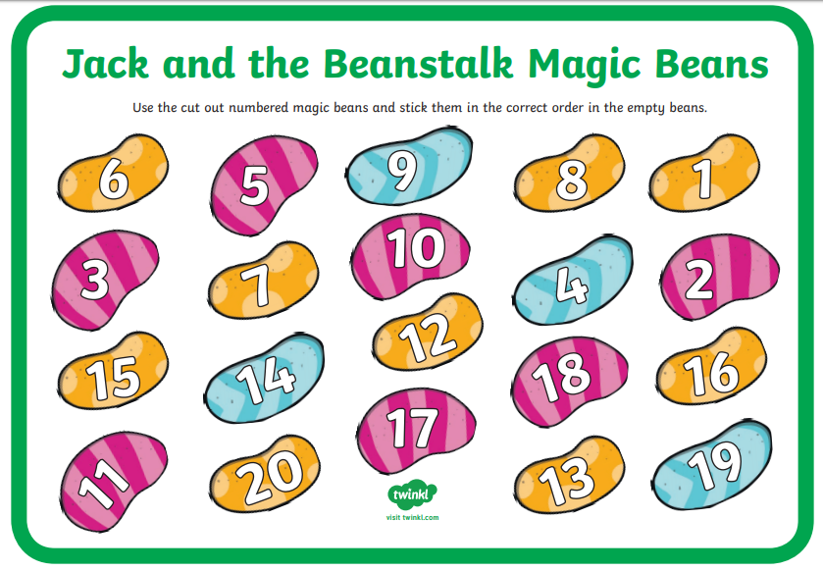

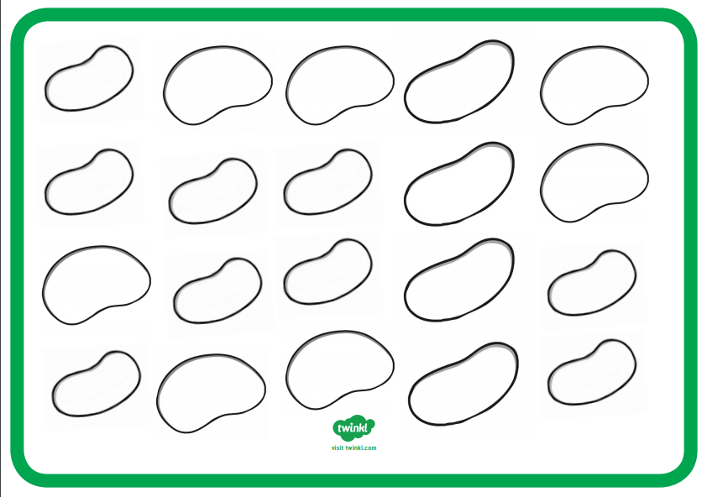

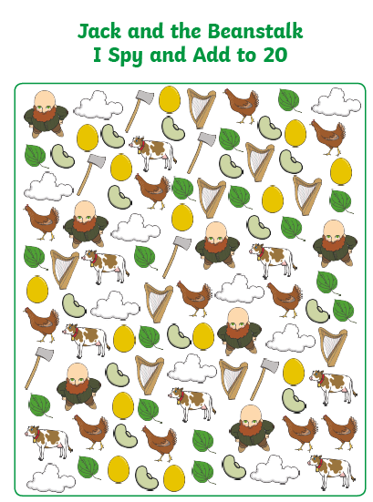

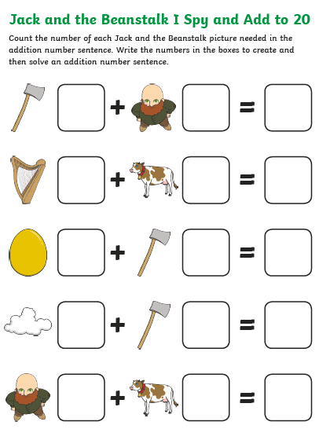

7

6

