**Home Learning**

**Year 5 – Summer Term 6 Week 4**

**22nd June 2020**

# Reading Comprehension

# 

# Writing – Wonderful Wizards

# Have a look at the Talk for Writing website for all of the plans on this unit of work. <https://www.talk4writing.com/wp-content/uploads/2020/06/Y5-Wizards.pdf>

# If you are unable to download the full resource pack, here are some ideas to get you started.

# 

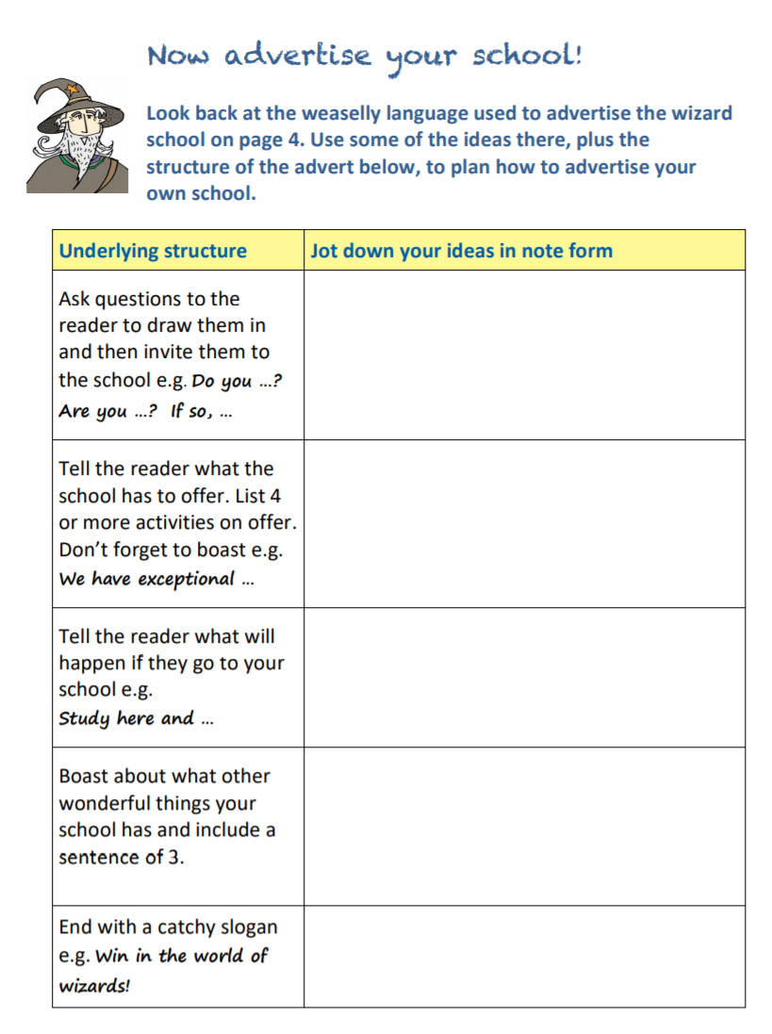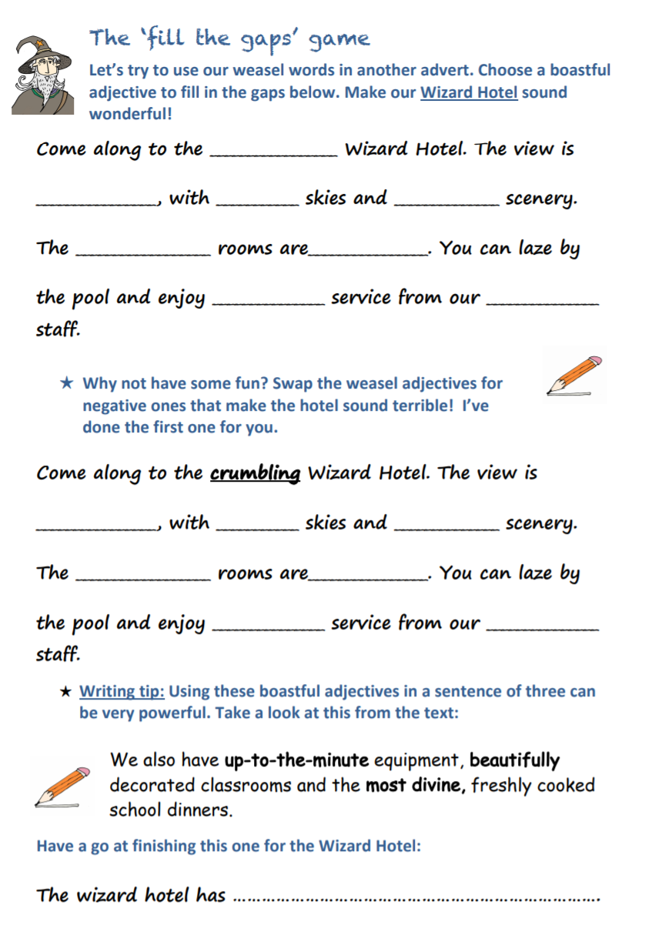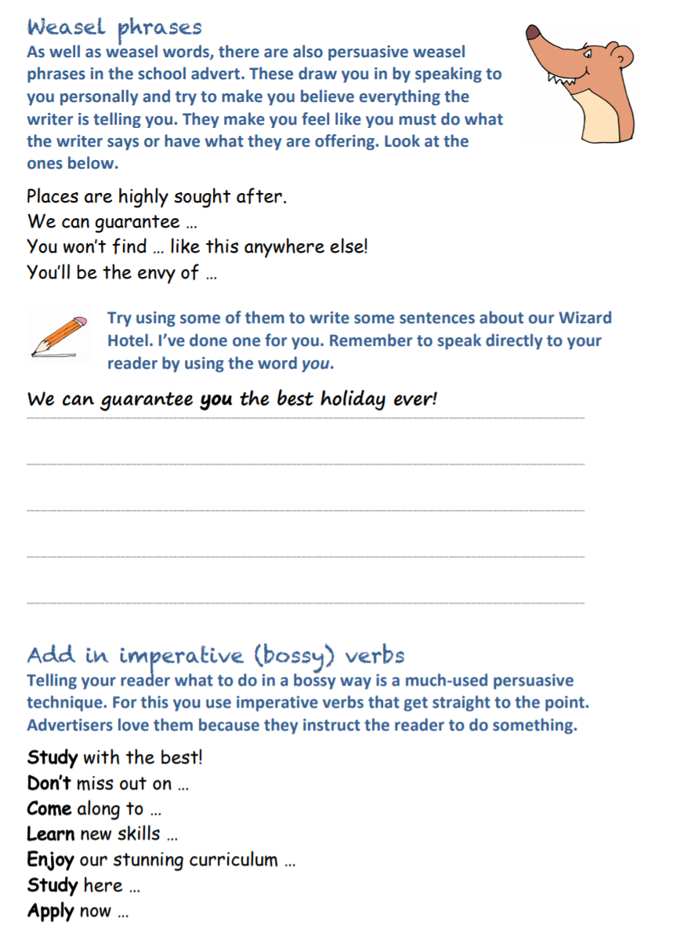

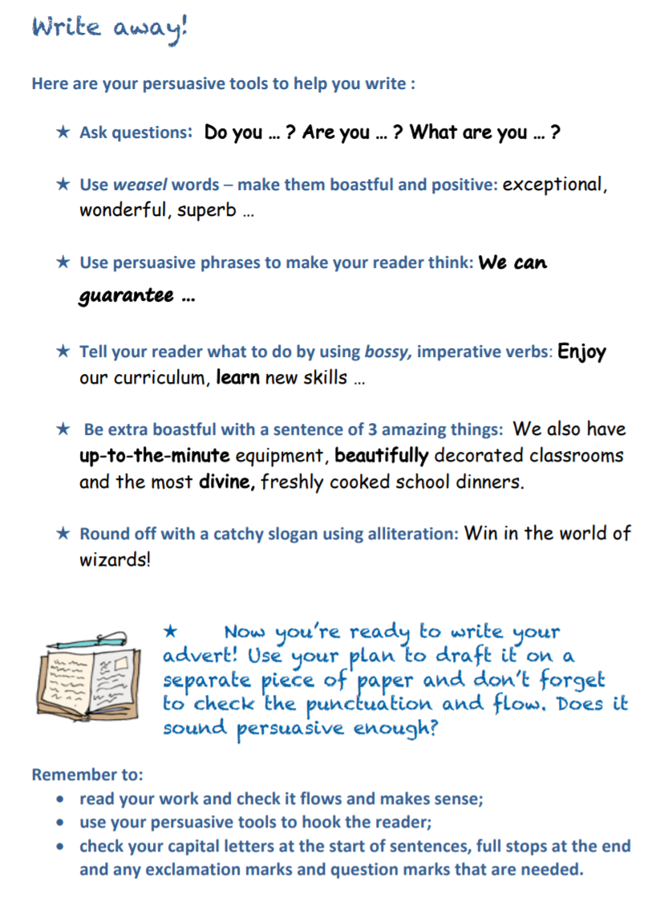

**Spellings:**

|  |  |  |
| --- | --- | --- |
| Mrs Wood’s group | Mrs Sloan and Mrs Valentine’s group | Mrs Wahl’s group |
| overthrow  overturn  overslept  overcook  overreact  overestimate  overuse  overpaid  overlook  overbalance | woman  wonder  month  brother  another  shovel  above  Monday  discover | still  learn  point  animal  listen  land  men  another  turn  air |

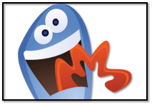

Spelling Strategy: **Saying the word in a funny way**

For example, pronouncing the 'silent' letters in a word

**Maths:**

**Flashback 4!**

This carroll diagram is used for sorting shapes. Which box would you put a circle in?

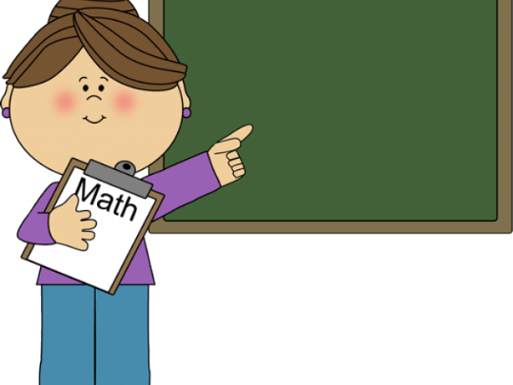

Maths

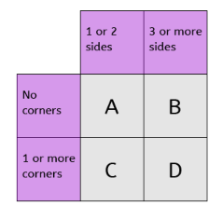

1. £32.06 + £27.19
2. 45200 ÷ 10
3. 9 x 7
4. ⅜ of 64

**WRH Summer Term Week 9 – decimals**

Look at the WRH website <https://whiterosemaths.com/homelearning/year-5/> Summer Term week 9 for all of the lessons on decimals. Each day you will find an easy to follow video tutorial with questions to work out. The children in year 5 have already done lots of work on decimals, so this will be useful revision for them. The worksheets can be found in the home learning area of the class page on the school website. Hard copies will also be available from the school office alongside the home learning.

Additional practice questions and worksheets can be found at the BBC Bitesize daily lesson website

<https://www.bbc.co.uk/bitesize/dailylessons>

When you have completed the lessons for the week, have a go at the 20 assessment questions on Professor Assessor. I will then be able to see how you are getting on.

**Science: Static Electricity**

Please look at the Oak Academy website for this week’s lesson on Static electricity.

<https://classroom.thenational.academy/lessons/what-is-static-electricity/>

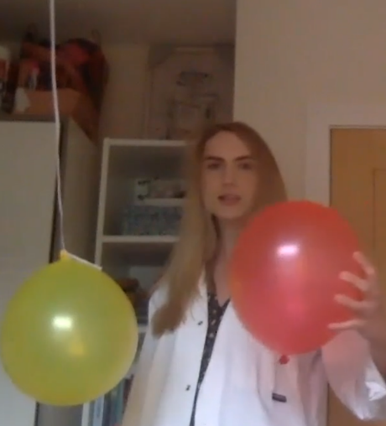If you would like to follow Miss Simkin’s demonstration, you will need 2 balloons and a piece of string

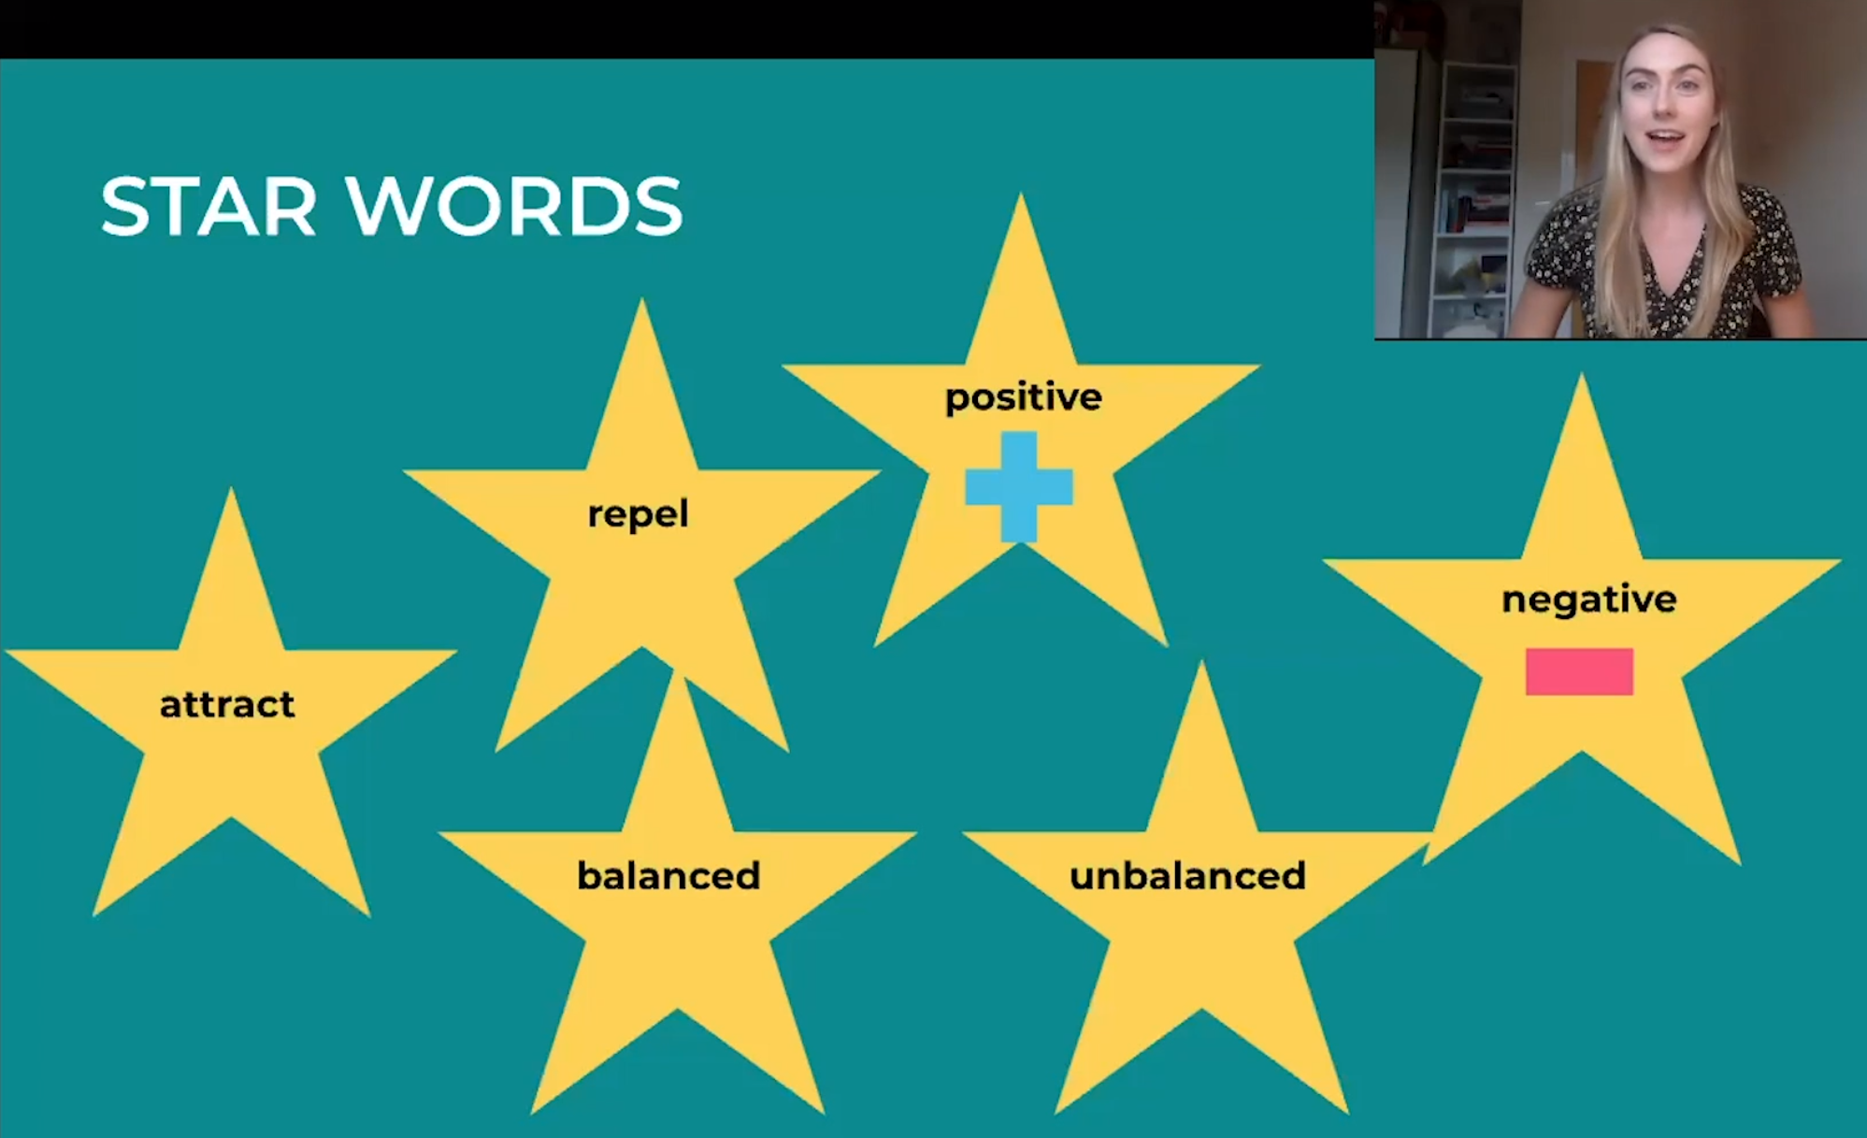

**Geography: Climate**

Look at the bbc bitesize website to find out about climate

<https://www.bbc.co.uk/bitesize/topics/z849q6f/articles/z7dkhbk>

## What is weather?

**Weather** is a description of what the conditions are like in a particular place. For example, it could be:

* hot or cold
* wet or dry
* windy or calm
* stormy, with thunder and lightning

## What is climate?

**Climate** is a description of the average weather conditions in a certain place for the past 30 or so years. Different areas of the world have different climates. Climate is influenced by lots of different things, including:

* how near or far it is from the Equator
* how near or far it is from the sea
* how high or low the ground is
* its position on a continent

## Climate change

The climate across the world has changed naturally over thousands and millions of years. In the past, the UK has experienced both freezing **ice ages** and warm **tropical** climates.

Today however, because people have been burning **fossil fuels** to power homes, factories and vehicles, more **carbon dioxide** has entered the Earth’s atmosphere.

Carbon dioxide acts like a **greenhouse**. It lets the sun’s rays through to heat up everything inside the atmosphere, but stops the heat from escaping. This is making our planet warm faster than it naturally would and is causing world climates to change.

Choose one of the following activities to investigate climate:

* Describe the climate in the UK
* Show climate zones on a world map and say what has a large impact on the UK’s climate
* Describe the relationship between distance from the equator and climate
* Explain the differences in climate between the UK and USA

**Art:**

Take a look at the Oak Academy website to try the circles lesson with Mrs Cara

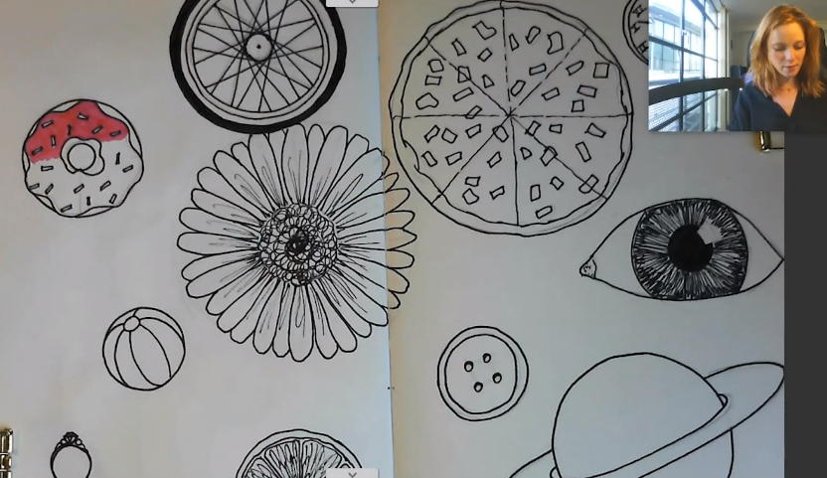<https://classroom.thenational.academy/lessons/the-circle-challenge/activities/1/>

**RE:**

The Baptism of Jesus

Building on from last week, we are going to think a little deeper about the Baptism of Jesus by John the Baptist.

**How do you think the Baptism affected Jesus? What did Jesus do immediately after his baptism? Look at Mark’s Gospel Ch1 v12-13. Why do you think he did this?**

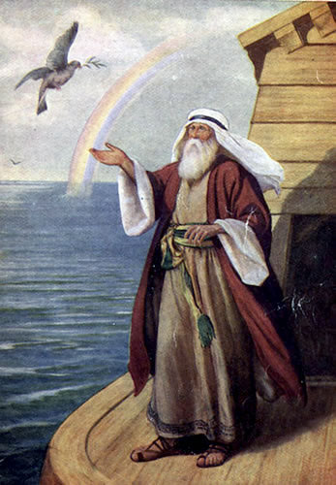**When a baby is baptised today the parents make promises. The Priest says something like this: “In asking for baptism for your child you are accepting responsibility for bringing him up in the practice of the faith. It will be your duty to bring him up to follow Christ's teaching, by loving God and our neighbour. Do you clearly understand what you are undertaking?” How can parents help a child understand what God is calling them to be? What should parents do?**

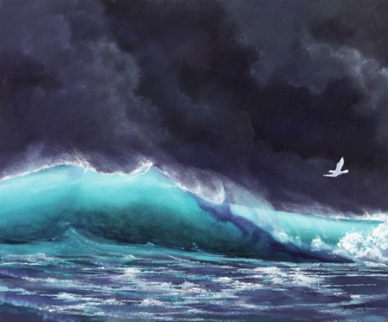**In the Bible the image of the spirit of God occurs many times. Look at these images. What event do you think they are describing?**

**In both cases something new is about to happen. What is that? When Jesus was baptised the Gospel writers talk about the spirit appearing. What is the new thing that will happen here? How will this change the world?**

**O Lord All The World Belongs To You**

1. **Read carefully the words of this hymn which is about God’s kingdom**

Lord all the world belongs to You

And You are always making all things new

What is wrong You forgive and the new life you give

Is what’s turning the whole world upside down

The world’s only loving to its friends,

But Your way of loving never ends

Loving enemies too and this loving with You

Is what’s turning the whole world upside down.

The world lives divided and apart

You draw men together and we start

In your body to see that in fellowship we

Can be turning the whole world upside down

The world wants the wealth to live in state

But You show a new way to be great

Like a servant You came and if we do the same

We’ll be turning the whole world upside down.

O Lord, all the world belongs to You

And You are always making all things new

Send your spirit on all in your Church whom You call

To be turning the world upside down.

**2. How does this hymn connect to the parable of the Tax Collector and the Pharisee?**

**3. According to the hymn how are we meant to live in the Kingdom?**

**4. Who is the Kingdom for?**

**5. Draw a picture to show on the one side how the world lives and on the other side how we should live in the Kingdom.**

**6. Write your own poem or hymn about the Kingdom or find examples from the news about the way the world lives/what the world thinks is important and the way Christians behave. Once you have your examples make a collage to show this. (You could look at Pope Francis as an example)**

**Languages/Music: Bonjour, Bonjour**

Learn to sing the song ‘Bonjour, Bonjour’. Can you find out what all the words mean in French?

<https://www.youtube.com/watch?v=atNkI6QFZ50&list=PL1s8C6MVDcSAxfUYr-0fWlBGzy8mhMwel>

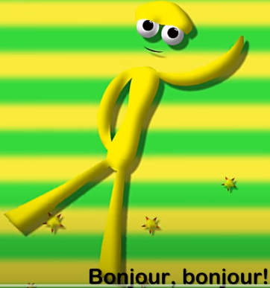

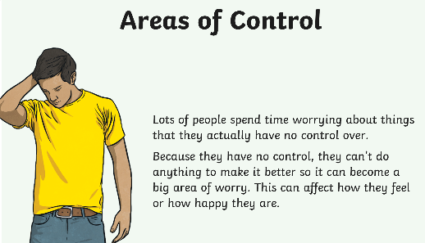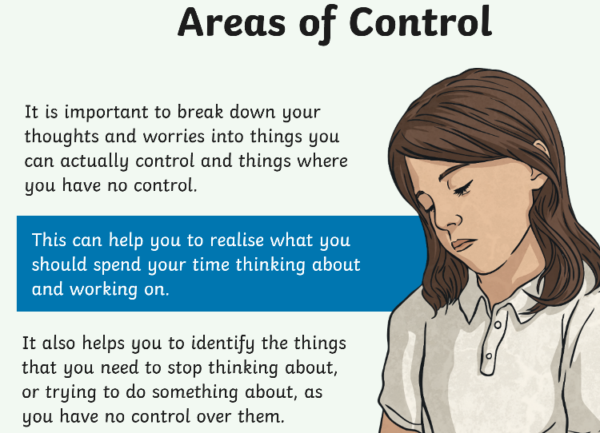**PSHE: Areas of Control**

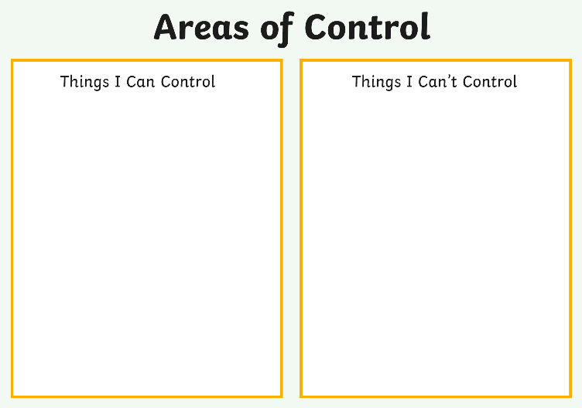

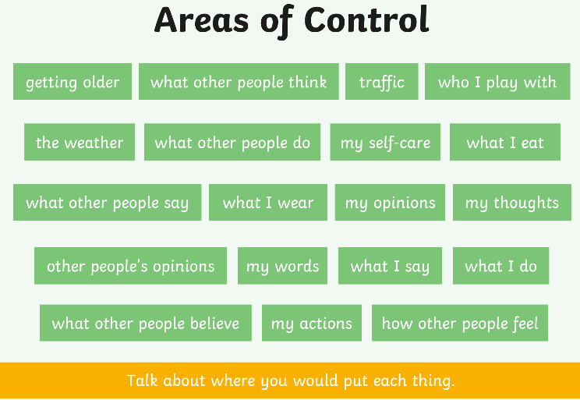

Perhaps you would like to write down your own thoughts and worries and place them into the chart of things that you can control and things that you can’t control. If you wanted to, you could talk with someone in your family or a friend about your ideas.