Home Learning
Year 5 – Summer Term 6 Week 2
8th June 2020

English

Reading Comprehension

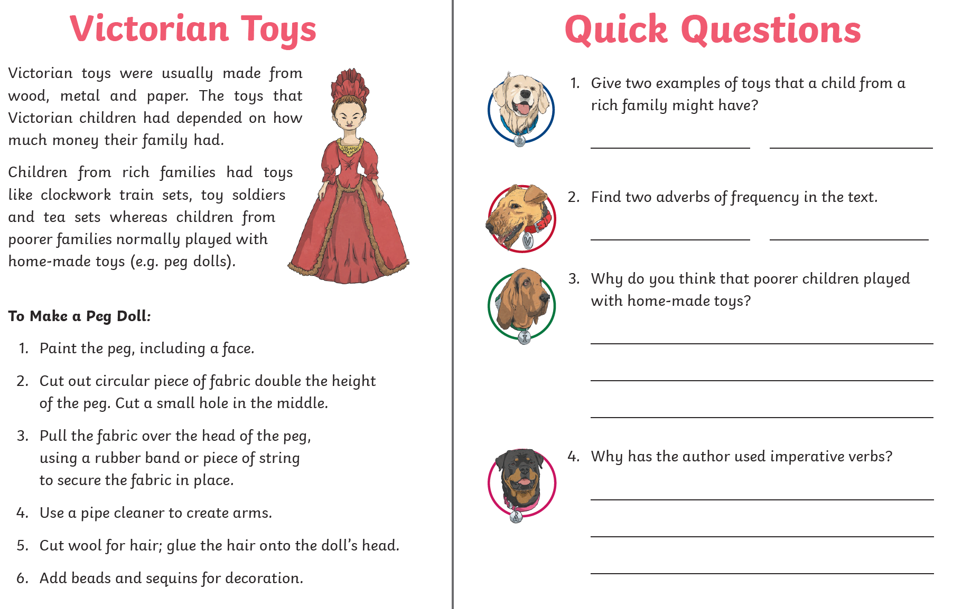

Writing – Free writing

This week I would like you to complete a piece of free writing. This could be a story, poem, newspaper article, letter, cartoon strip – anything that you would enjoy writing about.

Remember to check your work when you have finished and share it with a member of your family. Perhaps you could read it aloud, remembering to use expression in your voice.

Grammar: punctuation

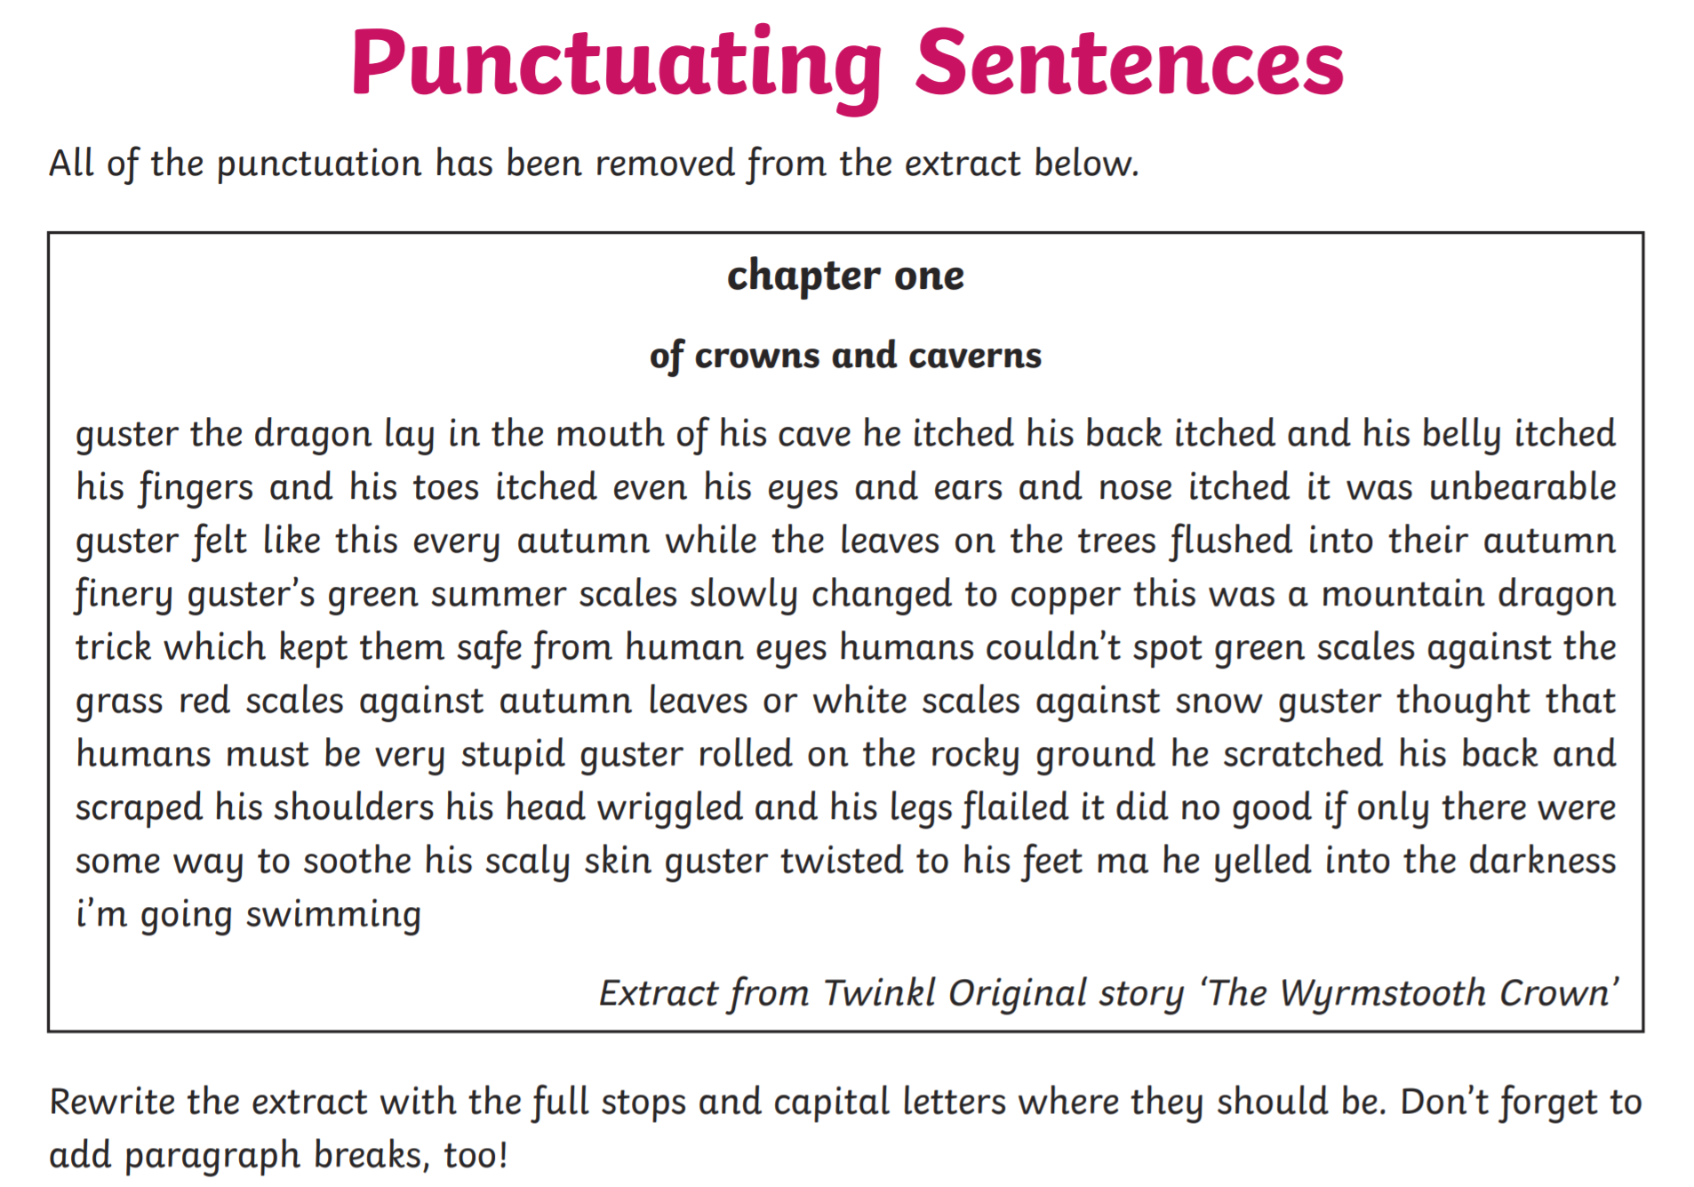


Spellings:
Mrs Wood’s group | Mrs Sloan and Mrs Valentine’s group | Mrs Wahl’s group
attractive  creative  addictive  assertive  co-operative  exhaustive  appreciative  offensive | instruct  instruction  construct  unit  union  united  universe  university | move  page  study  picture  here  need  such  well
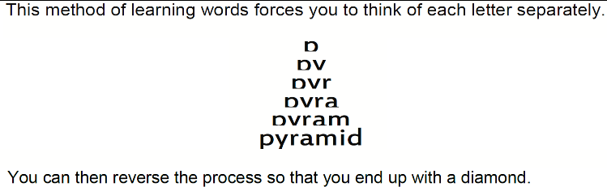
Spelling Strategy: Pyramid words

Maths:

Flashback 4!
What is the value of the Roman numeral?
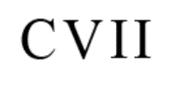
- 6405 - 3284

- 25% of 400

- 10000 - 150
Maths

- 25 x 31

WRH Sumer Term Week 7 – Decimals
Look at the WRH website https://whiterosemaths.com/homelearning/year-5/ Summer Term week 7 for all of the lessons on decimals. Each day you will find an easy to follow video tutorial with questions to work out. The children in year 5 have already done lots of work on decimals, so this will be useful revision for them. The worksheets can be found in the home learning area of the class page on the school website. Hard copies will also be available from the school office alongside the home learning.
Additional practice questions and worksheets can be found at the BBC Bitesize daily lesson website
https://www.bbc.co.uk/bitesize/dailylessons
When you have completed the lessons for the week, have a go at the 20 assessment questions on Professor Assessor. I will then be able to see how you are getting on.

Science: How do the rocks on our earth’s surface change?
Look at the Oak Academy website to find out about how the rocks on our earth’s surface change.
https://www.thenational.academy/year-5/foundation/how-do-the-rocks-on-our-earths-surface-change-year-5-wk5-3#slide-3
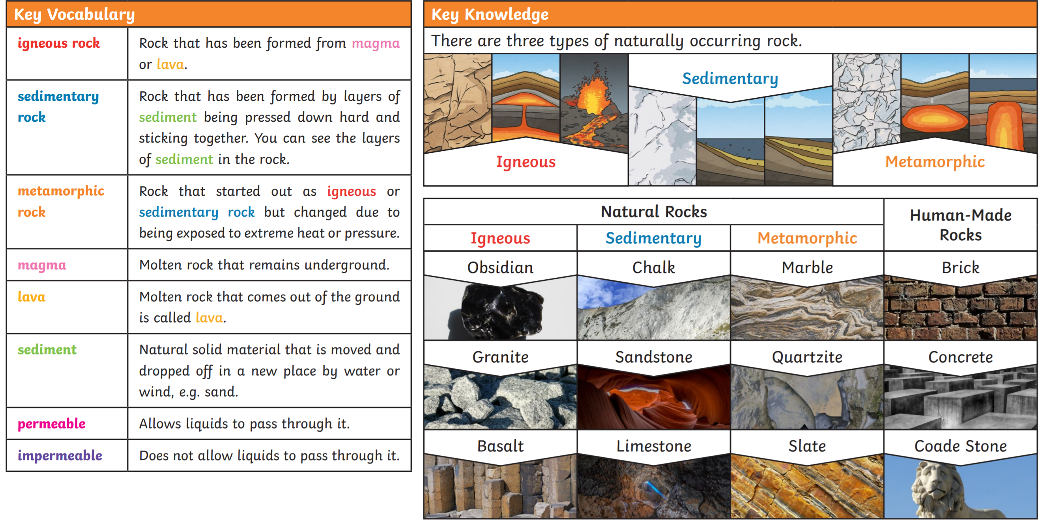
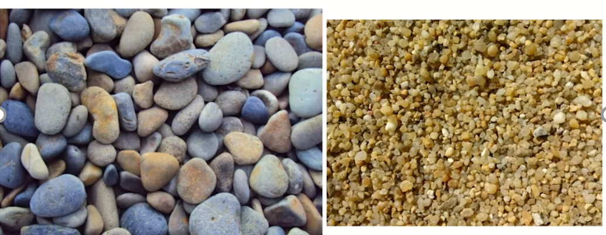

How do you think these pebbles and grains of sand were made?

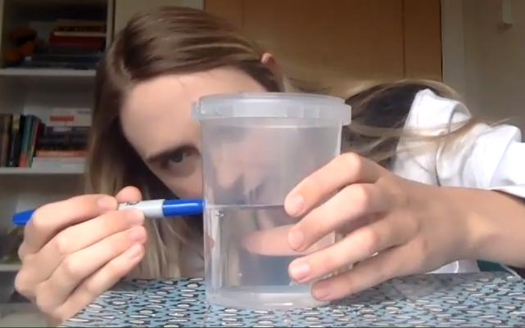
If you would like to follow Miss Simpkin’s demonstration, you will need a plastic container, some water and a permanent marker.
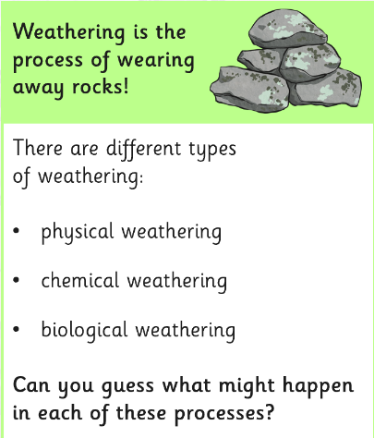

Draw arrows to match the different type of weathering with their description.

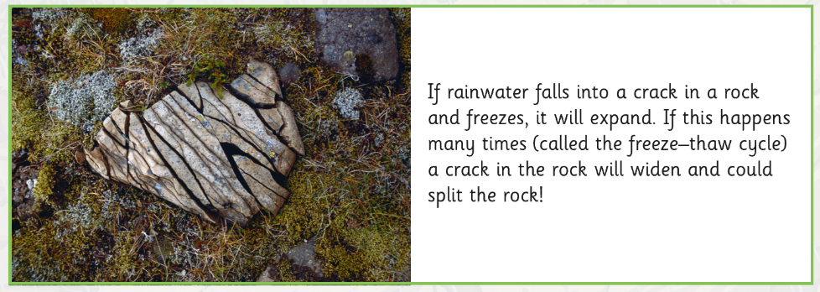
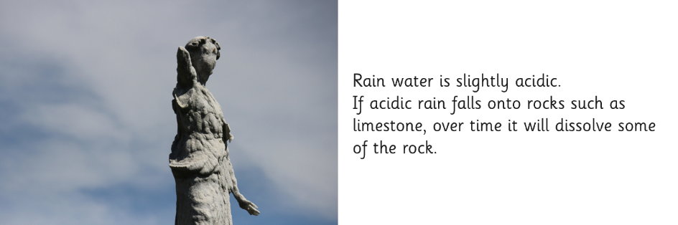
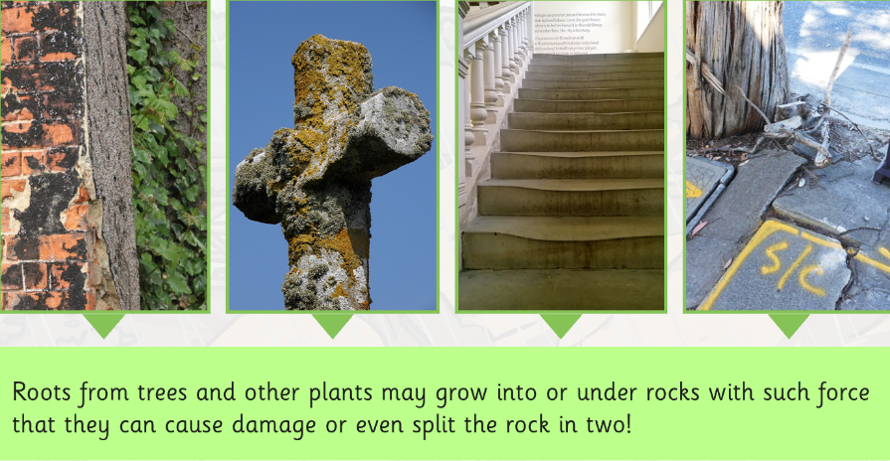
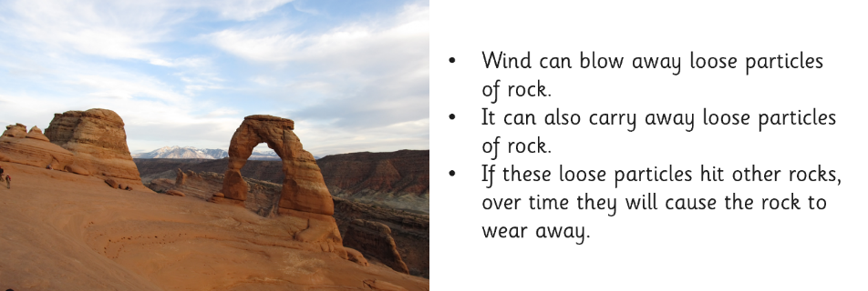

Biological weathering

Erosion

Physical weathering

Chemical weathering

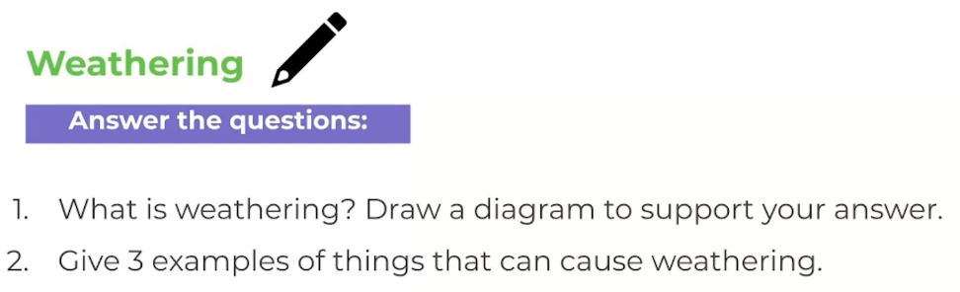

Geography:
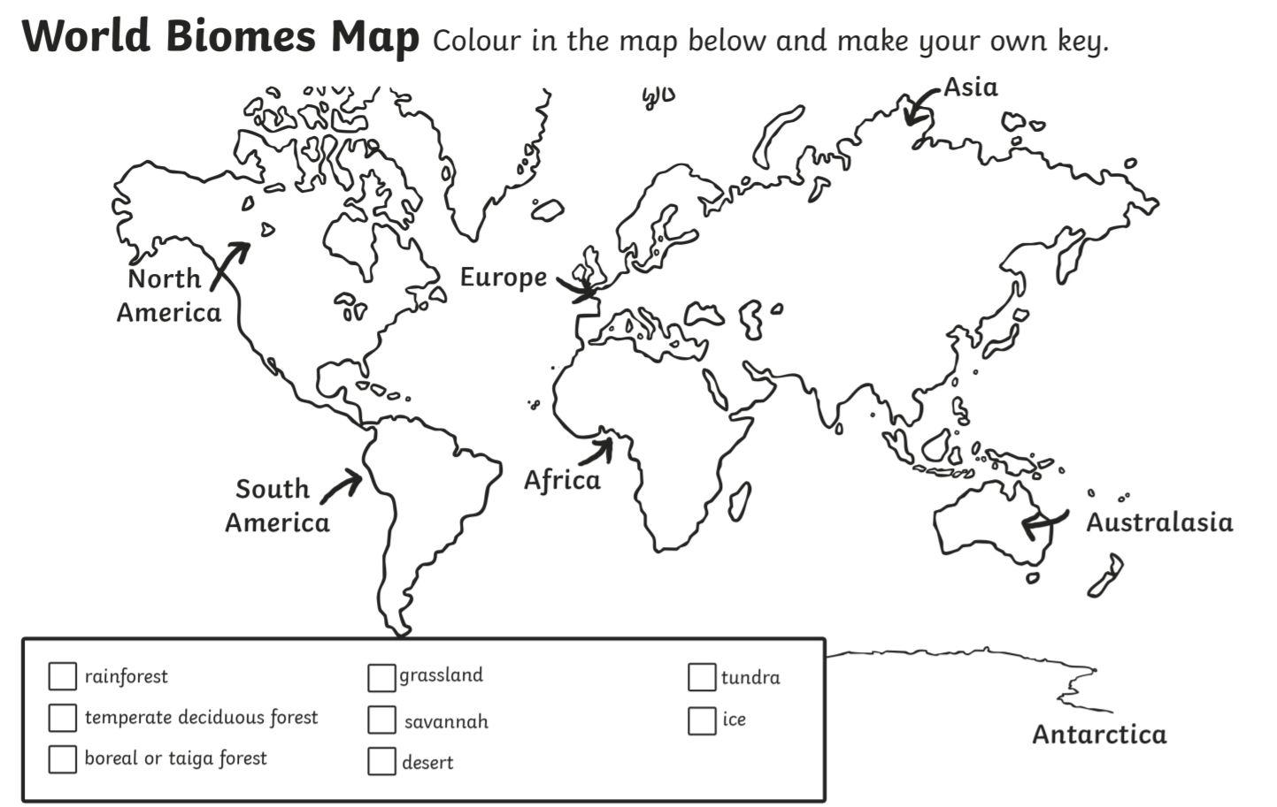
Learn about hot deserts (not hot desserts!) by reading this fact sheet.
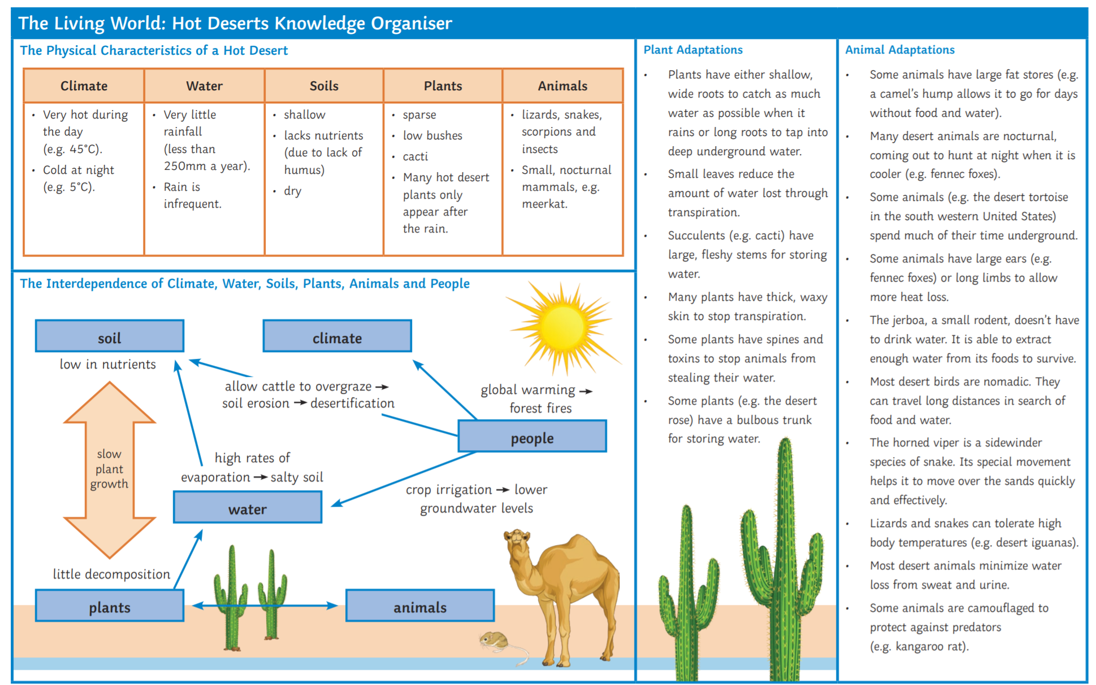

You have the next TWO weeks to complete your geography project.
Choose one of the biomes to write about. Think about what makes your biome unique and the types of plants and animals that live there as well as dominate weather patterns. As you gather information about the biome, take notes and think about how you can organize this information and put it into your own words. Pictures are encouraged to make your presentation interesting.
You will need to include:
1. The name of your biome (title page) which includes a short introduction to your project
2. The biome’s characteristics (climate, average temperature, average precipitation amounts, are there seasons?) and locations in the world (continents, countries)
3. 4-6 plants that are found in your biome. Choose one plant and describe how it has adapted to live in the biome.
4. 4-6 animals that are found in your biome. Choose one animal and describe how it has adapted to live in the biome.
5. Threats to the biome. Give some details to the threats (what are some causes/effects of the threats for example deforestation-destroying habitats.)
6. Why would someone want to visit this biome?
7. Pictures to include are: a map of the biome location, two plants you described, two animals you described, and one picture of the threat.

Science/Music
Learn to sing the ‘Rock Forms’ song by Mr Parr.
https://www.youtube.com/watch?v=0A5eeE93uEA
Sing the chorus nice and loud!

Art:
Design the title page for your geography project.
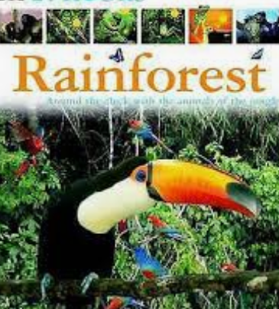

RE:
This week we will be looking at the symbolism attached to Pentecost. What Symbols for the Spirit are used in Acts Ch2? Now look up John’s Gospel Ch20 v19-23. What symbol is used here for the Spirit?
Holy Spirit of Fire by John Glynn
Holy Spirit of fire,
flame everlasting,
so bright and clear,
speak this day in our hearts.
Lighten our darkness
and purge us of fear,
Holy Spirit of fire.
The wind can blow or be still,
or water be parched by the sun.
A fire can die into dust:
but here the eternal Spirit of God
tells us a new world’s begun.
Holy Spirit of love,
strong are the faithful
who trust your power.
Love who conquer our will,
teach us the words
of the Gospel of peace,
Holy Spirit of love.
The wind can blow or be still,
or water be parched by the sun.
A fire can die into dust:
but here the eternal Spirit of God
tells us a new world’s begun.

The Spirit of God is referred to many times in the Bible. Look up the following passages: Matthew Ch3 v16, John Ch3 v5-8, Genesis Ch2 v7. What images are used here? Do you know or can you find any more passages in the Bible where it refers to God’s Spirit? The references all use different images to talk about the Holy Spirit.
Look at the words of the hymn by John Glynn - Holy Spirit of Fire. Can you identify all the symbols of the Spirit?
Try to write your own song about the work of the Spirit.


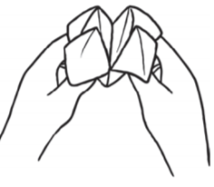
Languages: weather
Make this French weather fortune teller.

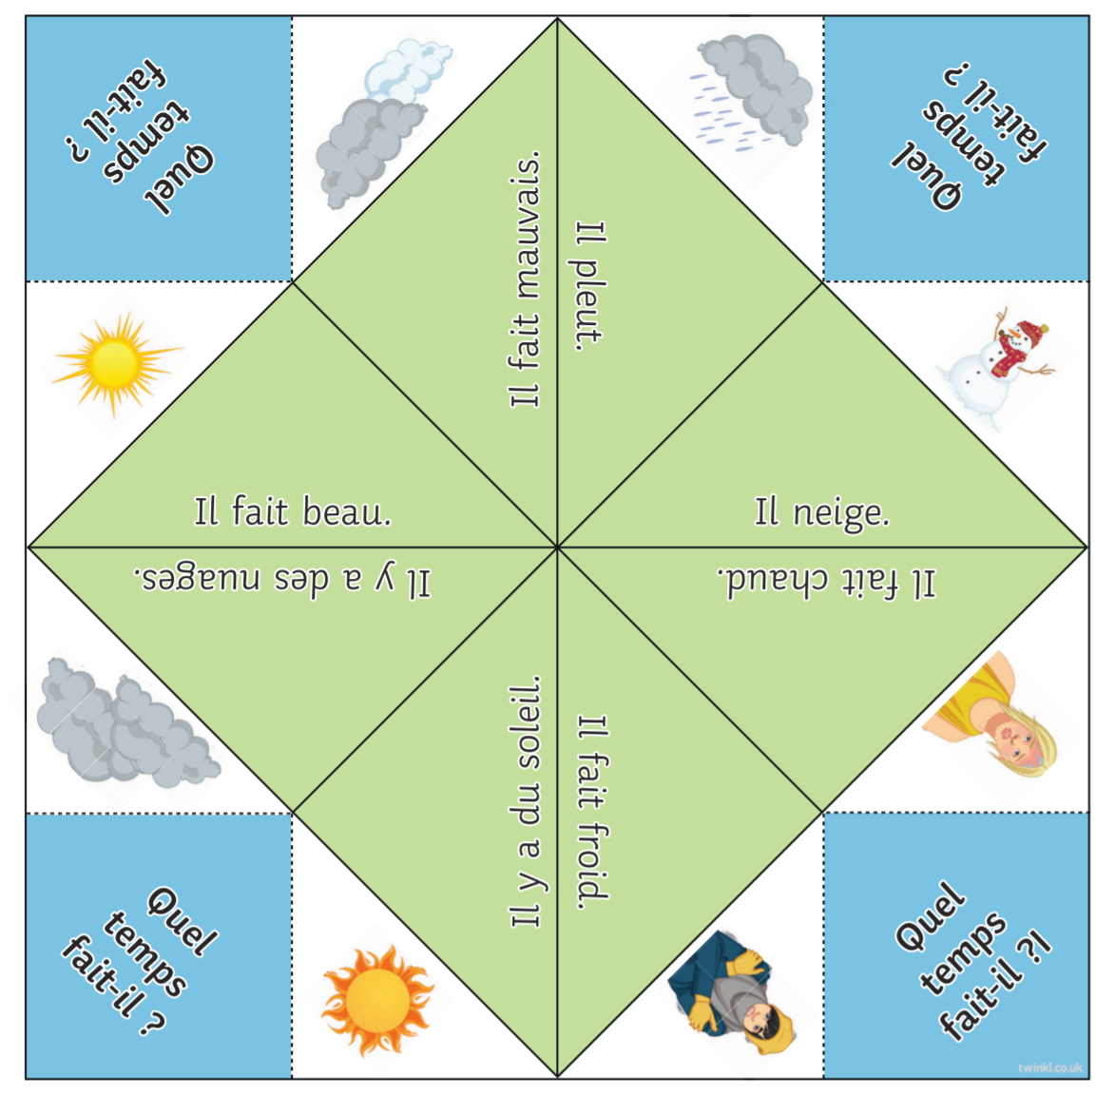

PSHE: Wellbeing
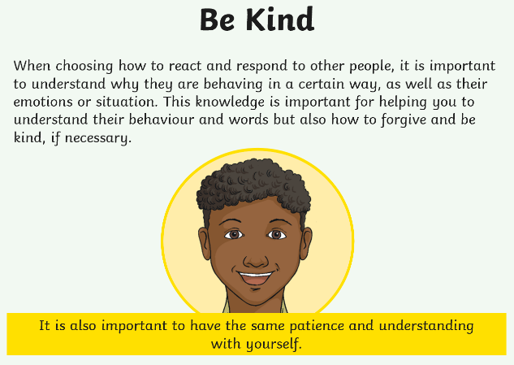
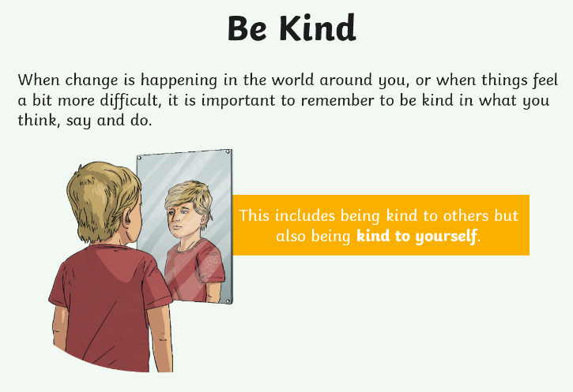

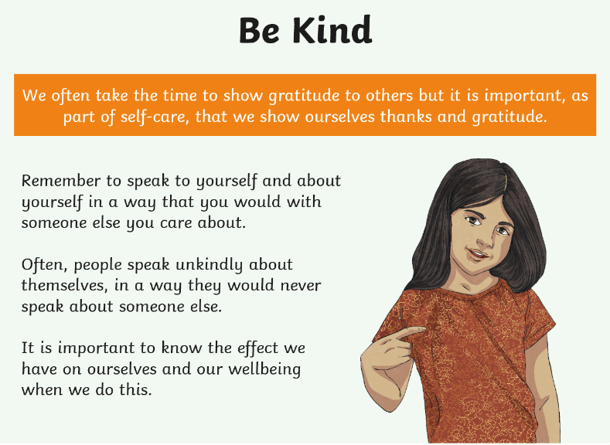









Times Tables:
- Login to Professor Assessor to practise your times tables.

PE
- Visit The Body Coach TV YouTube channel each morning at 9am as he will be providing a live PE at home lesson.
https://www.youtube.com/channel/UCAxW1XT0iEJo0TYlRfn6rYQ

Mindfulness
- Need a time out? Go online to Cosmic Kids Yoga and follow a guided relaxation video @ https://www.youtube.com/user/CosmicKidsYoga

