**Home Learning**

**Year 5 – Summer Term 6 Week 3**

**15 th June 2020**

# Reading Comprehension

# 

# Writing – Wonderful Wizards

# Have a look at the Talk for Writing website for all of the plans on this unit of work. <https://www.talk4writing.com/wp-content/uploads/2020/06/Y5-Wizards.pdf>

# If you are unable to download the full resource pack, here are some ideas to get you started.

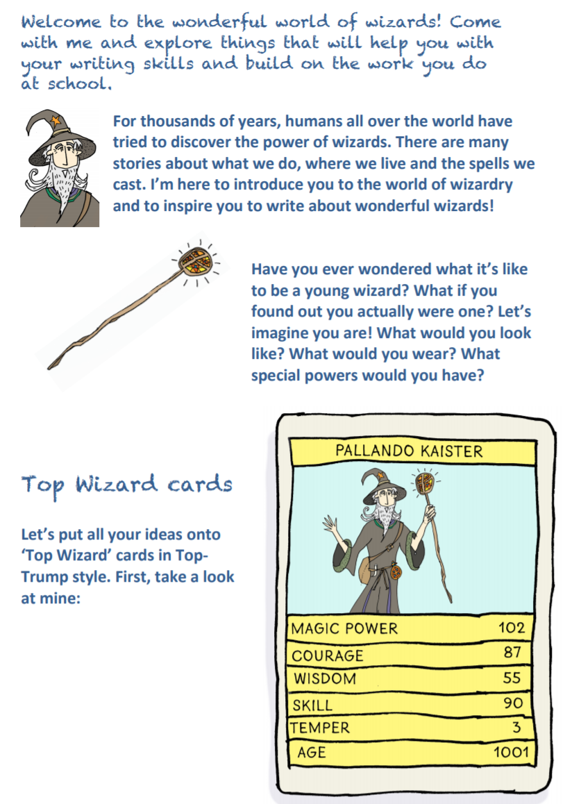

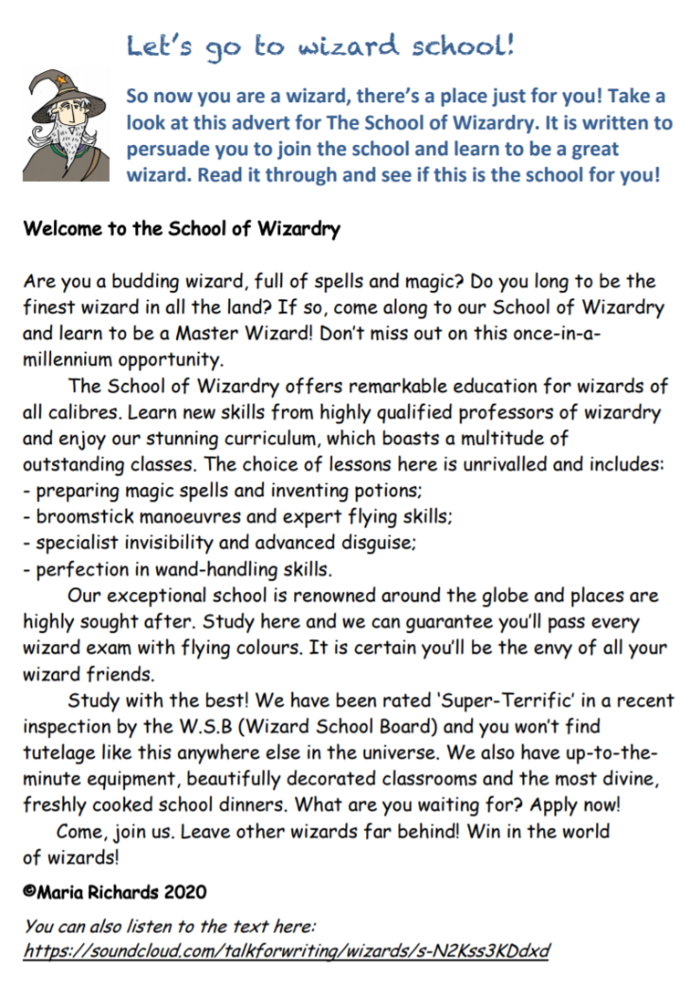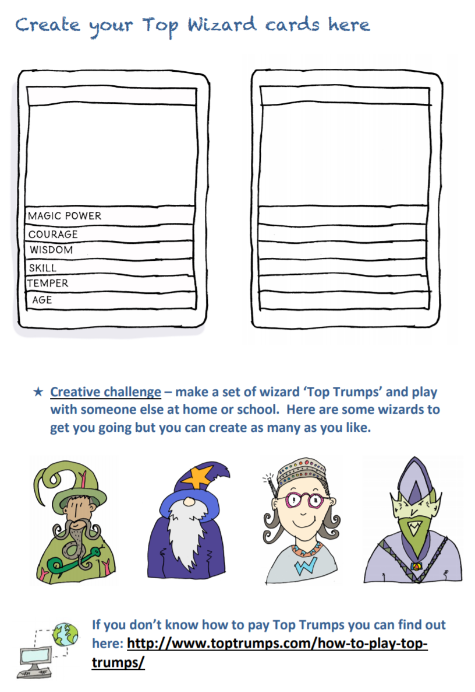

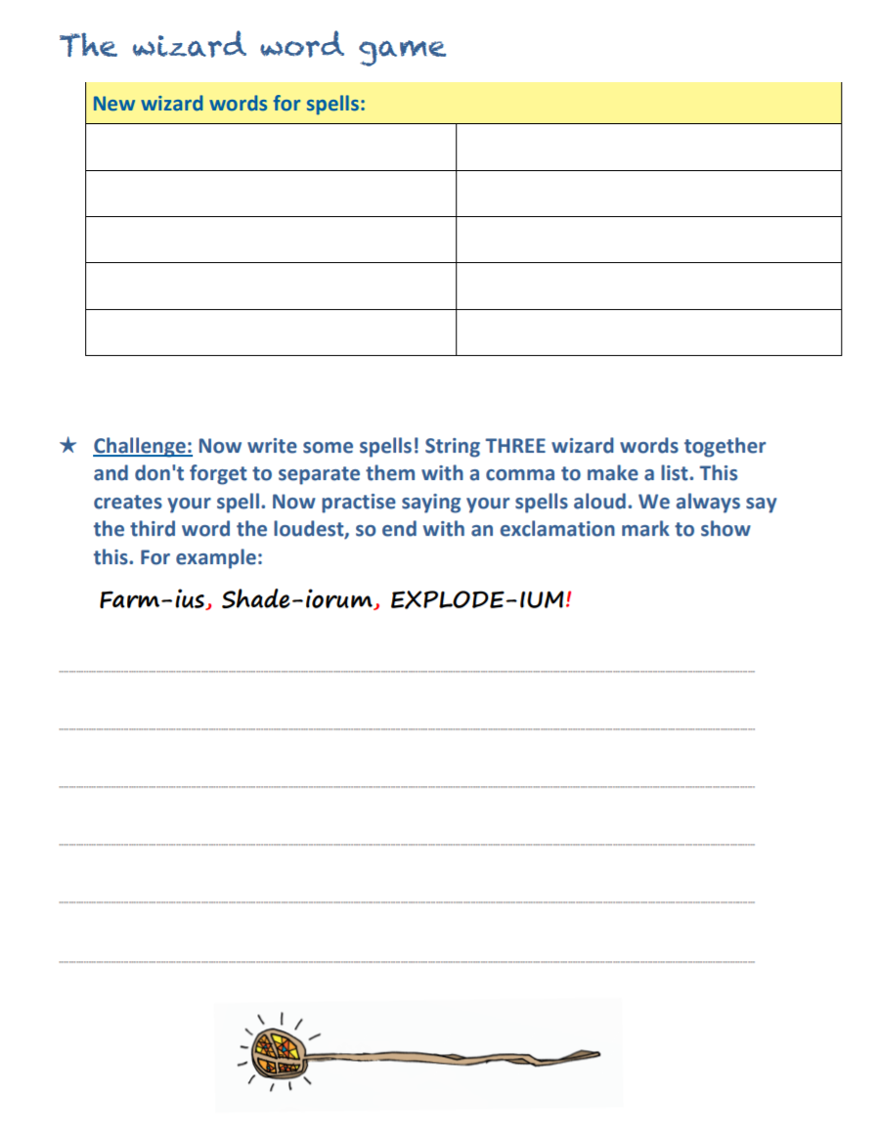

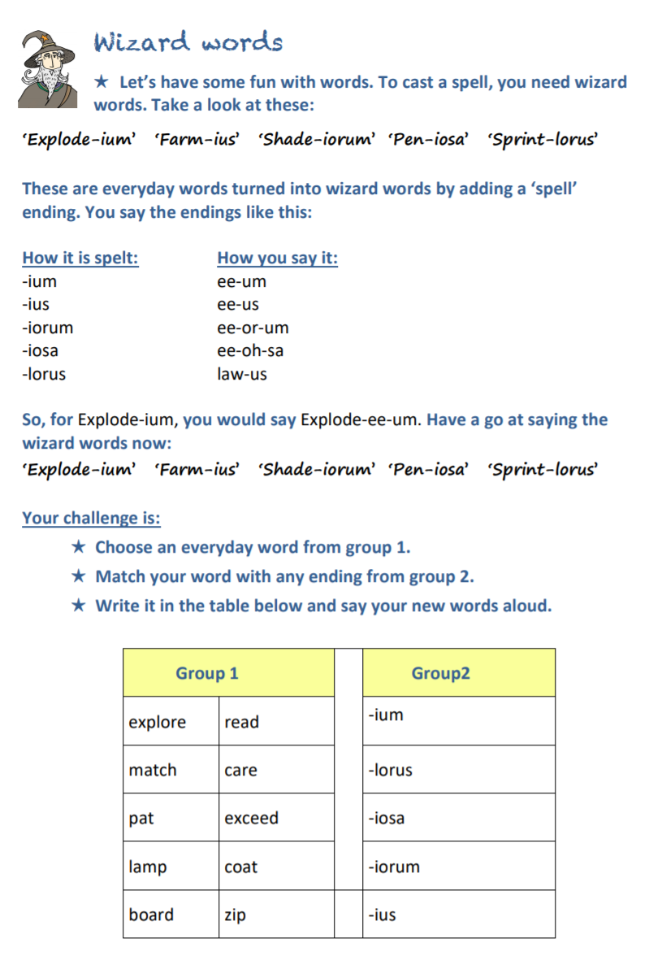

**Spellings:**

|  |  |  |
| --- | --- | --- |
| Mrs Wood’s group | Mrs Sloan and Mrs Valentine’s group | Mrs Wahl’s group |
| referring  referred  referral  preferring  preferred  transferred  transferring  transferral | enough  young  touch  double  trouble  country  courage  rough  tough | move  page  us  study  picture  here  need  such  well |

Spelling Strategy: clapping and counting to identify the syllables in the word.

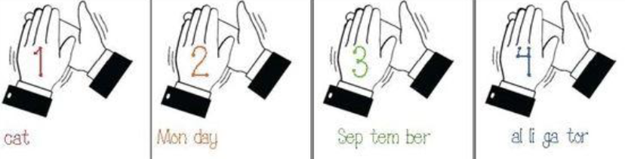

**Maths:**

**Flashback 4!**



Maths

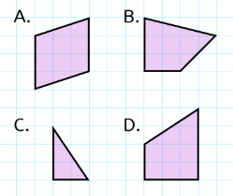

Which shape has no right angles?

1. 1 – 0.6
2. 362 x 1000
3. £46 + £32.50 + £0.62
4. ⅛ of 240

**WRH Summer Term Week 8 – percentages**

Look at the WRH website <https://whiterosemaths.com/homelearning/year-5/> Summer Term week 8 for all of the lessons on percentages. Each day you will find an easy to follow video tutorial with questions to work out. The children in year 5 have already done lots of work on percentages, so this will be useful revision for them. The worksheets can be found in the home learning area of the class page on the school website. Hard copies will also be available from the school office alongside the home learning.

Additional practice questions and worksheets can be found at the BBC Bitesize daily lesson website

<https://www.bbc.co.uk/bitesize/dailylessons>

When you have completed the lessons for the week, have a go at the 20 assessment questions on Professor Assessor. I will then be able to see how you are getting on.

**Science: What are the steps in the rock cycle?**

Please look at the Oak Academy website for this week’s lesson on the steps of the rock cycle.

If you would like to follow Miss Simkin’s demonstration, you will need some jelly beans, tinfoil, a small container, honey, flour and a pan of boiling water. Please ask an adult to supervise and help you with your experiment. It looks like brilliant messy fun this week and I think that you are allowed to eat some of the jelly beans!

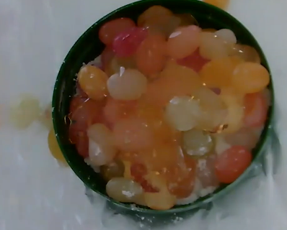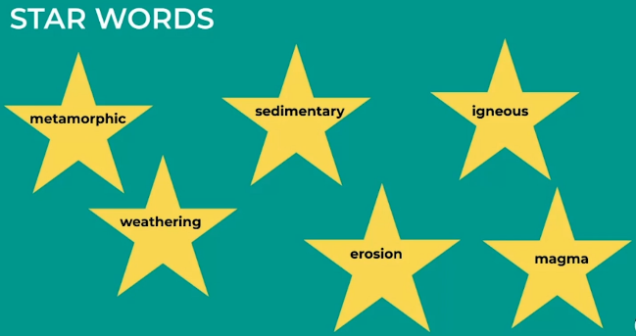

If you are unable to watch Miss Simkin’s video, perhaps you would like to draw your own diagram of the rock cycle.

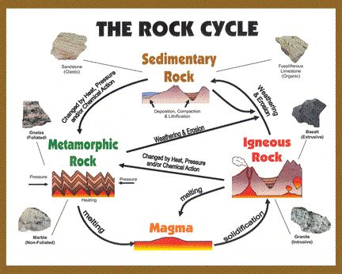

**Geography:**

Please continue to work on your 2 week Biomes project.

Choose one of the biomes to write about. Think about what makes your biome unique and the types of plants and animals that live there as well as dominate weather patterns. As you gather information about the biome, take notes and think about how you can organize this information and put it into your own words. Pictures are encouraged to make your presentation interesting.

You will need to include:

1. The **name of your biome** (title page) which includes a short introduction to your project  
2. The **biome’s characteristics** (climate, average temperature, average precipitation amounts, are there seasons?) and locations in the world (continents, countries)  
3. 4-6 **plants** that are found in your biome.  Choose one plant and describe how it has adapted to live in the biome.

4. 4-6 **animals** that are found in your biome.  Choose one animal and describe how it has adapted to live in the biome.  
5. **Threats to the biome**.  Give some details to the threats (what are some causes/effects of the threats for example deforestation-destroying habitats.)  
6.  Why would someone want to visit this biome?  
7. **Pictures** to include are: a map of the biome location, two plants you described, two animals you described, and one picture of the threat.

**Art:**

Carefully draw the illustrations for your Biomes project. Perhaps you could colour them with watercolour paints, pencil crayons, sketching pencils or felt pens.

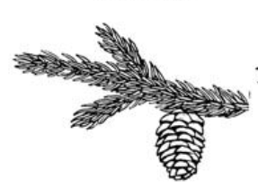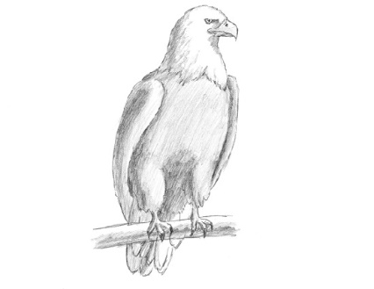

**RE:**

The Baptism of Jesus

This week, we are going to explore one of the most significant moments in the life of Jesus – His baptism. Watch the account by John from the film Jesus of Nazareth (available from YouTube at <http://www.youtube.com/watch?v=_CVXBCfdrF8> )

**The Baptism of Jesus as described in Matthew’s Gospel**

In those days John the Baptist came, preaching in the wilderness of Judea and saying, “Repent, for the kingdom of heaven has come near.” This is he who was spoken of through the prophet Isaiah:

“A voice of one calling in the wilderness,  
‘Prepare the way for the Lord,  
make straight paths for him.’

John’s clothes were made of camel’s hair, and he had a leather belt around his waist. His food was locusts and wild honey. People went out to him from Jerusalem and all Judea and the whole region of the Jordan. Confessing their sins, they were baptized by him in the Jordan River.

John said, “I baptize you with water for repentance. But after me comes one who is more powerful than I, whose sandals I am not worthy to carry. He will baptize you with the Holy Spirit and fire.”

Then Jesus came from Galilee to the Jordan to be baptized by John. But John tried to deter him, saying, “I need to be baptised by you, and do you come to me?”

Jesus replied, “Let it be so now; it is proper for us to do this to fulfil all righteousness.” Then John consented.

As soon as Jesus was baptized, he went up out of the water. At that moment heaven was opened, and he saw the Spirit of God descending like a dove and alighting on him. And a voice from heaven said, “This is my Son, whom I love; with him I am well pleased.”  
**How does this account differ from the video?**   
**What questions do you have?  
How is Mathew trying to show that Jesus was special?   
What does he claim about Jesus in the account?**

* 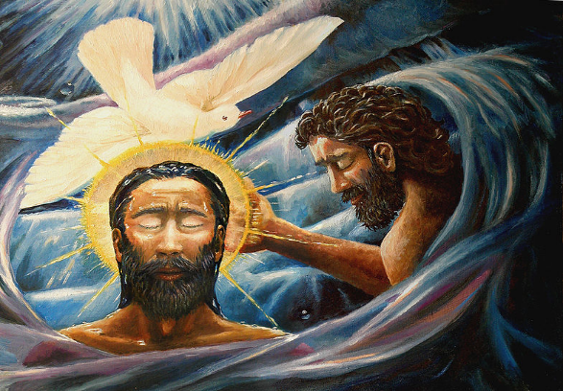Look at the painting. **Do you like the picture?** Give a reason for your answer. **Do you think it portrays the baptism of Jesus accurately?**   
  **The artist is trying to show Trinity. What do we mean by Trinity?  
  How does the artist show Trinity?   
  Can you think of another example from the Gospels where the writer says a voice from heaven was heard?**
* 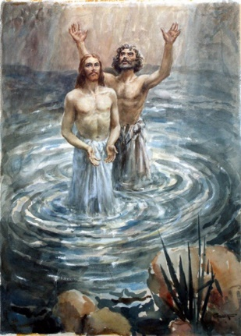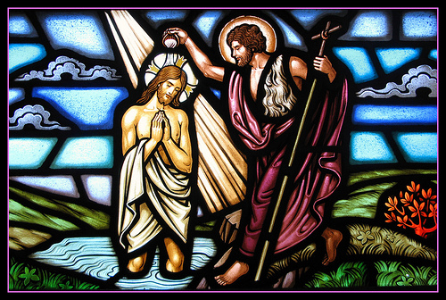In these pictures there is no dove. **How do the artists show something special is taking place?** *(Think about colours, light and gestures).* If you were to draw the scene how would you draw it to show  
   a) Jesus as Son of God and b) Trinity
* **Do you think people around Jesus heard a voice from heaven?** *(Think about this carefully if you heard a voice from heaven what would your reaction be?)*
* Create your own piece of artwork showing the baptism of Jesus, showing what you think is important about the event.

**Languages: First conversations**

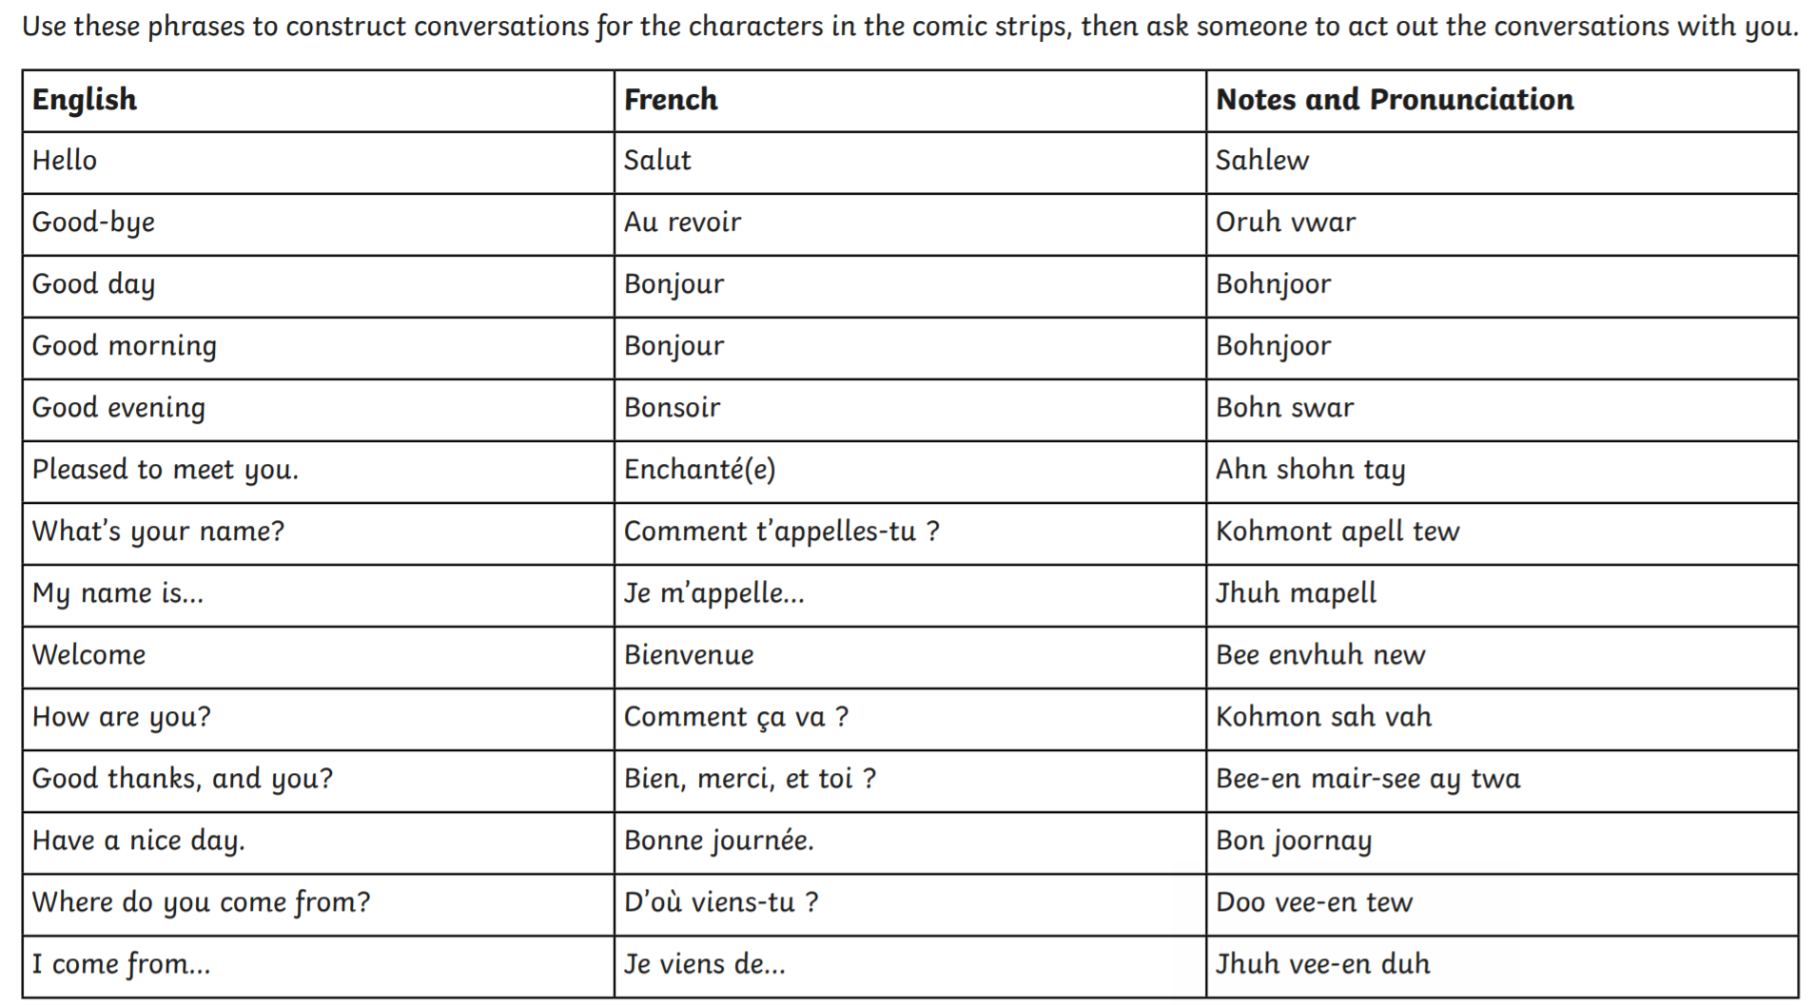

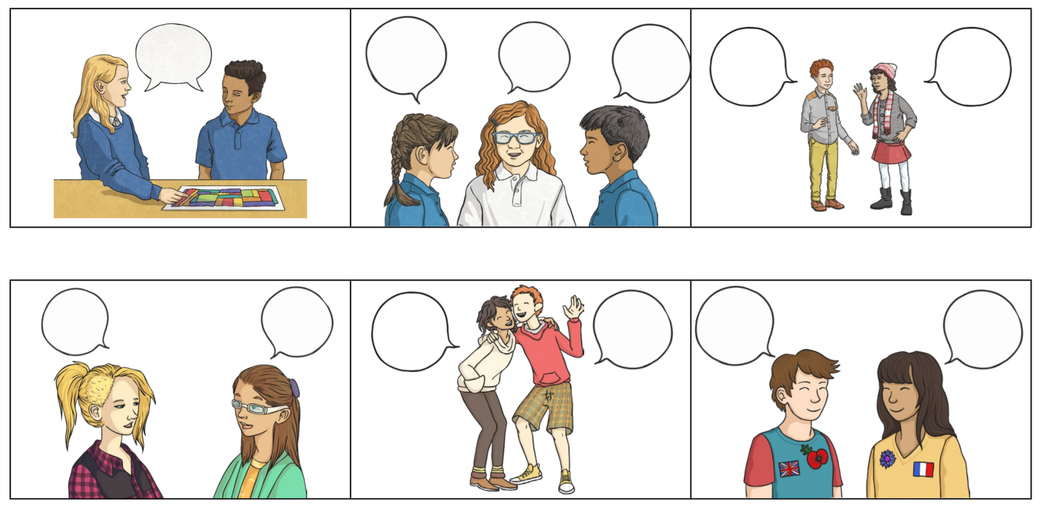

**PSHE: Positive Mindset**

