**Home Learning**

**Home Learning – Lockdown Challenge**

**Year 5: Term 6 Week 7 – 13th July 2020**

1. **Music / Drama / Dance Activity**

Listen to a piece of music and draw a picture of how it makes you feel. Perhaps you could move your pencil to the sounds that you hear with your eyes closed and then see what sort of picture you have created.

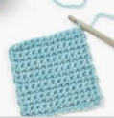

1. **Creative Activity**

Have a look at the video tutorials on our class page and see if you can make a pet pocket monster. You could use crotchet, knitting or sewing to create your monster.

1. **Social / Emotional Activity**

Could you create your own coat of arms? Have a look on our website, go to the COVID tab and then select ‘Resources’. This will take you to a template and PowerPoint which tells you in more detail how to complete this challenge.

1. **Physical Activity-**

Don’t forget to take part in 'The Rainbow Games' for our virtual Sports Day. You can find them in the Covid 19 News tab on the school website. Please send in your score sheet when you have finished so that your points can be added to your house total. Green bubble had great fun completing the challenges today!

Dear God

We thank you for our friends and for the happy times we share with them. Help us to be a good friend to them. Teach us how to play fairly and to share. Help us to recognize loneliness in others and show friendliness towards them. We know that you are our friend and will be with us always.

**Amen.**

1. **Spiritual / Reflective activity**

Think about the qualities that make a good friend. Write the word FRIENDS down the side of a piece of paper and see if you can write an acrostic poem.

1. **Supporting the Community Activity**

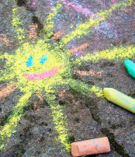Chalk your walk – brighten someone’s day by creating a fantastic chalk drawing outside your house on the pavement. If there isn’t a safe space to do this, draw a picture and put it in your window.

1. **Reading to Relax**

Don’t forget to sign up for the Summer Reading Challenge! <https://www.youtube.com/watch?v=CBLXTwXf4gs>

