The tropical Rainforest Biome

Rainforests are described as the lungs of the world. The rainforest biome is a vast expanse of humid area across the world. There are many different rainforests on earth, and all have different species of animals, insects and plants that live there. Rainforests cover 6% of the earth.

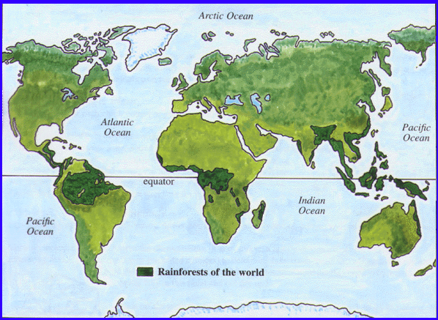

Rainforest characteristics

Rainforests are normally very humid. 50 to 160 inches of rain falls yearly. Rainforests belong to the tropical wet climate group. The temperature rarely rises higher than 34oC and drops lower than 20oC. Average humidity is between 77 and 88%. Tropical rainforests do not experience the seasons that we have in Britain. Instead they have dry and wet season. The dry season is noticeably drier than the average humid climate, and the wet season is noticeably wetter than the average humid climate. Both vague seasons last for approximately 6 months. Rainforests are found all around earth, and some main ones are; the amazon rainforest (Brazil, South America), the rainforests of central America (south of Mexico and USA), the Madagascar rainforest and the rainforests of southeast Asia. Almost all of the rainforests lie near the equator.

Rainforest plants

The worlds tropical rainforests are home to an incredible number of plant species. The amazon rainforest alone is home to around 40,000 different types of plant. A hot humid climate provides perfect conditions for plant life. However, with only 2% of sunlight reaching the forest floor and so many plants desperate to reach the canopy, there is competition for a place at the top. Different plant species have different strategies to reach the light, yet climbers have proven the most successful. When an old tree falls, it is a once in a lifetime chance to earn a place in the sun. all the plants below will suddenly begin to grow very rapidly, and in less than 2 months the gap will be re-filled once more. Some of the main plants that thrive in the rainforest are strangler figs, heliconia, silk cotton trees, orchids, mangrove reeds and kapok trees. A specific plant type called epiphytes lives on other plants. They don’t have roots in the ground and have various strategies for obtaining water and nutrients. One tree can be home to many different epiphyte species and can weigh up to a tonne. One particular type of fungi (Ophiocordyceps unilateralis) feeds on ants and other insects by infecting the brain, causing the unfortunate ant to feel disoriented and climb upwards. Once the other ants in the colony notice that the ant has been infected, they will move the infected ant far away from the colony, so that it doesn’t infect other ants. Once the infected ant is dead, the fungi will emerge from it’s head. There are different types of fungi for each insect species.

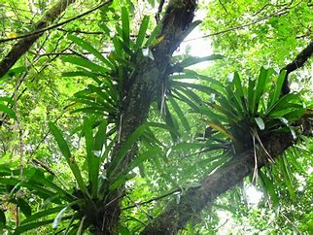

Rainforest insects

Rainforests cover 6% of the earth’s surface, and yet nearly half of the worlds animals and insects live there. In addition, it is thought that there are still millions of species to be discovered. more insects than animals have been discovered so far in the rainforest. The amazon rainforest may house up to 2.5 million species of insect, although only a tiny fraction of this number has been described by scientists. 90% of the amazon rainforest is made up of insects, and 30% is just ants. Experts predict that there may be 30 million different species on earth, and the majority of them are found in the tropical rainforests. One of the most famous ant species is the army ant, which can be found living in colonies of 600,000.

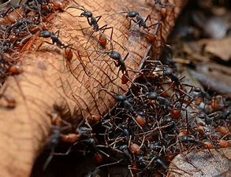

Rainforest animals

Many animal species also live in tropical rainforests. Different animals live in the different layers of the rainforest: Anteaters live on the forest floor, tree frogs live in the understory layer, howler monkeys live in the canopy layer and harpy eagles live in the emergent layer, to list a few. Some animals have adaptions that enable them to eat food that other animals can’t. For example, parrots have strong beaks to crack nuts open

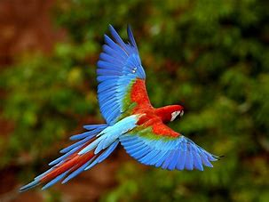

Rainforest threats

We are losing earth’s greatest biological treasures just as we are beginning to appreciate their true value. Rainforests used to cover 14% of the earth, but now they only cover a mere 6%. With one and a half acres (around the size of a football pitch) of rainforest being lost every second due to our human demands, experts predict that the remaining areas of rainforest could be consumed in less than 40 years. The forest is being destroyed by timber companies, logging industries and greedy landowners who only value the rainforest for it’s money-making materials. Almost half of the world’s plants, animals and microorganisms thrive in the forest, and deforestation could destroy them. Experts estimate that we are losing 137 plant, animal and insect species every day due to rainforest deforestation, which leads to 50,000 a year. As the rainforest disappears, so do many potential cures for life-threatening diseases. Currently 121 rainforest originated potential cures have been found for numerous illnesses. While 25% of western pharmacists rely on rainforest originated medicines, less than 1% of the plants and trees in the rainforest have been tested by scientists. Around 10 million Indians were living in the Amazon rainforest 5 centuries ago, whereas now there are less than 200,000. As their homeland is destroyed, so are the people living there.

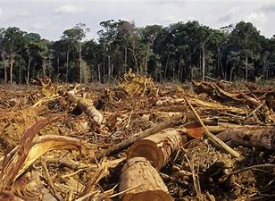

By Frieda Pearce