**Home Learning**

**Year 5 – Summer Term 5 Week 1**

**20th April 2020**

Dear Parents and Children,

I hope that you are all well and have had an enjoyable Easter. I wonder if you did any fun Easter activities during your time at home.

You will find below your first week of home learning for the Summer term which includes activities for maths and English and also learning tasks across the curriculum. Spellings have been set for each group so that you can still follow the same spelling programme. If you have access to the internet, there is a fantastic website resource for maths called White Rose Hub. This is the scheme that the school follows for maths so the children should recognise the same style of questions. Each day there is a video tutorial for parents and children to follow with additional questions to practice. If your child finds the maths concepts and questions too tricky, please take a look at the year group below.

Home Learning answers will be available to look at on the class page of the school website on Friday.

If you have any questions or queries, please contact me by emailing the school office and I will reply by email.

Kind regards

Mrs Wood

**Reading:**

Either…

Find a book that you would like to choose for your new reading book. Look at the front cover of your book and make a prediction on what you think the book will be about.

or

Choose a book that you have recently read. Write an alternative blurb for the book, summarizing the key events, to give readers an idea of whether they would like to read the text.

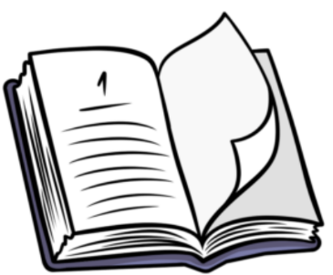

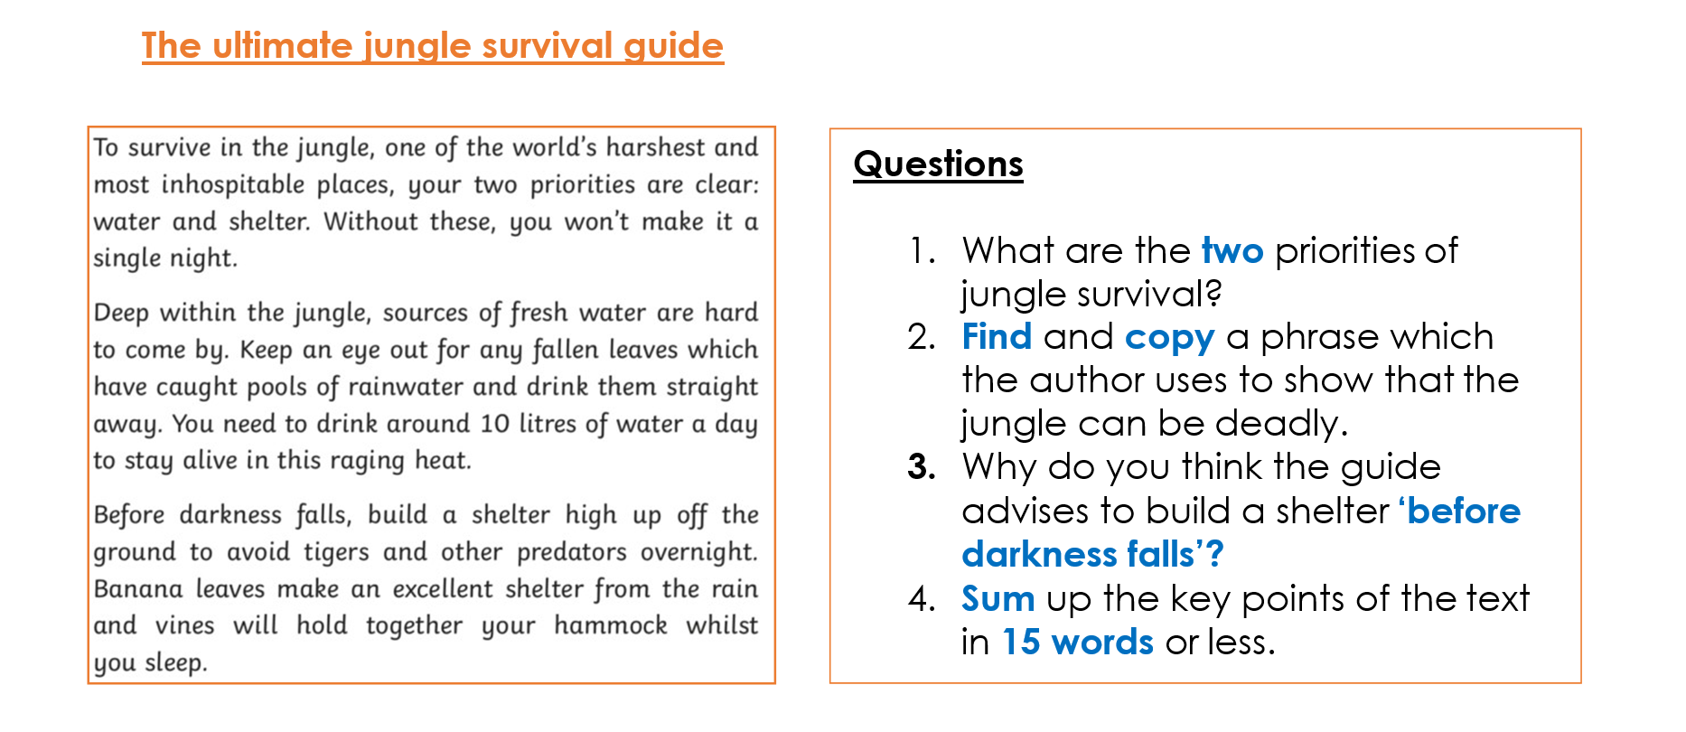**Comprehension:**

Complete the comprehension questions for the text below

**English:**

**Grammar – expanded noun phrases**

Have a go at the questions below; can you identify the noun phrases in each?

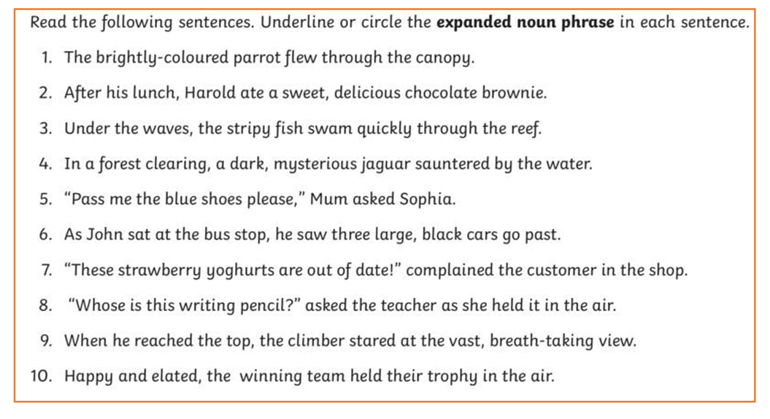

# Suspense writing

How to create suspense-

Here is a short piece of suspense writing. Read through it and think about what makes you feel suspenseful and tense whilst reading it.

Some of the features are:

* **simile and metaphor;**
* **Show, don’t tell**
* **short, snappy sentences;**
* **using sentences that appeal to the senses.**

*She arrived at the door and everything went cold. Her skin tightened. Her eyes were wide. Her palms were sweaty. Above her head, the trees stood like dark giants of impending doom looming over her with many reaching arms.*

*A loud rustling broke the silence and a smell like damp wood filled her nostrils. She lifted her hand to knock on the door, but before she could touch it, it creaked open.*

Use the features of a suspense text to **write** a paragraph about the photo. Remember that the **purpose** of the writing is to create **tension** and **suspense** for the reader. You may want to think about using your five senses and strategies such as **‘show don’t tell’** to build up the suspense in your writing.

Proof-read and edit your writing, checking for spelling errors, punctuation and improving your vocabulary.

**Spellings:**

|  |  |  |
| --- | --- | --- |
| Mrs Wood’s group | Mrs Sloan and Mrs Valentine’s group | Mrs Wahl’s group |
| yesterday  tomorrow  later  immediately  earlier  eventually  recently  previously  finally | unique  antique  mosque  cheque  technique | before  write  around  show  small  old  also  too |

**Look**: First look at the whole word carefully and if there is one part of the word that is difficult, look at that part in more detail.

**Say**: Say the word as you look at it, using different ways of pronouncing it if that will make it more memorable. **Cover**: Cover the word.

**Write**: Write the word from memory, saying the word as you do so.

**Check**: Have you got it right? If yes, try writing it again and again! If not, start again - look, say, cover, write, check.

**Maths:**

Do you know what this shape is called?

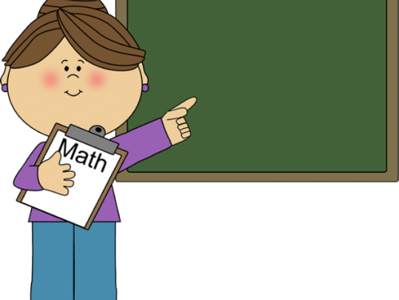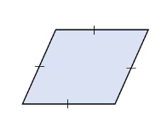

Maths

**Flashback 4!**

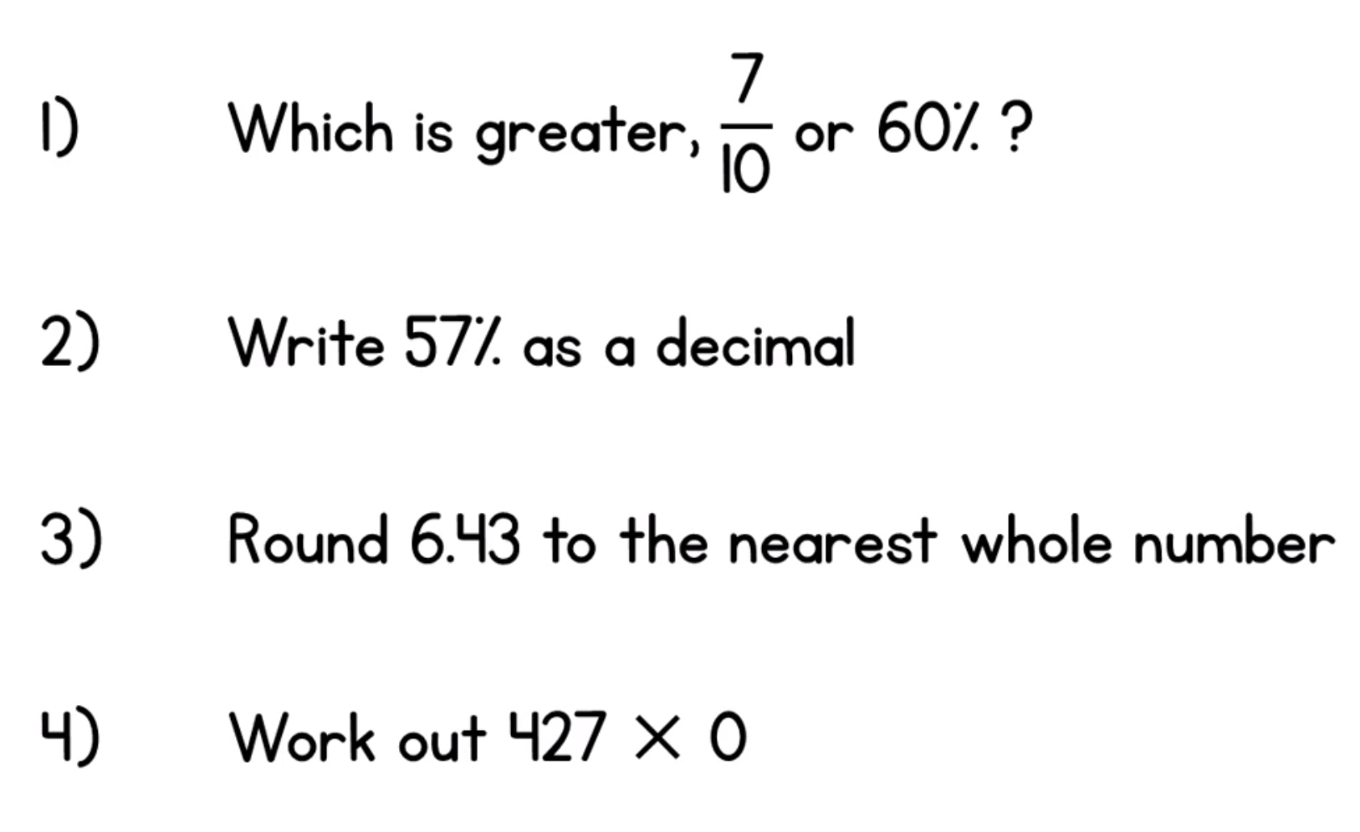

**WRH Sumer Term Week 1 - Adding and Subtracting Decimals**

Look at the WRH website <https://whiterosemaths.com/homelearning/year-5/> for all of the lessons and questions on adding and subtracting decimals. Each day you will find an easy to follow video tutorial with questions to work out.

When you have completed the lessons for the week, have a go at the 20 assessment questions on Professor Assessor. I will then be able to see how you are getting on.

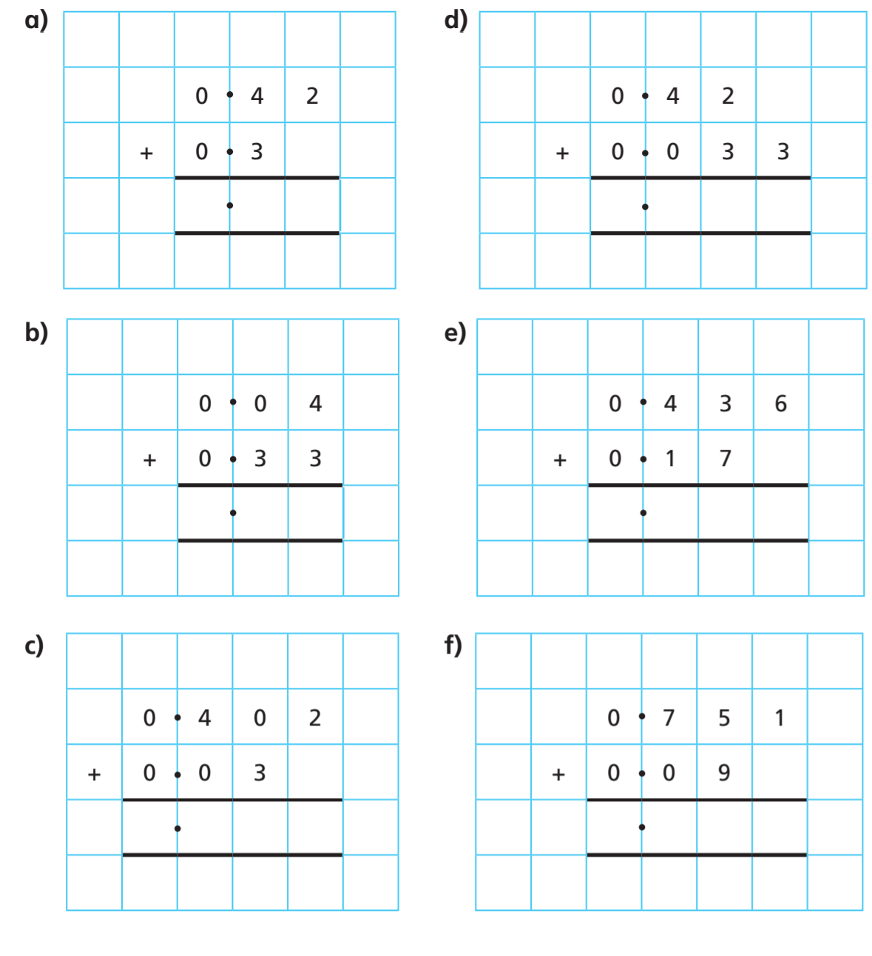

**Science:**

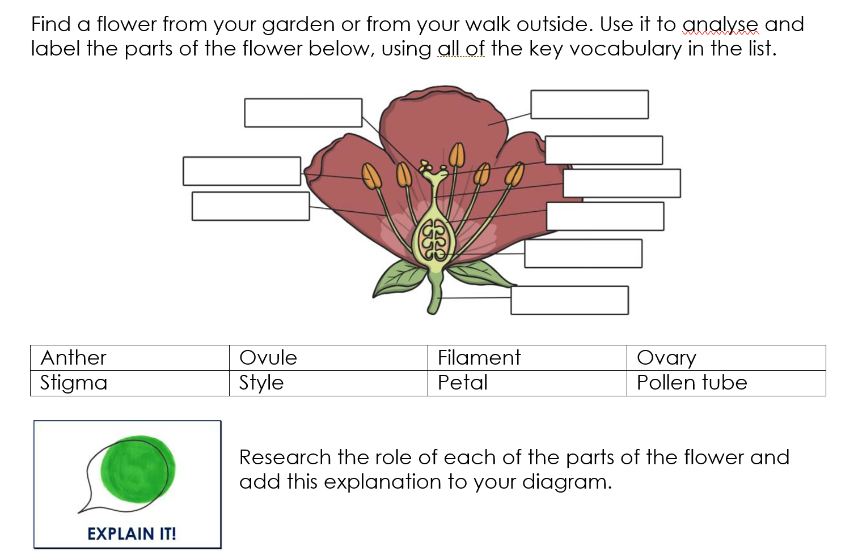

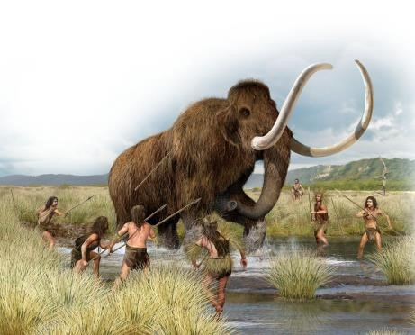**History:**

Think about and write down the answers to the following questions:

* What do you do for entertainment?
* What are your favourite foods?
* What types of transports do you use?
* What is it like where you live?

Now think about what life would be like if we were to take this all away? Imagine a world with no electricity, no shops, no houses like ours, no transport. How would you feel?

This is what life was like in the Stone Age. Can you find out some information about what life would have been like in the Stone Age? Think about where people lived, what they used for entertainment and the food they ate. What would life have been like for a child living in the Stone Age?

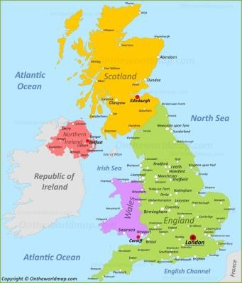

**Geography:**

* Research and find out the names of the countries within the UK.
* Do you know the name of the village, town or city you live in?
* What country do you live in?
* How many cities are there in England? Can you name 10?

**Art:**

*See RE.*

**RE:**

Look at the pieces of artwork below. What are the recurring symbols and images in each picture?  What do they mean?

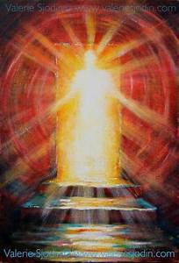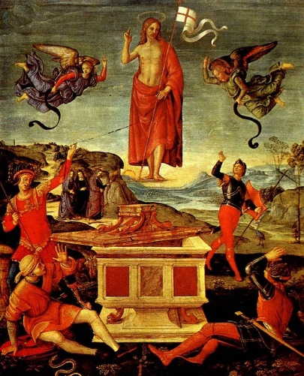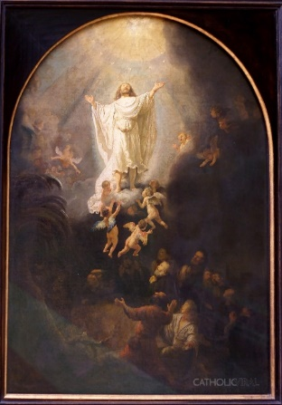

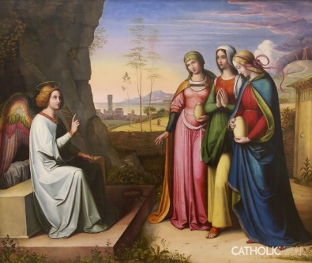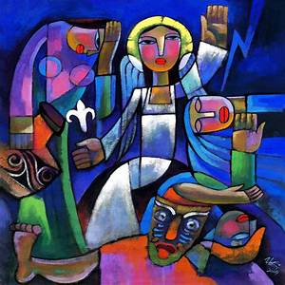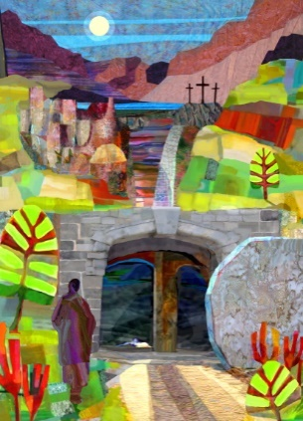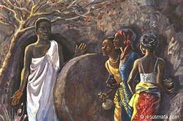

Think about

* *What colours have been used and what messages do they tell the viewer?*
* *Where would these pieces of art be displayed?*

Make a piece of spiritual art - a picture, painting or sculpture - with the title 'RESURRECTION'.  Send a photo of it to school at [sarah.taylor@st-patricks.wilts.sch.uk](mailto:sarah.taylor@st-patricks.wilts.sch.uk). It would be lovely to put some of your artwork on to our school website.

**Languages:**

* Can you write down the days of the week in French? Can you then teach someone in your home how to say these words?

**Times Tables:**

* Login to Professor Assessor to practise your times tables.

**PE**

* Visit *The Body Coach* TV YouTube channel each morning at 9am as he will be providing a live PE at home lesson.

<https://www.youtube.com/channel/UCAxW1XT0iEJo0TYlRfn6rYQ>

**Mindfulness**

* Need a time out? Go online to Cosmic Kids Yoga and follow a guided relaxation video @<https://www.youtube.com/user/CosmicKidsYoga>

**Useful Websites:**

<https://www.prof123.co.uk/>Children should have their login details

<https://www.topmarks.co.uk/>- Maths and English interactive activities

<https://www.youtube.com/user/GoNoodleGames>- Physical activities

<https://spellingframe.co.uk/>- Spelling Practice (There are free games – no signup needed)

<https://mathsframe.co.uk/>- Maths Practice (There are free games – no signup needed)

<https://www.nhs.uk/change4life/recipes>- Cooking Ideas